 | EUROPEAN COMMISSION  DIRECTORATE-GENERAL  TAXATION AND CUSTOMS UNION  Digital Delivery of Customs and Taxation Policies  Customs Systems

Section I: BUSINESS PROCESS THREADS FOR CORE BUSINESS

Aligned to the business scope of the REGULATION (EU) No 952/2013 OF THE EUROPEAN PARLIAMENT AND OF THE COUNCIL of 9 October 2013 laying down the Union Customs Code (UCC) and its Delegated and Implementing Acts
Date: | 27/07/2021
Status: | Submitted for acceptance (SfA)
Version: | 5.30 EN
Author: | CUSTDEV3
Approved by: | DG TAXUD
Reference number: | DLV-007-5.5-0-1-6
Public: | DG TAXUD external
Confidentiality: | Commission use (CU)

Document control information
Property | Value
Title | Section I: BUSINESS PROCESS THREADS FOR CORE BUSINESS
Subtitle | Aligned to the business scope of the REGULATION (EU) No 952/2013 OF THE EUROPEAN PARLIAMENT AND OF THE COUNCIL of 9 October 2013 laying down the Union Customs Code (UCC) and its Delegated and Implementing Acts
Author | CUSTDEV3
Project owner | Head of Unit of DG TAXUD Unit A2 Customs legislation
Solution provider | DG TAXUD Unit B1 Process and Data, Customer Relationship and Planning
DG TAXUD Project Manager | DG TAXUD Unit B1 Customs Systems
Version | 5.30 EN
Confidentiality | Commission use (CU)
Date | 27/07/2021

Contract information

Property | Value
Framework Contract | TAXUD/2013/CC/124
Specific Contract | SC22

Document history
The document author is authorised to make the following types of changes to the document without requiring that the document be re-approved:
- Editorial, formatting, and spelling;
- Clarification.
To request a change to this document, contact the document author or project owner.
Changes to this document are summarised in the table in reverse chronological order (latest version first).
Version* | Date | Description | Action | Section
5.30 | 27/07/2021 | Implementing QA4 and DG TAXUD review comments.  Submitted for Acceptance (SfA) to Taxation and Customs Union DG. | I/R | As Required
5.20 | 13/07/2021 | Implementing NA external review comments.  Submitted for Review (SfR) to Taxation and Customs Union DG. | I/R | As Required
5.10 | 08/04/2021 | Implementing QA4 and DG TAXUD review comments.  Submitted for Acceptance (SfA) to Taxation and Customs Union DG. | I/R | As Required
5.00 | 10/03/2021 | Implementing QTM007.  Submitted for Review (SfR) to Taxation and Customs Union DG. | I/R | As Required
Action: I=Insert R=Replace

*Previous Document History before v5.00 is not available.

Configuration management: document location
The latest accepted version of this controlled document is stored on: CIRCABC
Table of contents
1. General Introduction 6
1.1 Document and WORK overview 6
1.1.1 Background And Objectives 6
1.1.2 General Approach 6
1.1.3 Intended Readership 7
1.2 Definitions 7
1.2.1 Methodology Related Definitions 7
1.2.2 Business Related Definitions 8
1.3 Acronyms 11
1.4 References 13
1.5 Changes in the legislation 14
1.6 Assumptions 14
1.7 Symbolism used in the various models 15
1.8 Specific representations inside a process flow diagram 16
1.8.1 The Components of the process flow 19
1.9 Examples of textual description 21
1.9.1 Major Event 21
1.9.2 Process Pure NCTS 22
1.9.3 Result 22
1.10 Traceability between the DIFFERENT MODELS 24
2. “Pure” NCTS 25
2.1 Introduction 25
2.2 Interfaces with other IT systems 26
2.2.1 UCC AES 26
2.2.2 SPEED2 28
2.2.3 Risk analysis system 28
2.2.4 EOS Economic Operator Systems 29
2.2.5 UCC Customs Decisions system 29
2.2.6 TARIC3 30
2.2.7 C/ieCA 30
2.2.8 EU Customs Single Window 30
2.3 L4-TRA-01-00-Transit Core Business Master Process 31
2.4 L4-TRA-01-01 Process Departure - Acceptance and Controls 34
2.5 L4-TRA-01-02-Process Departure – Release 46
2.6 L4-TRA-01-03-Process Arrival 55
2.7 L4-TRA-01-04-Process Movement At Customs Office Of Transit 75
2.8 Handle enquiry 84
2.8.1 L4-TRA-01-05-Status Request 84
2.8.2 L4-TRA-01-06-Handle Enquiry - Enquiry Procedure (Option A) – Contacting the Holder of Transit Procedure 88
2.8.3 L4-TRA-01-07-Handle Enquiry - Enquiry Procedure (Option B)- Contacting Customs Office of Destination 95
2.9 Handle Recovery 102
2.9.1 L4-TRA-01-08-Handle Recovery - Recovery Procedure (Option A) – IE150 (Recovery request) is sent to Competent Authority at Destnation 102
2.9.2 L4-TRA-01-09-Handle Recovery - Recovery Procedure (Option B) – IE143 'Recovery request' or IE150 is received from Competent Authority at Destnation 109
2.10 L4-TRA-01-11-Process Query Movement Information 114
2.11 L4-TRA-01-12-Process Incidents En Route 117
2.12 L4-TRA-01-13- Process Formalities Prior To Exit Of Goods At Customs Office Of Exit For Transit 123
2.13 Assist users in their daily work 131
2.13.1 Services 131
2.13.2 Customs’ movements state system 131

List of figures
Figure 1: Example of a Process Flow Diagram 16
Figure 2: Example of Pools and Lanes 20
Figure 3: Example of a Start Event 20
Figure 4: Example of an Intermediate Event 20
Figure 5: Example of an End Event 21
Figure 6: Example of Gateway 21
Figure 7: Traceability between models 24
Figure 8: L4-TRA-01-00-Transit Core Business Master Process - Part A 31
Figure 9: L4-TRA-01-00 - Transit Core Business Master Process - Part B 32
Figure 10: L4-TRA-01-01-Process Departure - Acceptance and Controls - Part A 34
Figure 11: L4-TRA-01-01-Process Departure - Acceptance and Controls - Part B 35
Figure 12: L4-TRA-01-02-Process Departure – Release - Part A 46
Figure 13: L4-TRA-01-02-Process Departure – Release - Part B 47
Figure 14: L4-TRA-01-03-Process Arrival - Part A 55
Figure 15: L4-TRA-01-03-Process Arrival - Part B 56
Figure 16: L4-TRA-01-03-Process Arrival - Part C 57
Figure 17: L4-TRA-01-04-Process Movement At Customs Office Of Transit - Part A 75
Figure 18: L4-TRA-01-04-Process Movement At Customs Office Of Transit - Part B 76
Figure 19: L4-TRA-01-05-Status Request 84
Figure 20: L4-TRA-01-06-Handle Enquiry - Enquiry Procedure (Option A) – Part A 88
Figure 21: L4-TRA-01-06-Handle Enquiry - Enquiry Procedure (Option A) – Part B 89
Figure 22: L4-TRA-01-07-Handle Enquiry - Enquiry Procedure (Option B) - Part A 95
Figure 23: L4-TRA-01-07-Handle Enquiry - Enquiry Procedure (Option B) - Part B 96
Figure 24: L4-TRA-01-08-Handle Recovery - Recovery Procedure (Option A) - Part A 102
Figure 25: L4-TRA-01-08-Handle Recovery - Recovery Procedure (Option A) - Part B 103
Figure 26: L4-TRA-01-09-Handle Recovery - Recovery Procedure (Option B) 109
Figure 27: L4-TRA-01-11-Process Query Movement Information 114
Figure 28: L4-TRA-01-12-Process Incidents En Route - Part A 117
Figure 29: L4-TRA-01-12-Process Incidents En Route - Part B 118
Figure 30: L4-TRA-01-13-Process Formalities Prior To Exit Of Goods At Customs Office Of Exit For Transit - Part A 123
Figure 31: L4-TRA-01-13-Process Formalities Prior To Exit Of Goods At Customs Office Of Exit For Transit (Part B) 124

General Introduction

Document and WORK overview

Background And Objectives
The main goal of this “Functional Transit System Specification” (FTSS) is to provide – next to the Functional Requirements Report – a document that the intended readership is already familiar with. This document aims to identify the scope of the New Computerised Transit System (NCTS) and to provide detailed description of its functional specification. It is also intended to serve as a stable baseline for the NCTS detailed technical specification (see ‘Technical Transit System Specification’ [TSS-TSP-SYS]) DDNTA.

This document has been built on the "Functional Requirements Report (FRR). The FTSS document doesn't supersede the FRR which presents the detailed functional specification of the NCTS in its final situation (i.e. all Customs Offices working within the NCTS).

The FTSS document has been developed with a very structured and well proven methodology that supports the specification of NCTS from the perspective of analysing changes in the business process and data domains.

Following the adoption of the Union Customs Code Delegated (No 2015/2446) and Implementing Acts (No 2015/2447), there was a clear need for an update of the NCTS. The update requires changes both on Business Processes and Information Exchanges (IEs). The present document is aligned to these new UCC requirements. This document also covers the scope of the system for NCTS as identified by the MASP (Multi Annual Strategic Plan).

In the Business process domain, process flow diagrams and business process models (BPM) description are the models or work products that will be used to support the understanding and description of the business activities.

The State Transition Diagrams (STD), structure of the information to be exchanged and business rules lists will be the models to cover the Data domain.

All these models are presented in the “Definitions” and “Symbolism used in the various models” parts of this document.
System documentation to be read before or in parallel to this one includes:
- “Functional Requirements Report and its annexes defining the functional system specifications.

General Approach
The detailed functional specification of the pure NCTS has been realised by further detailing business areas, process threads and process steps previously identified in the FSD document.

The business areas and process threads are those described in the FSD document, while the process steps have been decomposed into elementary business processes in order to guarantee that they can be performed by one person, at one location and one time.

The full business process documentation of this document will contain for each process thread within business areas (Transit Core Business, Transit Guarantee Processing Management, Transit Guarantee Validation Management), a diagram showing the main process flow, completed by textual description of the process flow components: events launching or triggering the process thread, elementary business processes and their results. The textual description will include reference to the organisation(s) responsible to perform the processes and to the location(s) where they are performed. The diagrams only show the location(s).

This documentation will also be enriched by indicating the reference to information to be exchanged between processes, when these exchanges involve processes performed at different locations.
The structure of the information to be exchanged will be fully supported by the data definition of the logical data model. This document identifies all processes involved in the scope of the full NCTS.

This document contains several sections and appendices:
SECTION I: BUSINESS PROCESS THREADS FOR CORE BUSINESS
- Chapter 1 - General Introduction: In the subsections of this chapter following areas are presented:
  - Document and work overview, along with a detailed list of abbreviations, references, locations, legislation changes.
  - Definition of symbols used in the various models.
  - Textual description of the ARIS modes.
- Chapter 2 - Pure NCTS: In the subsection of this chapter following areas are presented:
  - Description of NCTS process threads.
  - Definition of basic terms
  - All core processes diagrams description.
SECTION II: BUSINESS PROCESS THREADS FOR GUARANTEE MANAGEMENT
- Detailed description of Guarantee Management Subsystem is included in respective document.

Intended Readership
The intended readership for this document includes:
- any person responsible for the functional and technical specification or implementation of the NCTS;
- any person responsible for the definition of tests for the NCTS;
- any other authorised body concerned with the NCTS including EC/EFTA Joint Committee on Common Transit, the Steering Committee, Traders Associations.

Definitions

Methodology Related Definitions
Many definitions related to methodology, especially in the domain of Business process, are already provided in the referenced documents.
The table below lists additional definitions for terms related to the models of this document and for which the symbolism is explained in “1.8- Specific representations inside a process flow diagram”.

Name | Description
Attribute | An attribute is a data element in which information is to be exchanged (IE).
Data group | A Data group is a set of data containing one or more attributes.
Event | An event is an occurrence that triggers the Business to respond to a predictable fashion. It may occur outside but is important to the business process. The two categories of events are internal event (event that occurs within a process thread. It may result from the completion of another process, the meeting of a certain condition, or the arrival of a particular point in time) or external event (event that occurs outside the process thread).
Location | A location is the place where the business is performed.
Organisation | An organisation is a number of individuals acting in concerned way towards a common business purpose with allocated roles and responsibilities.
Result | A result is an outcome of the business response to an event. A result can be an external result (result that goes beyond the business area to affect its environment) and internal result (result that goes outside the process thread but will stay in the business area). A result can be major, if it is main response of a process thread to an event, or minor if it occurs in addition to the major result.

Business Related Definitions
Definitions of Organisation and Location have special importance in the way business activities in the process flow diagram and description are documented. Therefore, in the forthcoming chapters additional information on these areas along with an exhaustive list of Organisations and locations are provided.

Organisation
As stated in the table of definitions, an Organisation is a number of individuals acting in a concerned way towards a common purpose with allocated roles and responsibilities.
Within NCTS, Internal Organisations – partially responsible of System’s performance and External Organisations that provide information to NCTS are identified. In the following table, detailed description of all involved Organisations along with respective “End Users” is provided.
The table below gives the list of the organisations involved in the NCTS, completed with the list of Users, who belong to these organisations:

Organisation | Internal/  External | Description | End Users
National Customs Administration | Internal | National Customs Administration of a country participating in the NCTS project. | - Customs Officers;  - Data Manager for the National Domain;  - System Administrator for National Domain.
DG TAXUD | Internal | Organisation responsible for the Transit Computerisation Project. | - System Business Owner  - System Administrator for Common Domain.
Trader | External | Generic term for the Economic Operators who interact with the Transit procedures. | - Holder of Transit Procedure;  - Authorised Consignor  - Authorised Consignee
Guarantor | External | The financial organisation, for example a bank, which provides surety for a guarantee. | - Guarantor

Locations/Actors
In the previous chapter, it was mentioned that Location is the place where business is performed. Nonetheless, this definition should not be interpreted as the geographic term but as the place where various processes for a specific Transit Operation or maintenance of reference data are performed. Detailed list is described in below table.
AES | The Automated Export System
Actual Customs Office Of Destination | The Customs Office where goods placed under the Transit procedure have been presented de facto in order to complete the Transit Operation
Actual Customs Office Of Exit For Transit | The Customs Office competent for the place where the goods arrive in order to leave the customs territory of the Safety and Security Area for a destination outside that territory.
Actual Customs Office of Transit | The Customs Office where goods placed under the Transit procedure have been presented de facto in order to cross into or exit from the territory of the National Administration.
Any Customs Office | Any Customs Office of Departure, Customs Office of Destination, Customs Office of Transit, Customs Office of Exit for Transit, Customs Office of Incident Registration, and Customs Office of Guarantee.
Competent Authority Of Enquiry At Departure | The Customs Authority responsible for the enquiry procedure at Departure.
Competent Authority Of Enquiry At Destination | The Customs Authority responsible for the enquiry procedure at Destination
Competent Authority Of Recovery At Departure | The Customs Authority responsible for the recovery procedure at Departure.
Competent Authority Of Recovery In Any Country | The Customs Authority responsible for the recovery procedure at any country other than the country at Departure.
Customs Authority | The Customs Division of a National Administration responsible for executing each particular business process of NCTS depending on the status of the movement and the role of the Customs Office.
Customs Office Of Departure | The Customs Office where the customs declaration placing goods under a transit procedure is lodged. This customs Office controls the goods, allows (or not) the goods to be released for transit, initiates the Enquiry procedure if necessary and discharges the transit operation or initiates the Recovery procedure.
Customs Office Of Destination | The Customs Office where the goods placed under a transit procedure are to be presented in order to end the procedure.
Customs Office Of Guarantee | The Office where comprehensive guarantees data, flat rate guarantees, and associated NCTS vouchers data and guarantee waiver data are recorded. Additionally, it is the Customs Office where individual guarantee in the form of a cash deposit or vouchers, is lodged.
Customs Office Of Transit | (a) The Customs Office competent for the point of exit from the customs territory of the Union or from a common transit country when the goods are leaving that territory in the course of a transit operation via a frontier between the Union or a common transit country and a third country other than a common transit country, or  (b) The Customs Office competent for the point of entry into the customs territory of the Union in the course of a transit operation from a common transit country or a third country, or  (c) The Customs Office competent for the point of entry into the customs territory of a Contracting Party to the Convention on a Common Transit Procedure when the goods move under the common transit procedure, or the customs Office competent for the point of exit from the customs territory of a Contracting Party when the goods are leaving that territory in the course of a transit operation via a frontier between that Contracting Party and a third country.
Customs Office Requesting Competency For Recovery | Any Customs Office requesting from the Competent Authority of Recovery at Departure to become competent for performing recovery.
Customs Office of Exit for Transit | The Customs Office competent for the point of exit from the Security Area responsible for assessing safety and security data. Specifically, the role Customs Office of Exit for Transit can be assigned to:  a) the Customs Offices that are located in the EU Member States having a border with a CTC country (other than those that belong to the Security Area, such as NA-CH and NA-NO);  b) the Customs Offices located in a National Administration that belongs to the Security Area with air/sea traffic.
Customs Office of Incident Registration | The nearest customs authority of the National Administration (participating in NCTS) in whose territory the goods and the means of transport are located is responsible to register the incidents occurred in that territory during the journey of the consignment to the Office of Destination.
Customs Officer | A customs officer is a law enforcement agent who enforces customs laws, on behalf of a National Administration. The Customs Officer supervises goods traffic in ports, airports, and land border crossings, and within the territory of the National Administration.
Customs Officer At Premises Of The Trader | Customs Officer visiting the Premises of the Holder of the Transit Procedure or the Authorised Consignee either at the Customs Office of Departure or at the Customs Office of Destination.
Declared Customs Office Of Destination | The Customs Office of Destination where the transit movement is declared by the Holder of the Transit Procedure to end its journey as submitted in the initial declaration.
Declared Customs Office Of Exit For Transit | The Customs Office of Exit for Transit where the transit movement is declared by the Holder of the Transit Procedure to leave the Safety and Security Area as submitted in the initial declaration.
Declared Customs Office Of Transit | The Customs Office of Transit where the transit movement is declared by the Holder of the Transit Procedure to enter/exit the frontiers of a NCTS Contracting Party as submitted in the initial declaration.
Guarantor | An Economic Operator, for example a bank, which provide surety for a guarantee.
Holder Of The Transit Procedure | The person who lodges the Transit declaration, or on whose behalf that declaration is lodged or the person to whom the rights and obligations in respect of a customs procedure have been transferred. The Holder of the Transit Procedure is considered the proprietor of the transit movement.
Involved Customs Offices | Any expected or actual Customs Office that has received any of the following messages: IE001, IE003 (positive), IE050 or IE115 (positive), IE160 or IE165 (positive), IE181. Essentially, it is the Office where incidents have been registered or where the transit movement crosses the frontiers or leaves Safety and Security Area or where ends its journey.
NCTS | The New Computerised Transit System.
Premises Of The Trader In His/Her Country | Premises of the Economic Operator in the country where they are established.
Premises Of The Guarantor | Premises of the Economic Operator or Financial Organisation which provide surety for a guarantee.
Premises Of The Trader At Departure | Premises of the Holder of the Transit Procedure where the Transit Movement is Initiated.
Premises Of The Trader At Destination | Premises of the Authorised Consignee where the Transit Movement ends.
Querying Authority | Any Customs Office (other than the Customs Office of Departure), or the Competent Authority of Recovery which query the Customs Office of Departure for the movement information.

Acronyms
The following acronyms are used in this document.
Acronym | Description
AAR | Anticipated Arrival Record
AEO | Authorised Economic Operator
AES | Automated Export System
ARIS | ARIS Architect – Modelling Tool
ATR | Anticipated Transit Record
AXR | Anticipated Exit for Transit Record
BPM | Business Process Modelling
BPMN | Business Process Modelling Notation
C/ieCA | Common IE Conversion Application
COL | Customs Office List
CTC | Common Transit Countries
DA | Delegated Act
DDNTA | Design Document for National Transit Application
DG TAXUD | Directorate General for Taxation and Customs Union
DTI | Direct Trader Input
EC | European Commission
EDI | Electronic Data Interchange
EEC | European Economic Community
EFTA | European Free Trade Association
ENS | Entry Summary Declaration
EORI | Economic Operators Registration and Identification
EOS | Economic Operator Systems
EU | European Union
EXS | Exit Summary Declaration
FRR | Functional Requirements Report
FSD | Functional Scope Document
FSS | Functional System Specifications
FTSS | Functional Transit System Specification
GMS | Guarantee Management System
GRN | Guarantee Reference Number
IA | Implementing Act
ID | Identifier
IE | Information Exchange
ieCA | IE Conversion Application
ISO | International Organisation for Standardisation
IT | Information Technology
L4 | Level 4: Functional Requirements BPM (BPMN) and Information Exchanges (MAD)
LRN | Local Reference Number
MASP | Multi Annual Strategic Plan
MRN | Master Reference Number
MS | Member State(s)
N/A | Not Applicable
N/ieCA | National IE Conversion Application
NACK | Non-Acknowledgement
NCF | Notification Crossing Frontier
NCTS | New Computerised Transit System
Ref | Reference
SAD | Single Administrative Document
STD | State Transition Diagrams
TAD | Transit Accompanying Document
TCUIN | Third Country Unique Identification Number
TIN | Trader Identification Number
TIR | Transports Internationaux Routiers
TSAD | Transit Security Accompanying Document
UCC | Union Customs Code
UNECE | United Nations Economic Commission for Europe

References
Reference | Title | Version | Date
Transit Manual | The Transit Manual | TAXUD/A1/TRA/005/2020-EN | 30.06.2020
Convention | DECISION No 2/2007 OF THE EC-EFTA JOINT COMMITTEE ON COMMON TRANSIT  of […]  amending the Convention of 20 May 1987 on a common transit procedure | TAXUD/1642/2006 EN - final | 16 April 2007
http://ec.europa.eu/taxation_customs/dds2/col/col_home.jsp?Lang=en | List of authorised Customs Offices for Community/common Transit operations, original source of the current "Customs Office List" published on the TAXUD website on EUROPA |  | 2021
Functional Requirements Report | Functional Requirements Report and its annexes defining the functional system specifications | 6.10 | 2021
UCC | Union Customs Code which was adopted on 9 October 2013 as Regulation (EU) No 952/2013 of the European Parliament and of the Council |  | 9/10/2013
UCC/DA | Commission Delegated Regulation (EU) 2015/2446 of 28 July 2015 supplementing Regulation (EU) No 952/2013 of the European Parliament and of the Council as regards detailed rules concerning certain provisions of the Union Customs Code) - |  | 25/7/2019
UCC/IA | Commission Implementing Regulation (EU) 2015/2447 of 24 November 2015 laying down detailed rules for implementing certain provisions of Regulation (EU) No 952/2013 of the European Parliament and of the Council laying down the Union Customs Code. |  | 01/01/2020

Changes in the legislation
The New Computerised Transit System has required the adaptation of the existing legal provisions to satisfy, in particular, the new procedural and legal certainty needs.

The very first provisions have been integrated in the existing legal framework trough the adoption of:
- European Community level for Community transit:
Commission Regulation (EC) No. 502 of 12 February 1999 amending Regulation (EEC) No. 2454/93 laying down provisions for the implementation of Council regulation (EEC) No. 2913/92 establishing the Union Customs Code;
- Αt conventional level for the Common Transit Procedure:
- Decision No 1/99 of the EC/EFTA Joint Committee on common transit of 12 February 1999 amending Appendices I, II and III of the Convention of 20 May 1987 on a common transit procedure.
- Union Customs Code (UCC), which is part of the modernisation of customs and serves as the new framework regulation on the rules and procedures for customs throughout the EU. Its substantive provisions have entered into force on 1 May 2016;
- UCC Delegated Act, which was adopted on 28 July 2015 as Commission Delegated Regulation No 2015/2446; UCC Delegated Act has been modified twice: Articles 2, 3, 104, 106, 112, 113, 128, 138, 141, 144, 146, 181 and 184 were amended and Articles 122a, 124, 124a, 126, 126a and 129a to 129d, were added by the UCC Transitional Delegated Act in order to include some transitional provisions, which will apply until the relevant IT systems are fully operational. Articles 139 and 141 of the UCC Delegated Act have been corrected by a Commission Delegated Regulation.
- UCC Implementing Act, which was adopted on 24 November 2015 as Commission Implementing Regulation No 2015/2447. It has been modified once by a Commission Implementing Regulation amending notably Articles 62, 68, 163 and 329(8). The amendment enters into force on 14 June 2017.

Assumptions
The following general assumptions have been made in writing this document:
- The NCTS will only deal with the Union/Common/TIR Transit procedure and will not consider any specificity for countries not signatory to the Common Transit Convention at the time of writing.
- All Customs Offices in a Customs Administration are supposed to be able to access any data stored in that Customs Administration, subject to National Administration profiles for access for offices and individuals, even if that data was initially dedicated to a specific Customs Office. In order to illustrate this assumption, two examples are given here under:
- The information to be exchanged based on message IE001 Anticipated Arrival Record (AAR) (which is identified in the process thread ‘’L4-TRA-01-02- Process Departure - Release”) is an information provided by an Office of Departure to the declared Office of Destination. The assumption makes the data of that information exchange (IE001) available to Offices of Destination other than the one declared, provided those Offices belong to the same Customs administration as the declared Office of Destination.
- The management of authorisations to use simplified procedure, given to the Trader, is under the responsibility of the organisation “National Customs Administration” at the location “National Domain Central Services Office”. The assumption makes that information available to all Offices of Departure and Offices of Destination provided that those Offices belong to the same Customs administration as the Central service. With this assumption, the Office of Departure is able to verify that the Holder of the Transit Procedure, who submits a declaration under simplified procedure is authorised to do so. For the same reason, the Office of Destination is able to verify that the Consignee, who notifies the arrival of the transit movement under simplified procedure is authorised to do so.
- NCTS data will be kept on-line for a specified time to allow link with external systems i.e. other national computerised customs procedures. Only one process is foreseen, at destination, to present this data to these external systems. Authorised Consignees/Consignors require electronic connections (EDI). Wherever human intervention is involved, no response time can be guaranteed by NCTS. If response time is critical and no response is received in a pre-defined delay, default actions will have to be defined. E.g. Authorised Consignees should be informed about the Customs Officer’s decision to control the goods after the reception of unloading remarks in a very short delay. Therefore, a reminder should be sent by NCTS to the Customs Officer if his/her decision is not provided after a pre-defined delay. For these process steps where human intervention is involved, without defined rules, NCTS does not guarantee response time.

Symbolism used in the various models
This document contains models which support the description of the various business processes (Business process model view) and the description of data that NCTS will manipulate and store (Data model view).
We provide here the list of the models belonging to the Business process model view, for which we will also provide in the following headings details on the symbolism used:
- A diagram providing a graphical representation of the Transit business thread. This diagram is called a process flow diagram. It shows how the business arranges its processes to respond to external events (e.g.: Transit consignment arrives at destination) and to produce results (e.g.: Presentation rejected at destination). This specific technique allows for full understanding of the Transit business before detailing the information technology solution supporting those processes. Many businesses have similar processes, but the arrangement of the processes—the dynamics or process flow—may be very different.
- Textual description of the components of the Transit business thread are shown on the process flow diagram:
- the (major and minor) events that launch the thread;
- the processes that are involved in the thread;
- the (major and minor) results produced by the thread.
- When applicable, specific assumptions, constraints or remarks will be provided for each of the elements.
The Data model view will be limited to the following two models:
- The model of the State Transition Diagram presents the life cycle of the data, showing the different states and the way, it goes from one state to the next one. State Transition Diagrams are provided for the most significant process threads.
- During the execution of the Transit business threads, information is exchanged between processes.

Specific representations inside a process flow diagram
The following diagram is an example of a process flow diagram which represents the “Process Query Movement Information” at any Customs Office:
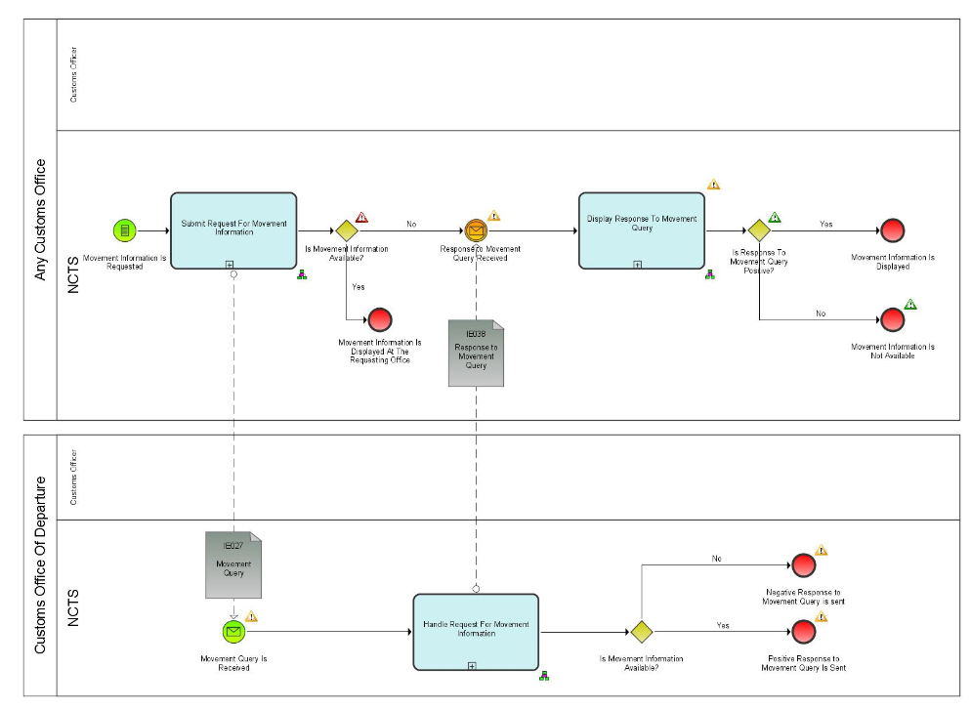
8
1
2
10
6
9
7
5

4
3
Figure 1: Example of a Process Flow Diagram
Process flows are composed by the following elements:

1
: Pool
2
: Lane
Group | Object | Type | Attribute / Definition
Lanes and Pools | 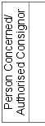 | Uncollapsed pool | A Pool may have internal activities, in the form of the Process that will be executed – “Uncollapsed Pool”
Lanes and Pools |  | Collapsed pool | A Pool may have no internal activities, i.e., it can be a “black box” – “Collapsed Pool”.
Lanes and Pools |  | Lanes | A Lane is a subdivision of a pool and is used to organise and categorise activities.
3
: Start Events
Group | Object | Type | Attribute / Definition
Events |  | Empty start event | An Empty start event used for a subprocess that starts when the flow is triggered by its parent process.
Events |  | Conditional start event | A Conditional start event is triggered when a condition becomes true.
Events |  | Message start event | A Message start event is used when an IE is received, and it triggers the process.
4
: Intermediate Events
Group | Object | Type | Attribute / Definition
Events |  | Intermediate message event | Intermediate message event is triggered when an IE (Information Exchange) is received.
Events |  | Intermediate timer event | Intermediate timer event acts as a delay mechanism based on a specific time - date or a specific cycle.
Events |  | Intermediate conditional event | Intermediate conditional event is used to demonstrate the fulfilment of a condition that is outside the process in scope. On a specific condition which is not an explicit output of the preceding object.
5
: Gateway
Group | Object | Type | Attribute / Definition
Gateway |  | Exclusive gateway | Exclusive gateway routes the sequence flow to exactly one of the outgoing branches
Gateway |  | Event based gateway | An event-based gateway allows the sequence flow to be routed to the subsequent event/task, whichever is to occur first
Gateway |  | Parallel gateway | In a parallel gateway all outgoing branches are activated simultaneously

6
: Call Activity - Subprocess
Group | Object | Type | Attribute / Definition
Call Activity |  | Call activity (Always collapsed) | A Call Activity triggers another standalone process, which relates to one business function.
Subprocess |  | Subprocess | Subprocess is a set of activities that have a logical sequence that meet a clear purpose. It is compound in that it can be broken down into a finer level of detail

: End Events
7
Group | Object | Type | Attribute / Definition
Events |  | Empty end event | An Empty end event is the standard modelling to end the process.
Events |  | Terminate end event | A Terminate end event triggers the immediate termination of a process
8
: Information Exchange
Group | Object | Type | Attribute / Definition
Data objects |  | Information exchange | An Information Exchange object represents the content of communication between two processes, actors etc.

: Sequence Flow
Group | Object | Type | Attribute / Definition
Flow | 9 | Sequence Flow | A Sequence Flow is used to show the order that Activities will be performed in a Process
10
: Message Flow
Group | Object | Type | Attribute / Definition
Flow |  | Message Flow | An Information Exchange object represents the content of communication between two processes, actors etc.

The Components of the process flow
The following section provide basic components applied in BPMN in L4.

Pools and Lanes
1
2
Pools represent actors, and more specifically roles (as presented in 1.2.2.2), in a process. Each pool contains the activities performed by that actor or role.
For example:
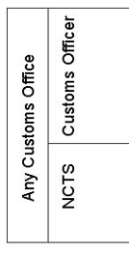
Figure 2: Example of Pools and Lanes
A lane is a subdivision of a pool. Lanes are used to indicate the split between the physical user and the system.
Interaction between lanes of the same pool is modelled by sequence flow (full line – indicating ‘what comes next’).
9
Interaction between pools is modelled by message flows (dotted line).
10

Events
Events represent something that happens at a specific time and is not specifically an “action” (like a task). Events affect the flow of the model and usually have a cause (trigger) or an impact (result). There are three types of Events, based on when they affect the flow: Start, Intermediate, and End. For each of these event types a small introduction will be provided with some specific guidelines, like which subtypes are used for modelling within the EU Customs BPM projects.
3
- Start Event:
A start event is modelled when the event starts a (sub) process or a call activity and causes a sequence of processes to start or to restart after an end event. The event is represented as a green 1 thin-lined event.
For example:
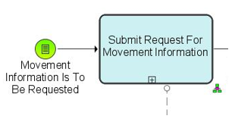
Figure 3: Example of a Start Event
If a process is started due to the end of another process, the start event is to have the exact same name as the end event in the previous process.
- Intermediate Event:
4
An intermediate event is modelled when the event occurs within the process. The symbol used is an orange 2 thin-lined event.
For example:
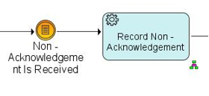
Figure 4: Example of an Intermediate Event
8
- End Event:
An end event is modelled when the event ends the process. The symbol used is a red thick-lined event.
For example:
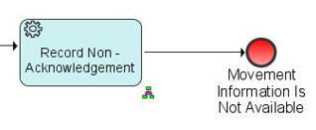
Figure 5: Example of an End Event

Gateways
5
A gateway is used to control the divergence and convergence of sequence flows in the process. In addition, loops are modelled with a gateway. Icons within the diamond shape of the Gateway will indicate the type of flow control behaviour.
For example:
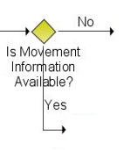
Figure 6: Example of Gateway

Examples of textual description
Textual description is provided for the following components of a Transit business thread:
- events;
- process in the context of the pure NCTS;
- results.

Major Event
Each event is described by:
- Event’s Name;
1

- Who produces the event (Organisation);
2

- Where the event happens (Location);
3

- Event’s description.
4

1
Movement information is requested
Organisation : National Customs Administration
2
Location : Customs Office of Departure, Customs Office of Destination, Customs Office of Guarantee, Customs Office of Transit, Customs Office of Exit for Transit, Customs Office of Incident Registration
3
A Customs Officer with an appropriate level of authorisation and access to NCTS at any Customs Office, requests the movement information for a movement with a given MRN.
4
N.B. This includes the case of an incident registration if access to the NCTS is available.

Process Pure NCTS
Processes
Each process is described by the following attributes:
- Process Name;
1
- Process identification;
2
- Who performs the process (Organisation);
3
4
- Where the process is performed (Location);
4
- Which constraints apply (blank if no constraints apply);
5
- What activities are included in the process (process description)
656

- Which information is exchanged between two locations (if applicable);
7

- Final situation description, where System exits the process. (this final situation is not meant to duplicate what is said in the description of what the process does but only mentions the most relevant information).
85

Submit request for movement information  1 | Process: L4-TRA-01-11-01
Organisation : National Customs Administration
Location : Customs Office of Departure, Customs Office of Destination, Customs Office of Guarantee, Customs Office of Transit
2
3
Constraint : The movement information may be located in a different country (that of the Customs Office of Departure).
5
4
A Customs Officer submits a request for movement information based on a given MRN.
6

NCTS looks for the movement:
- when the movement information is available at the Office where the request is submitted, NCTS retrieves and displays it to the Customs Officer immediately.
- when the movement information is not available at the Office where the request is submitted, NCTS notifies the Customs Officer that the information is not available and automatically sends (IE027) a request to the Country of Departure.
The requesting Customs Offices receives (IE038) the response to the request. NCTS displays the received information or the received error message.
7

Final situation :
8
The movement information is returned or a request for movement information is submitted to the Customs Office of Departure.

Result
1
Each result is described by:
1
- Result Name;
1
- Who uses the result (Organisation);
2
- Where the result is used (Location);
3
- Result description.
4

Movement information displayed
Organisation : National Customs Administration
Location : Customs Office of Departure, Customs Office of Destination, Customs Office of Guarantee, Customs Office of Transit
3
2
1
The information on the requested movement is displayed.
4
The model contains a description of the results, who uses them (Organisation) and where they are used (Location).

Traceability between the DIFFERENT MODELS
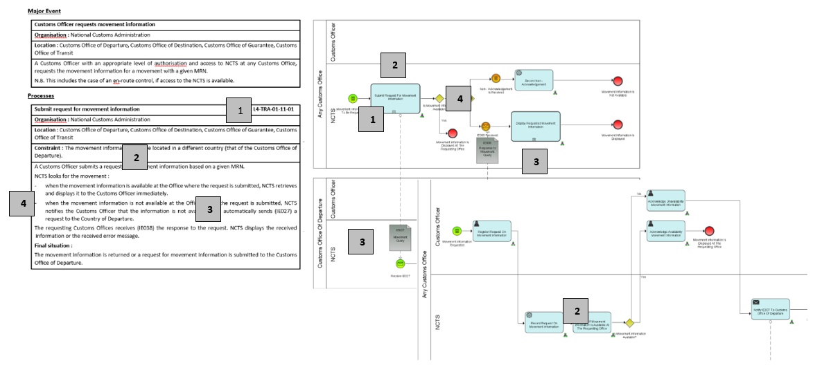
Figure 7: Traceability between models

- Start event for process “Customs Officer requests movement information”.
1
- Process “Submit Request For Movement Information” textual and graphical description
2
- Information to be exchanged is identified with letters IE followed by numeric identifier (e.g. IE027 and IE038).
3
- Gateway is used to identify if movement's information is available or not.
4

“Pure” NCTS

Introduction
This section presents the various business process threads of the Transit core business.
This introduction (and only this introduction) provides a description and a graphical overview of the core business which is not intended to be neither exhaustive nor methodologically correct. It is rather intended to highlight the major items of the core business and the links that exist between them. These major items will then be described in the rest of this section.
The major process threads are:
- process departure;
- process movement at Customs Office of Transit;
- process formalities at Customs Office of Exit for Transit;
- process arrival;
- process incidents En-Route;
- handle enquiry;
- handle recovery.
Clearly, these process threads are inter-dependent, e.g. the processing of a Transit movement crossing a frontier will happen after the processing at departure. The ‘link’ between those two processes is the journey of the consignment from the Customs Office of Departure to the Customs Office of Destination via Offices of Transit and/or via Offices of Exit for Transit. This link appears in the diagrams below, but not in the process threads themselves.
Major item of the core business is that NCTS delivers data for Safety and Security risk analysis and communicates the results of risk analysis and control results between the offices concerned.
An overview of the main path is:
The movement is initiated. Thereafter, the Holder of the Transit Procedure receives the NCTS Accompanying Document or MRN of Transit Declaration in an electronically readable format and the vehicle with the consignment goes to the first Customs Office of Transit (if any). In normal procedure, as per Article 41 of Appendix 1 of CTC, in case of CTC country, Customs Office of Departure has to provide printout of TAD to the Declarant.
The following might happen not at all or several times. The consignment arrives at the Customs Office of Exit for Transit in order to leave the Security Area. Following risk assessment at the Customs Office of Exit for Transit, and based on the risk assessment results, in case it is decided that the movement is allowed to leave the Security Area, the consignment arrives at a Customs Office of Transit where the processing of crossing a frontier occurs. Subsequently, the consignment leaves either to the next Customs Office of Transit or ends its journey to its final destination.
Normally, when the consignment arrives at destination, the goods are presented to the Customs Office of Destination which processes the arrival notification of the movement (usually sent by the Consignee). Once the arrival processing is complete, the Customs Office of Departure writes-off the movement after the reception of the destination control results.
In case the Customs Office of Departure does not receive any feed-back about the arrival of the movement and/or control results from the Customs Office of Destination within the expected period, an enquiry procedure is started. Depending on the result of the enquiry and/or whether destination control results contain any discrepancies (i.e. minor/major), additional taxes and duties might need to be collected, meaning that the recovery procedure might be started. In all cases, sooner or later, the movement is written-off.
The following diagram depicts that main path, but for purposes of clarity without showing details such as:
- correction / amendment;
- declaration validation, acceptance, and verification;
- risk analysis;
- cancellation / invalidation;
- control processes either at departure or at destination;
- handling of control results;
- possibility to have a route with Customs Offices of Transit and Customs Offices of Exit for Transit involved into the transit movement;
- diversion;
- query of movement information;
The following Transit procedures are processed by NCTS:
- Common Transit, which is used for the movement of goods among the EU member states and Common Transit Convention countries and between the Common Transit Convention countries themselves;
- Union Transit (applicable only to EU member states), which is the procedure that provides for the movement, under Customs control, of goods that are not in free circulation through the Union and for the movement of free circulation of goods in certain circumstances. It comprises of two separate procedures:
- The External Union Transit procedure (T1) and
- The Internal Union Transit Procedure (T2);
- TIR Transit (applicable only to EU member states) which allows the movement of goods internationally over one or more frontiers and where some portion of the journey between the start and end of the TIR operation is conducted by road.
NCTS caters for the lodgement of the safety and security data together with a Transit declaration. This data can be lodged for Entry of Goods and/or Exit purposes into/from the Safety and Security Area.

Interfaces with other IT systems
The following important interfaces with other IT systems apply only to EU Member States:

UCC AES
In order to synchronise the transit and export procedures in a harmonised way and to avoid open movements, NCTS needs to interface with AES when export is followed by transit. This interface is part of the so-called national domain, taking place entirely within EU. NCTS needs to interface with AES:
- When the goods are released for export and then the external transit procedure follows, the customs office of exit shall be the customs office of departure of the transit operation (UCC IA Article 329).
- In case of internal transit, the customs Office of exit shall be the customs office of departure and the customs office of destination is situated either:
  - in a common transit country (UCC IA Article 329), or
  - at the border of the customs territory of the Union and the goods are taken out of that customs territory, after having passed through a country or territory outside the customs territory of Union (UCC IA Article 329).

The export followed by transit scenario is triggered when at least one (1) Export MRN is referenced in the transit declaration. Specifically, the Export MRNs should be declared by the Holder of the Transit Procedure into the Previous Document data group under each House Consignment data group of the transit declaration (i.e. one (1) House Consignment of the transit declaration corresponds to the details of one (1) Export MRN).
In case of Internal Transit, and for the purpose of the interconnection between NCTS and AES, an Office of Destination (where the goods of the transit movement are to be / have been presented) can be considered appropriate when it belongs to:
- an EU MS that possesses the role ‘EXT-Office of Exit’, or
- a Common Transit Convention country (i.e. that operates in NCTS).

The Office of Departure will inform the Office of Exit:
- In case a transit declaration with previous procedure Export is received (i.e. an Export MRN is declared into the Previous Document data group under the House Consignment data group of the transit declaration), the Office of Departure sends the transit declaration to the Office of Exit for validation. In case the Office of Exit confirms to the Office of Departure that the transit declaration is valid, then the Office of Departure notifies the Office of Exit to allocate the Transit MRN for the specific Export MRN(s).

- In case a transit declaration that has not yet been released for transit, contains Export MRN(s) as previous procedure and is amended by the Holder of the Transit Procedure, the Office of Departure will also send the amended transit declaration to the Office of Exit for validation in the event modifications are performed to the Export MRN(s).

- In case the transit declaration is invalidated. This communication is necessary so that the Office of Departure notifies the Office of Exit to de-allocate the Transit MRN from the Export MRNs (so that the export movement(s) follow a different procedure from transit in AES).

- In case the transit declaration is not released for Transit. This communication is necessary so that that the Office of Departure notifies the Office of Exit to de-allocate the Transit MRN from the Export MRNs (so that the export movement(s) follow a different procedure from transit in AES).

- In case of External Transit, and when the movement is released for transit, the Office of Departure sends the AES destination control results to the Office of Exit. That concludes the interconnection between the Office of Departure and the Office of Exit (i.e. no further communication between NCTS and AES).

- In case of Internal Transit, and when the movement has arrived to an inappropriate Office of Destination (please see above definition of inappropriate Office of Destination), the Office of Departure notifies the Office of Exit with the AES destination control results after the Office of Departure is notified by the Office of Destination for the arrival of the movement. That concludes the interconnection between the Office of Departure and the Office of Exit (i.e. no further communication between NCTS and AES).

- In case of Internal Transit, and when the movement has arrived to an appropriate Office of Destination (please see above definition of appropriate Office of Destination), the Office of Departure notifies the Office of Exit of the AES destination control results after the Office of Departure receives the transit destination control results from the Actual Office of Destination. That concludes the interconnection between the Office of Departure and the Office of Exit (i.e. no further communication between NCTS and AES).

- Finally, for the exceptional case of recovery, the Office of Departure will inform the Office of Exit when the recovery process is initiated but only in case no destination control results have previously been sent to Office of Exit (AES). That concludes the interconnection between the Office of Departure and the Office of Exit (i.e. no further communication between NCTS and AES).

SPEED2
NCTS P5 will interact with the centrally deployed SPEED2. This interaction only concerns EU MS partner countries that participate into the NCTS/TIR-DATA Pilot Project so that the ‘TIR’ transit declaration initiated by these EU MS is also sent to third countries that also participate into the NCTS/TIR-DATA Pilot Project (e.g. Russia).

Risk analysis system
- NCTS interfaces with the national risk analysis systems of the National Administrations that belong to the Safety and Security Area and ensures that risks analysis is initiated once the transit data with Safety & Security data are received and validated by the NCTS.

- The national risk analysis systems of the National Administration that belong to the Safety and Security Area carry out the required risk analysis using the common risk criteria plus national risk criteria and eventually send the risk analysis results back to NCTS.

- Risk analysis result codes are defined on EU level and are managed in the national risk analysis systems; they are not transparent to NCTS.

- NCTS forwards the risk analysis results related to a specific transaction to the relevant Customs Offices involved in the process with the main precondition that these Customs Offices exchanging messages belong to National Administrations that are part of the Safety and Security Area.

EOS Economic Operator Systems
- Where the regulation requires or allows Traders to be registered in EOS (i.e. they are mainly established in EU MS or in collaborating third countries), a unique EORI or TCUIN is assigned to that Trader by the relevant Member State or third county. The EORI or TCUIN number is managed and registered in EOS.

- Where EOS registered Traders are to be declared in an NCTS message, the EORI or TCUIN number shall be declared.

- When validating a received NCTS message, NCTS consults the EOS in order to check the provided EORI or TCUIN number.

- If the declared EORI or TCUIN number is not valid or if it is not declared where it is required, NCTS rejects the transit data set using the appropriate NCTS error message.

- Authorised Economic Operators and their AEO-certificates are registered and managed in EOS.

- When validating a received data set, NCTS consults the EOS to check whether the appropriate Traders are registered as AEO and whether they have a valid AEO-certificate of the relevant type. The query will be performed based on the declared EORI or TCUIN.

- Where NCTS checks the provided data against the validated data authorised by Customs preferably the common database to be consulted. Alternatively, a national replica can be consulted, provided that the necessary frequency of the synchronisation is ensured.

- CRS is an introduced central system that will also be used to get consultation for AEO, EORI.

UCC Customs Decisions system
- The Customs Decisions system allows the electronic processing and central storage of the applications and authorisations and publication of the list of holders on the Internet. The IT system will facilitate the necessary consultations between MS' customs authorities during the decision taking period and the management of the authorisations process.

- When validating a received data set for which authorisations are valid in more than one MS, NCTS consults the UCC Customs Decision system to check the existence and validity of the customs decisions.

- CRS is an introduced central system that will also be used to get consultation for Customs Authorisations.

TARIC3
NCTS P5 will interact with the centrally deployed TARIC3 system to validate the commodity codes declared in the transit declaration. The aim of TARIC system is to be a compilation of the community tariff, commercial and agricultural legislation, codified in a unique and consistent way.

C/ieCA
The NCTS P5 Application can interact with an NCTS P4 Application by using the C/ieCA (i.e. centrally deployed ieCA) during the transition period (i.e. where both Phase 4 & 5 NCTS Applications exist). This interface is optional though (i.e. other conversion application such as N/ieCA could also be used) and supports the conversion of common domain messages from edifact format to XML format (i.e. upgrade) and the conversion of common domain messages from XML format to edifact format (i.e. downgrade).

The Transition Handler is another component (nationally deployed) and is responsible for the conversion choreography required by the Common Domain Protocol Policy. In case conversion is needed, the Transition Handler will call the C/ieCA or N/ieCA or other conversion application (implemented by the NA) and dispatch the converted message to its recipient.

EU Customs Single Window
EU Customs Single Window enables economic operators to lodge electronically and once only all the information required by customs and non-customs legislation for EU cross-border movements of goods.

Single Window will allow parties involved in trade and transport to lodge standardised information and documents with a single-entry point to fulfil all transit-related regulatory requirements.

L4-TRA-01-00-Transit Core Business Master Process
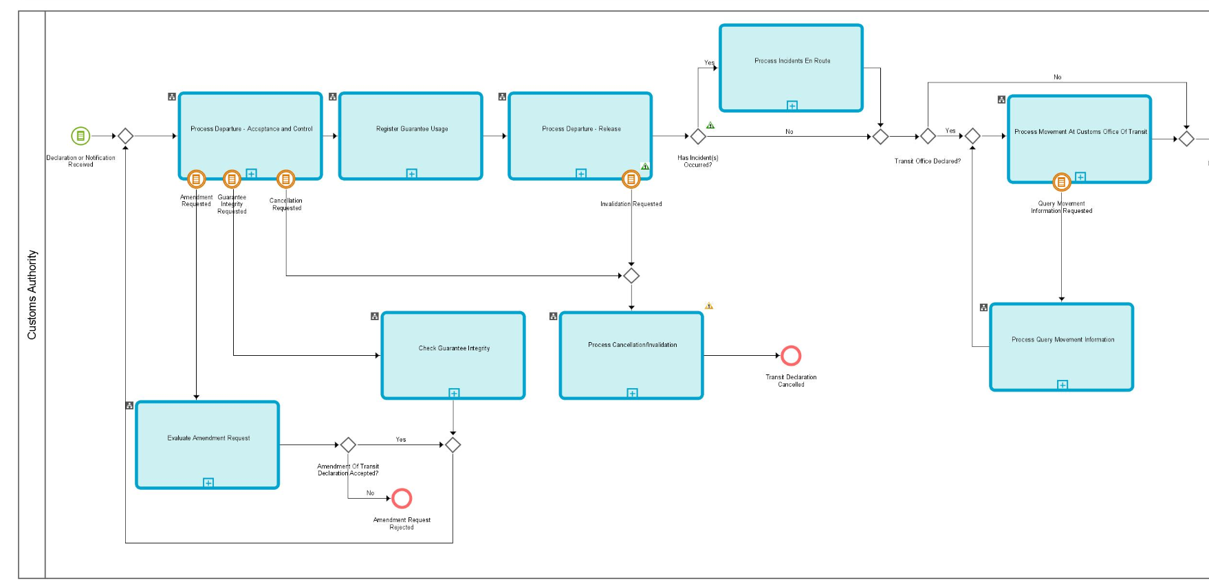
Figure 8: L4-TRA-01-00-Transit Core Business Master Process - Part A
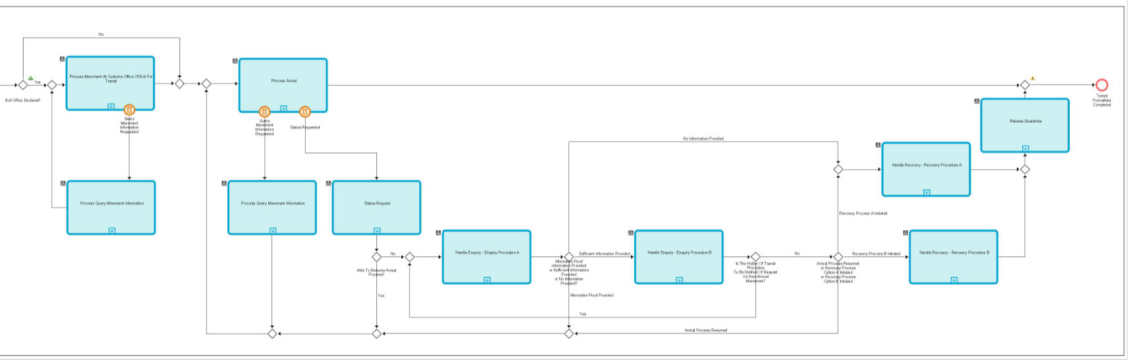

Figure 9: L4-TRA-01-00 - Transit Core Business Master Process - Part B
In this overview, it is interesting to highlight the parts of processing that may be fully automated.
Unless human intervention is specifically required by national policy, NCTS will allow fully automated processing of:
- process departure (from declaration reception, guarantee registration to release for Transit);
- process arrival (from presentation to release of the goods);
- write-off movement.
Though this automated processing will occur for most movements of Authorised Traders (Consignors and Consignees), it will only happen under the following strict conditions:
- at departure (see UNdep.195):
  - the declaration is formally valid and;
  - the declaration is submitted within the hours agreed for that purpose and;
  - the risk analysis does not propose to control the goods and / or documents and;
  - write-off;
  - the verification of data indicates no problems.
- at destination (see UNdes.165):
  - the notification is submitted within the hours agreed for that purpose and;
  - the risk analysis does not propose to control the consignment and;
  - the unloading remarks indicate no problems (i.e. Simplified Procedure only);
  - no discrepancies are reported;
  - goods released from transit;

L4-TRA-01-01 Process Departure - Acceptance and Controls
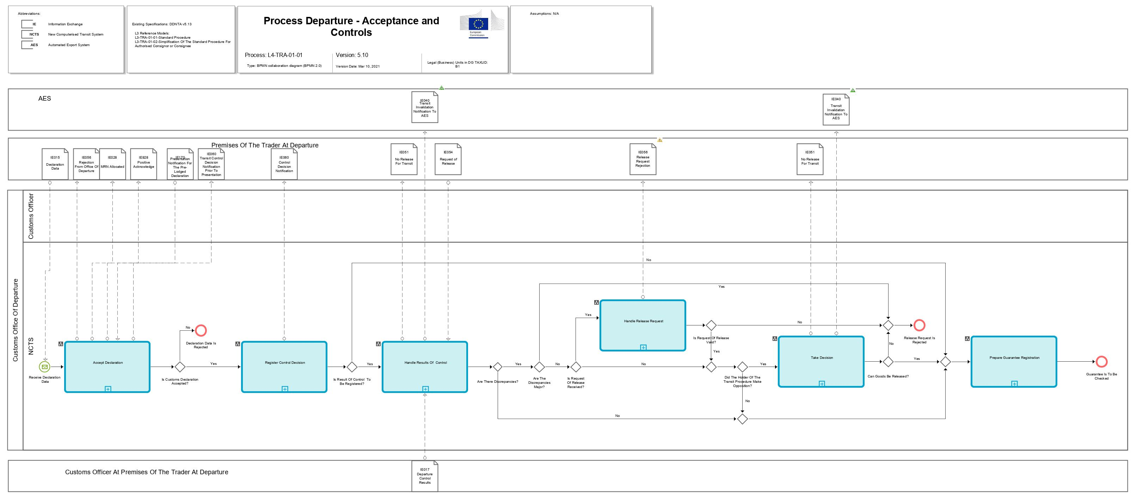
Figure 10: L4-TRA-01-01-Process Departure - Acceptance and Controls - Part A
Figure 11: L4-TRA-01-01-Process Departure - Acceptance and Controls - Part B
Major Event
Receive declaration data
Organisation : National Customs Administration
Location : Customs Office of Departure
The Holder of the Transit Procedure or Authorised Consignor initiates the Union / Common Transit movement by sending the transit declaration data (IE015) to the Customs Office of Departure.

Processes
Accept Declaration | Process: L4-TRA-01-01-01
Organisation : National Customs Administration
Location : Customs Office of Departure
Constraint :
If NCTS is also used for the purpose of safety and security and the Customs Office of Departure is located in the Safety and Security Area or in case safety and security data are lodged in a CTC country and the Customs Office of Transit is the Customs Office of First Entry into the Safety and Security Area, then full safety and security related risk analysis for all the goods shall be performed additionally within the prescribed time limits.
Description :
The declaration data must be submitted (IE015) by electronic means to the Customs Office of Departure (except where the Business Continuity Procedure applies (Annex 72-04 of IA)).
The Holder of the Transit Procedure must provide a Local Reference Number (IE015.TRANSIT OPERATION. LRN) that allows the Holder of the Transit Procedure and the Customs Office of Departure Officer to reference the data in the NCTS before acceptance of the transit declaration. The Holder of the Transit Procedure shall specify whether the NCTS declaration shall be used for the purpose of safety and security (IE015.TRANSIT OPERATION. 'Security' is set to '1' (ENS), or ‘2’ (EXS) or ‘3’ (ENS and EXS) or not (IE015. TRANSIT OPERATION. 'Security' is set to ‘0’ (Not used for safety and security purposes’). NCTS validates data contained in IE015 and performs checks if the provided LRN is unique. In case declaration validation fails (IE015 is rejected), the Holder is notified via IE056 (rejection reason included IE056.FUNCTIONAL ERROR. Error Reason).
Upon validation completion and in case the Country of Departure is EU MS, where an EORI number or a third country unique identification number (TCUIN) is declared, NCTS validates it against EOS (Economic Operators system) and completes the Trader data in the declaration. If the EORI number or the third country unique identification number (TCUIN) is not valid, the transit declaration will be rejected (IE056). Where a Holder of the Transit Procedure Identification Number is declared whose country code does not belong to EU MS, NCTS does not validate it against EOS but checks its existence later against the Guarantee Management System.
In case of valid IE015, the Customs Office of Departure sends a positive acknowledgement (IE928) to the Holder of the Transit Procedure. If upon the submission of the transit declaration, the goods of the consignment are also presented and all other checks are completed, the transit declaration is accepted and the MRN is generated and communicated to the Holder of the Transit Procedure (IE028). The case when the goods are not presented at the time when the transit declaration is submitted to the Customs Office of Departure is analysed below.
Transit declaration with reduced data set: Transit declaration (other than ‘TIR’) with reduced data requirements (IE015.TRANSIT OPERATIONS. Reduced Dataset Indicator is ‘1’) can be used only when the Authorised Consignor holds the pertinent Authorisation to use transit declaration with a reduced dataset (Column 9e, Annex A of Delegated Regulation (EU) 2015/2446).
The applicants applying for Transit simplifications must fulfil the Authorised Economic Operator (AEO) criteria specified in Articles 39(a) (b) and (d) of the UCC.
Acceptance of Declaration Declared Under Normal Procedure:
When a Transit declaration is submitted (IE015) under normal procedure (IE015.AUTHORISATION.Type = 'C521' is not present), NCTS checks whether the location of goods where the consignment can be controlled is declared (IE015. LOCATION OF GOODS is present). If this is the case the declared location of goods is manually validated by the Customs Officer. In case no location of goods is present in the transit declaration, then the goods need to be presented to the premises of the Customs Office of Departure.
If an invalid location of goods is declared, the transit declaration is rejected, and the Holder of the Transit procedure is notified (IE056) that the declaration is invalid with the reason of the rejection. The process ends at this point. Upon communication of Positive Acknowledgement (IE928), NCTS registers whether Goods are present or not where there are two options:
- If Goods are presented upon initial submission of the transit declaration, the Customs Office of Departure accepts the declaration and the MRN of the Transit Operation is communicated (IE028) to the Holder of the Transit Procedure.
- If Goods are not presented upon initial submission of the transit declaration , the Office of Departure generates the MRN (i.e. Master Reference Number), but it is not communicated to the Holder of the Transit Procedure until the acceptance of the transit movement. The MRN (i.e. Master Reference Number) is generated so as to be used internally by the Customs Office of Departure for risk analysis purposes. NCTS requests and records Risk Analysis Results and the Customs Officer decides whether to control or not the Goods prior to presentation. This decision is recorded in NCTS and the timer “Awaiting for Presentation Notification” (30 days duration) is initiated. In addition, in case of positive decision to control then NCTS sends message IE060 ”Control Decision Notification” to the Holder of the Transit Procedure (and only in case he/she is AEO) to notify him/her on the Goods control.
  - If the timer “Awaiting for Presentation Notification” expires and Goods are not yet presented, then the Transit Declaration (IE015) is rejected and NCTS notifies the Holder of the Transit Procedure with message IE056 “Rejection from Office of Departure”.
  - If Goods are presented before the timer “Awaiting for Presentation Notification” expires, the Holder of the Transit Procedure notifies the Customs Office of Departure with an IE170 “Transit Presentation Notification” which is validated by NCTS. Following the reception of the Presentation Notification (IE170) message, the re-validation of the full Transit Declaration information is performed (in terms of syntax and R/Cs), considering the initial data (IE015) and any latest corrections (IE013) as well as reference data validation (based on the date of reception) by the time the IE170 is received:
    - IE170 is not valid, and thus it is rejected, but IE015 is still valid. IE170 is rejected and NCTS notifies the Holder of the Transit Procedure with message IE056. The Holder of the Transit Procedure is able to resend another IE170, only in case the timer “Awaiting for Presentation Notification” has not yet expired;
    - The re-validation declaration data (IE015 + possible IE013 + IE170) is not valid, and as result both IE170 and IE015 are rejected. NCTS notifies the Holder of the Transit Procedure with message IE056 and the Transit Declaration is also rejected;
    - In case validation results are positive, IE170 is recorded in NCTS and the timer “Awaiting for Presentation Notification” stops. The Customs Office of Departure accepts the declaration and the MRN is communicated (IE028) to the Trader at Departure.
Acceptance of Declaration Declared Under Simplified Procedure:
When the transit declaration is submitted (IE015) under simplified procedure (IE015.AUTHORISATION.Type = 'C521' & TRANSIT OPERATION.Limit date is present), NCTS checks that the Holder of the Transit Procedure who is responsible for the declaration (IE015. HOLDER OF THE TRANSIT PROCEDURE. 'Holder of the Transit Procedure identification n°') is indeed authorised to use simplified procedure at that Customs Office of Departure.
NCTS checks also the declared ‘Location of goods’ (IE015. LOCATION OF GOODS) where Customs can control the consignment. There are 2 options:
- The Holder of the Transit Procedure has not declared an ‘Authorised place’ (IE015. LOCATION OF GOODS.Type Of Location is not ‘B’): in this case NCTS considers that the location of goods is the one specified in the authorisation for the Customs Office of Departure;
- The Holder of the Transit Procedure has declared an ‘Authorised place’ (IE015. LOCATION OF GOODS.Type Of Location is ‘B’): in this case NCTS checks it against the various authorised places, for the Customs Office of Departure in question, specified in the authorisation.
When the Holder of the Transit Procedure uses seals (IE015.TRANSPORT EQUIPMENT.SEAL.Identifier) then NCTS checks them against the seals mentioned in the authorisation. NCTS also checks the type of goods in order to be sure that none of them is excluded from the authorisation.
If the Holder of the Transit Procedure is not authorised to use simplified procedure or if he/she has declared an invalid ‘Authorised place’ (including the case of no indication of one location amongst the several authorised locations for the Customs Office of Departure in question) or invalid seals, NCTS rejects the declaration and notifies (IE056) the Holder of the Transit Procedure that the declaration is invalid, giving the reason of the rejection.
When the declaration is valid, a positive acknowledge is communicated (IE928) to the Trader and the declaration data is recorded in the NCTS. NCTS registers the decision if there is a presentation notification and respective results are recorded in the NCTS where there are two options:
- If Goods are presented upon initial submission of the transit declaration, the Customs Office of Departure accepts the transit declaration and the MRN is communicated (IE028) to the Holder of the Transit Procedure.
- If Goods are not presented upon initial submission of the transit declaration, the Office of Departure generates the MRN (i.e. Master Reference Number), but it is not communicated to the Holder of the Transit Procedure until the acceptance of the transit movement. The MRN (i.e. Master Reference Number) is generated so as to be used internally at the Office of Departure for risk analysis purposes. NCTS requests and records Risk Analysis Results and the Customs Officer decides whether to control or not the Goods prior of presentation. This decision is recorded in NCTS and the timer “Awaiting for Presentation Notification” (30 days duration) is initiated. In addition, in case of positive decision to control then NCTS sends message IE060 ”Control Decision Notification” to the Holder of the Transit Procedure (and only in case he/she is AEO) to notify him/her on the Goods control.
  - If the timer “Awaiting for Presentation Notification” expires and Goods are not yet presented, then the Transit Declaration (IE015) is rejected and NCTS notifies the Holder of the Transit Procedure with message IE056 “Rejection from Office of Departure”.
  - If Goods are presented before the timer “Awaiting for Presentation Notification” expires, the Holder of the Transit Procedure notifies the Customs Office of Departure with an IE170 “Transit Presentation Notification” which is validated by NCTS. Following the reception of the Presentation Notification (IE170) message, the re-validation of the full Transit Declaration information is performed (in terms of syntax and R/Cs), considering the initial data (IE015) and any latest corrections (IE013) as well as reference data validation (based on the date of reception) by the time the IE170 is received:
    - IE170 is not valid, and thus it is rejected, but IE015 is still valid. IE170 is rejected and NCTS notifies the Holder of the Transit Procedure with message IE056. The Holder of the Transit Procedure is able to resend another IE170, only in case the timer “Awaiting for Presentation Notification” has not yet expired;
    - The re-validation declaration data (IE015 + possible IE013 + IE170) is not valid, and as result both IE170 and IE015 are rejected. NCTS notifies the Holder of the Transit Procedure with message IE056 and the Transit Declaration is also rejected;
    - In case validation results are positive, IE170 is recorded in NCTS and the timer “Awaiting for Presentation Notification” stops. The Customs Office of Departure accepts the declaration and the MRN is communicated (IE028) to the Holder of the Transit Procedure. When the declaration is submitted (IE015) under simplified procedure, the timer “Awaiting for automatic release” is started to progress towards no control decision and guarantee registration after the timer has expired.
Risk Analysis :
NCTS triggers the risk analysis process which is carried out by the national risk analysis system. The declaration that contains Safety & Security data is sent to the risk analysis system/s and processed against risk rules (including common risk criteria and national standards where applicable). The risk analysis system sends back the risk analysis result.
NCTS registers the risk analysis results.
If high risk is identified, the process continues with the control task. If the declaration is declared under simplified procedure the timer “Awaiting for automatic release” is never started in case of high risk. The Customs Officer at the Customs Office of Departure is alerted and asked to register a control decision (L4-TRA-01-01-03-Register Control Decision).
If no risk is identified or if risk analysis could not be performed, the process continues with the Guarantee Registration. If the declaration is declared under simplified procedure NCTS awaits the timer “Awaiting for automatic release” to expire.
Exception in case of business continuity (Annex72-04) :
Where the decision to apply the business continuity procedure is taken, any transit data with LRN or MRN allocated to the transit operation shall be withdrawn from the electronic transit system on the basis of information provided by a person who lodged transit data into the electronic transit system. However, in case of unavailability of the computerised system of the Holder of the Transit Procedure and/or network failure, the customs authority may allow the Holder of the Transit Procedure to submit the transit declaration in one copy (making use of the SAD or the TAD/TSAD) to the Customs Office of Departure in order to have it processed by the electronic transit system.
Final situation :
If the declaration is invalid or if the location where the goods of the consignment can be controlled is invalid or it is not specified in the Authorisation (simplified procedure), the declaration is rejected and the IE056 message is sent to the Holder of the Transit Procedure. The state of the Transit Operation is set to ‘Rejected’.
In the other cases and only after the presentation of goods (if not present already by time the IE015 is received), the declaration is accepted and the MRN is communicated (IE028) to the Holder of the Transit Procedure. The result of the risk analysis is known. The state of the Transit Operation is set to ‘Accepted’.

Register control decision | Process: L4-TRA-01-01-03
Organisation : National Customs Administration
Location : Customs Office of Departure
Constraint :
Description :
If the risk analysis results stated that goods shall not be loaded/released at departure because there are reasonable grounds for the Customs Office of Departure to consider that the introduction of the goods into the Safety and Security Area would pose such a serious threat to the safety and security that immediate intervention is required or if preventive measures should be taken at the Customs Office of Departure, then NCTS alerts the Customs Officer to consider it for the control decision.
The Holder of the Transit Procedure cannot submit an amendment request (IE013) or invalidation request (IE014) after he/she receives the Control Notification message (IE060). However, after completion of the control, the Holder of the Transit Procedure is allowed to amend the transit declaration, because in case of valid amendment, an updated risk assessment is conducted, and the control decision needs to be taken again based on the amended transit declaration data.
If the declaration is declared under simplified procedure, and the Officer at the Customs Office of Departure updates NCTS with a control decision, the timer ‘Awaiting For Automatic Release’ is stopped:
- In case it is decided to control the goods, the Holder of the Transit Procedure is notified (IE060) of the decision to control. The Customs Officers will go to the ‘Authorised place’ (IE015. LOCATION OF GOODS.Type of location = 'B') to perform control within the time period agreed in the Authorisation. The state of the transit operation is set to “Under Control”.
- In case it is decided not to control the goods, then the guarantee registration takes place. The state of the transit operation is set to “Guarantee under registration”.
If the declaration is declared under normal procedure, and the Officer at the Customs Office of Departure updates NCTS with a control decision:
- In case it is decided to control the goods, the Holder of the Transit Procedure is notified (IE060) of the decision to control in order to allow him/her to be present during the control (declaration amendments/invalidation are no longer accepted by the Customs Office of Departure. However, it is allowed after completion of control, meaning that in case of valid amendment, updated risk assessment is conducted, and control decision needs to be taken based on the amended transit declaration data). The state of the transit operation is set to “Under Control”.
- In case it is decided not to control the goods, then the guarantee registration takes place. The state of the transit operation is set to “Guarantee under registration”.
Final situation:
If the decision to control is registered, the state of the Transit Operation is set to ‘Under Control’.
If the decision not to control is registered, the Guarantee registration is prepared (L4-TRA-01-01-07-Prepare Guarantee Registration).

Handle results of control | Process: L4-TRA-01-01-04
Organisation : National Customs Administration
Location : Customs Office of Departure
Constraint :
Description :
In any case of minor, major or no discrepancies, the results of control are registered at the Customs Office of Departure. NCTS records type of control performed and the results of this control per type.
The following circumstances can be encountered:
- The control revealed no discrepancies, the controlled goods together with the ‘Satisfactory’ control results are registered. After calculation of the duties and taxes (see process ‘L4-TRA-01-01-07-Prepare Guarantee Registration’), the processing continues with ‘L4-TRA-01-02-01-Evaluate Guarantee Registration Result’, except for guarantee type 'B' for which no registration is required.
- The control revealed minor discrepancies and the Holder of the Transit Procedure gives his/her advice right away (IE017.TRANSIT OPERATION. Release requested flag is present), in this case he/she makes no opposition (i.e. he/she accepts the revisions). Customs registers the controlled goods and revises the declaration data based upon the results of a control and the ‘Satisfactory’ control results are logged. After calculation of the duties and taxes (see process ‘L4-TRA-01-01-07-Prepare Guarantee Registration’) the processing continues with ‘L4-TRA-01-02-01-Evaluate Guarantee Registration Result’, except for guarantee type 'B' for which no registration is required.
- The control revealed minor discrepancies and the Holder of Transit procedure gives his/her advice right away (IE017.TRANSIT OPERATION. Release requested flag is present), and he/she makes opposition (i.e. he/she does not accept the revisions). The Customs Office of Departure needs to decide to allow or not allow the transit movement to be released for transit. Therefore, the declaration is put in an idle state where it waits until further action.
- Minor discrepancies are detected during the control of the goods and/or supporting documents. The Holder of Transit procedure has not yet communicated his/her advice (IE017.TRANSIT OPERATION. Release requested flag is absent) on minor revisions. A timer “Declaration awaiting release request” is started to protect a non-release request of the goods coming from the Holder of Transit procedure. In case the timer expires, and the Holder of Transit procedure has not yet communicated his/her advice, the declaration is put in an idle state where it waits until further action.
- The control revealed major discrepancies or reasonable grounds for the Customs Office of Departure to consider that the introduction of the goods into the Safety and Security Area would pose a serious threat to the safety and security. The controlled goods, major discrepancies and the ‘Unsatisfactory’ control results are registered. The Customs Office of Departure notifies (IE051) the Holder of Transit procedure that the movement cannot be released for transit, and sanctions may be applied. Additionally, in case the transit declaration contains Export MRNs as previous procedure (i.e. Export followed by external/internal Transit), NCTS notifies AES of the fact that the transit movement is not released for Transit (IE040).
Final situation :
- There are no discrepancies, the satisfactory results of the control are recorded, the state of the Transit Operation is set to ‘Guarantee under registration’, or
- There are minor discrepancies and
  - the advice of the Trader is known, where s/he makes opposition, the state of the Transit Operation is set to ‘Idle’,
  - the advice of the Trader is known, where s/he makes no opposition, the guarantee can be registered, the state of the Transit Operation is set to ‘Guarantee under registration’, or
- There are minor discrepancies and Customs wait for a release request, the state of the Transit Operation is set to ‘Under release request’, or
- There are major discrepancies or the threat to the safety and security is confirmed and the unsatisfactory control results are registered, the movement cannot be released for transit, the state of the Transit Operation is set to ‘Not released for Transit’.

Handle release request | Process: L4-TRA-01-01-05
Organisation : National Customs Administration
Location : Customs Office of Departure
Constraint :
Description :
A goods release request is received (IE054) from the Holder of the Transit Procedure, who communicates his/her advice to the Customs Office of Departure.
- Opposition:
When the Holder of the Transit Procedure makes opposition (IE054.TRANSIT OPERATION. Release requested = ‘No’) (i.e. he/she does not accept the revisions), the movement cannot be released. The timer ‘Declaration awaiting release request’ is stopped. The declaration is put in an idle state where it waits until a decision is taken by the Customs Office of Departure whether the movement can be released for transit or not.
- No opposition:
When the Holder of the Transit Procedure makes no opposition (IE054.TRANSIT OPERATION. Release requested = ‘Yes’) (i.e. he/she accepts the revisions), the movement can be released. The timer ‘Declaration awaiting release request’ is stopped. The ‘Satisfactory’ control results are registered. After calculation of the duties and taxes (see process ‘L4-TRA-01-01-07-Prepare Guarantee Registration’), the processing continues with the registration of the guarantee.
- Invalid:
The release request received fails to pass the validation process or is received after the expiration of the timer “Declaration awaiting release request”. The rejection from the Customs Office of Departure is communicated (IE056) to the Holder of Transit procedure. The Holder of the Transit Procedure is allowed to send another release request (IE054) in case the timer “Declaration awaiting release request” has not yet expired.
Put declaration in idle state
A goods release request is not received (IE054) from the Holder of the Transit Procedure in time (the timer “Declaration awaiting release request” has expired). NCTS will automatically put the declaration in an idle state waiting for a decision from the Customs Office of Departure whether the movement can be released for transit.
Final situation :
The release request is invalid, the state of the Transit Operation stays in ‘Under release request’, or the declaration is put in an idle state, the state of the Transit Operation is set to ‘Idle’, or the guarantee is ready to be registered and the state of the Transit Operation is set to ‘Under guarantee registration’, or the release request is not received and the declaration is put in an idle state, the state of the Transit Operation is set to ‘Idle’. In cases where the transit movement is set to the ‘Idle’ status, the Customs Office of Departure needs to take a decision whether the transit movement can be released for transit.

Take decision | Process: L4-TRA-01-01-06
Organisation : National Customs Administration
Location : Customs Office of Departure
Constraint :
Description :
When the Customs Officer decides that the movement cannot be released for transit, the ‘Unsatisfactory’ control results are logged. The Customs Office of Departure notifies (IE051) the Holder of Transit procedure that the movement cannot go to Destination, sanctions may be applied. In case Export follows external/internal Transit, the Office of Departure notifies the Office of Exit (IE040) for the non-release of the movement for Transit. Therefore, the Export MRNs are de-allocated in AES for the specific transit movement and can be used with another process (i.e. continue with another transit declaration or continue without a transit declaration).
When the Customs Officer decides that the movement can still be released, then the ‘Satisfactory’ control results are recorded. After calculation of the duties and taxes (see process ‘L4-TRA-01-01-07-Prepare Guarantee Registration’), the processing continues with ‘L4-TRA-02-03-Register Guarantee Usage’.

Final situation :
Either unsatisfactory control results are registered, and the movement cannot be released, the state of the Transit Operation is set to ‘Not released for Transit’, or,
Satisfactory control results are registered, the state of the Transit Operation is set to ‘Under guarantee registration’.

Prepare guarantee registration | Process: L4-TRA-01-01-07
Organisation : National Customs Administration
Location : Customs Office of Departure
Constraint :
Description :
The guarantees can be checked and registered. Duties and taxes are calculated: manually by the Customs Officer or automatically when such a facility is provided in the national application. The amount calculated is registered in NCTS.
Final situation :
Duties and taxes are calculated, the state of the Transit Operation is set to ‘Under guarantee registration’.

Major Results
Guarantee is to be checked
Organisation : National Customs Administration
Location : Customs Office of Departure
A check and registration of the guarantee(s) has been asked. This result activates the Customs Office of Departure to ask for the check of guarantees which triggers the process “"L4-TRA-01-02-01-Evaluate Guarantee Registration Result”.

Goods are not released for Transit
Organisation : National Customs Administration
Location : Premises of the Trader at Departure or Customs Office of Departure
The movement is not released because of major discrepancies detected by the Customs Officer or because of safety and security reasons or because of minor discrepancies, opposition from the Holder of the Transit Procedure and the Customs Office of Departure decided not to allow the transit movement to be released for transit. The Holder of Transit procedure is notified of the fact that he/she may not forward the goods to the destination.
Minor Results
Declaration data is rejected
Organisation : National Customs Administration
Location : Premises of the Trader at Departure or Customs Office of Departure
The Holder of Transit procedure is notified of the fact that the declaration is rejected, because it is invalid.

Release request is rejected
Organisation : National Customs Administration
Location : Premises of the Trader at Departure or Customs Office of Departure
The Holder of Transit procedure has sent an invalid Release request.

Constraints
- Calculation of duties & taxes
- Due to the fact that:
- the calculation of the duties & taxes involved in a movement is a national matter;
- The estimation of the duties & taxes will be done as stated in process ‘L4-TRA-01-01-07-Prepare Guarantee Registration’. In any case, the Customs Officer will be allowed to use the service "enter/modify the calculated/proposed amount" (see under Heading ‘2.13.2’: The Customs Officer at Departure).
Remark
- Papers in case of continuity procedure
- The filing service offered by the NCTS only covers filing at departure of SAD paper declarations and presented by Holders of Transit procedure, and associated documents.
In the pure NCTS environment, the NCTS Accompanying Document or MRN of Transit Declaration in an electronically readable format (TAD/TSAD) is the only paper-based document printed by the system at departure, during the initiation of a movement. The NCTS Accompanying Document or MRN of Transit Declaration in an electronically readable format is optional (upon the request of the Holder of the Procedure). In normal procedure, as per Article 41 of Appendix 1 of CTC, in case of CTC country, Customs Office of Departure has to provide printout of TAD to the Declarant.

L4-TRA-01-02-Process Departure – Release
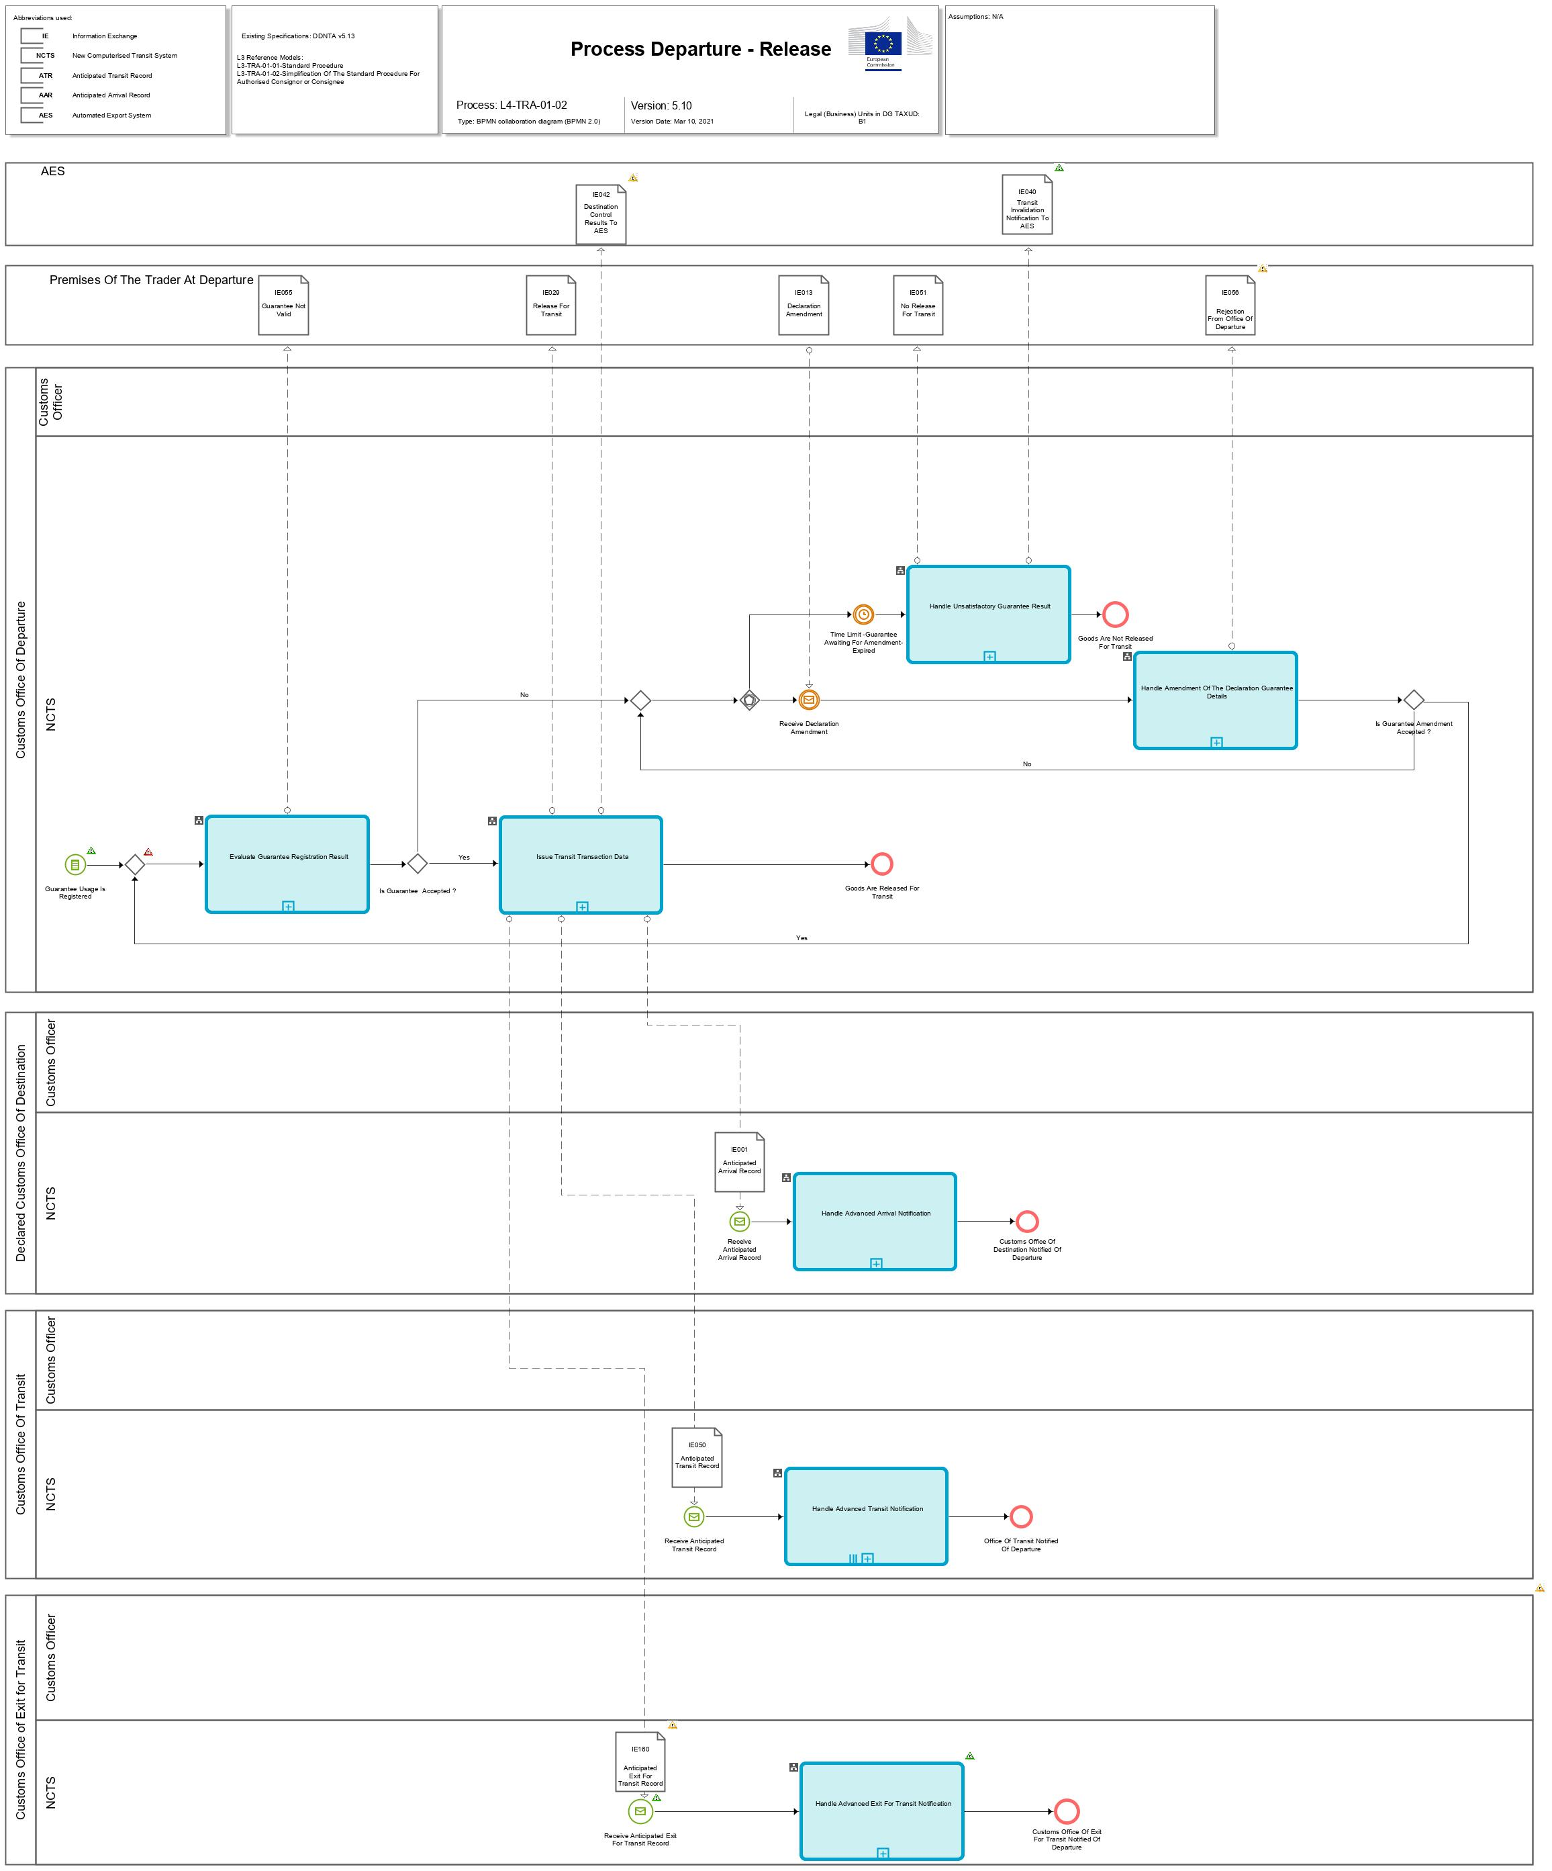
Figure 12: L4-TRA-01-02-Process Departure – Release - Part A
Figure 13: L4-TRA-01-02-Process Departure – Release - Part B
Major Event
Guarantee usage is registered
Organisation : National Customs Administration
Location : Customs Office of Departure
The results of the check and registration of the guarantees are available (Guarantee Usage is registered or Guarantee not valid).

Minor Events
Receive declaration amendment
Organisation : Trader at Departure
Location : Premise of Holder of Transit Procedure at Departure or Customs Office of Departure
The Holder of Transit procedure or Authorised Consignor amends the original guarantee details in order to avoid a non-release for Transit.

Time Limit -Guarantee Awaiting for Amendment- expired
Organisation : National Customs Administration
Location : Customs Office of Departure
At the expiration of the timer ‘Guarantee Awaiting For Amendment” the declaration is automatically not released for Transit.
Processes
Evaluate guarantee registration result | Process: L4-TRA-01-02-01
Organisation : National Customs Administration
Location : Customs Office of Departure
Constraint :
Description :
Before the movement is released for transit, the Office of Departure decides to register the guarantees. In case of Guarantee(s) maintained by Office of Guarantee, the Guarantee Use message (IE203) is sent. The Office of Guarantee replies with the Guarantee Use Result (IE205) message. When one of the checks of the registration of the guarantee usage fails (the data group INVALID GUARANTEE REASON is present in the IE205), the Holder of Transit procedure is notified (IE055) that the declared guarantee is not valid.
The Holder of Transit procedure has the possibility to amend the invalid guarantee, so that the movement can still be released. A timer “Guarantee Awaiting For Amendment” is started to protect a non-amendment of the guarantee.
When all the checks of the registration of the guarantee usage are successful, then the movement is ready to be issued.
Final situation :
Either the guarantee is registered, the state of the Transit Operation is set to ‘Guarantee registered’, or the Holder of Transit procedure has to amend the guarantee details, and the state of the Transit Operation is set to ‘Guarantee under amendment’.

Issue Transit transaction data | Process: L4-TRA-01-02-02
Organisation : National Customs Administration
Location : Customs Office of Departure
Constraint :
If NCTS is also used for the purpose of safety and security, then full safety and security related risk analysis for all the goods shall be performed within the prescribed time limits and can be communicated between involved offices under following condition:
- All involved offices are located inside the Safety and Security Area.
Description :
The three following dates are defined in the appropriate way when the movement is issued:
- The expected arrival date of the movement at the Customs Office of Destination (time allowed for the movement) is based only on the countries of departure and destination. The timer “Awaiting of Receipt of Arrival Advice” is started. If no arrival advice has arrived by the date fixed and the timer “Awaiting of Receipt of Arrival Advice” is expired, an enquiry will have to be started according to Handle Enquiry (process starts with L4-TRA-01-05 Status Request).
- The date when the control results are expected to be returned from the Customs Office of Destination. The timer “Awaiting Receipt of Control Results” is started. This date is the expected arrival date plus a fixed number of days commonly defined by the national administrations (6 or 12 calendar days). If no control result is received by the date fixed and the timer “Awaiting Receipt Of Control Results” is expired, an enquiry will have to be started according to “Handle Enquiry” (process starts with L4-TRA-01-05 Status Request).
- The expected arrival date of the movement at the Offices of Transit [CUSTOMS OFFICE OF TRANSIT (DECLARED).Arrival date and time (estimated)]
- If the Transit declaration is used for security purposes (TRANSIT OPERATION. Security = '1’(ENS) and
- If the Customs Office of Transit is located in an EU Member State.
This piece of information is used for risk analysis purposes in the context of safety and security.
The anticipated arrival record (AAR) is sent (IE001) to the Declared Customs Office of Destination [IE015. CUSTOMS OFFICE OF DESTINATION (DECLARED)].
If the Transit declaration is used for security purposes (TRANSIT OPERATION. Security = ‘2’ (EXS) or ‘3’ (ENS and EXS), a notification of the Anticipated Exit for Transit record (AXR) is sent (IE160) to the Customs Office of Exit for Transit. The Customs Office of Exit for Transit is responsible for the record of the risk analysis results, the record of control decision and the control results and whether the transit movement is allowed to leave the Safety and Security Area.
In addition, and only for the EU Member States, in case the Goods are released for Transit, and only under external transit, NCTS identifies if Transit follows Export and the destination control results to AES (IE042) message is sent to AES. This concludes the interaction between NCTS and AES and there is no further interconnection between them.
An anticipated transit record (ATR) is sent (IE050) to each declared Customs Office of Transit [IE015. CUSTOMS OFFICE OF TRANSIT (DECLARED)].
The risk analysis results shall be included in the anticipated transit record (IE001/IE050) under the following conditions:
- IE001:
  - The Customs Office of Departure and the Customs Office of Destination are both located inside the Safety and Security Area.
- IE050:
  - The Customs Office of Departure and the Customs Office of Transit are both located inside the Safety and Security Area.
The release information is communicated (IE029) to Holder of the Transit Procedure. The release information (IE029) corresponds always to the current (latest) version of the Transit operation data. This means that it contains the amended declaration data (if any) and/or the revised declaration data after a control (if any) and completed with the departure control results. At the request of the Holder of the Transit Procedure the NCTS Accompanying Document or MRN of Transit Declaration in an electronically readable format (TAD) is printed under the responsibility of the Customs Office of Departure, either at the Customs Office of Departure or at the Authorised Consignor’s premises.
Final situation :
The Transit transaction is issued; the NCTS Accompanying Document or MRN of Transit Declaration in an electronically readable format is printed and provided on the request of the Holder of Transit Procedure; the movement may go to destination; the state of the Transit Operation is set to ‘Movement released’. In case Transit follows Export, and only under external transit, the Customs Office of Exit is informed by the Customs Office of Departure with the destination control results to AES (IE042) message.

Handle advanced Transit notification | Process: L4-TRA-01-02-03
Organisation : National Customs Administration
Location : Declared Customs Office of Transit
Constraint :
If NCTS is also used for the purpose of safety and security, then full safety, and security related risk analysis for all the goods shall be performed within the prescribed time limits under following conditions:
- The Customs Office of Transit is located inside the Safety and Security Area.
Description :
The Office(s) of Transit receive(s) (IE050) and store(s), in advance, the movement description information of any movement in which it is declared as Customs Office of Transit [IE015.CUSTOMS OFFICE OF TRANSIT (DECLARED)].
If risk analysis results are communicated by the Customs Office of Departure, the results shall be recorded.
If the constraint is met:
- Full safety and security related risk analysis for all the goods shall be initiated by NCTS and performed by the national risk application according to the rules set out by the risk management framework.
- The national risk analysis system communicates the risk analysis result to NCTS and NCTS records it in the transit declaration. If the risk analysis result relates to a specific goods item, then the relevant goods item is recorded (RISK ANALYSIS IDENTIFICATION.RISK ANALYSIS.Declaration goods item number). In any other case the ’ RISK ANALYSIS IDENTIFICATION.RISK ANALYSIS.Declaration goods item number’ remains unused.
- The manner, that the risk analysis identification code (IE050. RISK ANALYSIS IDENTIFICATION.Code) is assessed, is not transparent to NCTS but used by NCTS to identify the nature of risk and identify any appropriate actions.
  - The value is 'R': Risk identified, to be handled at the next Customs Office (other than Office of Departure).;
  - The value is 'Y': Combined risk identified (national & common);
  - The value is 'X': National risk identified;
  - The value is 'Z': No risk analysis performed at the Office of Departure.
- Random risk parameters shall be used additionally.

Final situation :
Office(s) of Transit is (are) ready to receive the consignment, the state of the Transit Operation is set to ‘ATR Created’.

Handle advanced arrival notification | Process: L4-TRA-01-02-04
Organisation : National Customs Administration
Location : Declared Customs Office of Destination
Constraint :
Description :
The Declared Customs Office of Destination receives and stores (IE001), in advance, the movement description information of any movement in which it is declared as Customs Office of Destination [IE015. CUSTOMS OFFICE OF DESTINATION (DECLARED)].
The Customs Office of Destination executes an automatic risk analysis on the received anticipated arrival record. If risk analysis results are communicated by the Customs Office of Departure, the results shall be recorded.
After arrival of the movement at the Declared Office of Destination, control decision shall be based on the risk analysis result. Additionally, it will be possible to deduce from the Identification number of Consignee (CONSIGNEE.Identification number), whether the goods will be presented at the premises of an Authorised Consignee or not.
Final situation :
Customs Office of Destination is ready to receive the consignment; the state of the Transit Operation is set to ‘AAR Created’.

Handle advanced exit for transit notification | Process: L4-TRA-01-02-07
Organisation : National Customs Administration
Location : Declared Customs Office of Destination
Constraint :
Description :
The Declared Customs Office of Exit for Transit receives and stores (IE160), in advance, the movement description information of any movement in which it is declared as Customs Office of Exit for Transit [IE015. CUSTOMS OFFICE OF EXIT FOR TRANSIT (DECLARED)]. This office role is situated at the frontier of the Safety and Security Area and either allows or not the transit movement to leave the Safety and Security Area.
Upon reception of the Anticipated Exit for Transit record (IE160), the Customs Office of Exit for Transit executes an automatic risk analysis on the received Anticipated Exit for Transit record.
After arrival of the movement at the Declared Office of Exit for Transit, a decision (whether to leave the Safety and Security Area or not) shall also be based on the risk analysis result from the previous risk assessment (upon reception of the IE160) and the new risk assessment after arrival of the movement.
NOTE: In case the movement is not allowed to leave the Safety and Security Area due to safety and security reasons, the Declared Office of Exit for Transit becomes Actual Office of Destination and the destination formalities will follow. In that case, the Actual Office of Destination records in NCTS the arrival of the movement.
Final situation :
The Customs Office of Exit for Transit expects the consignment; the state of the Transit Operation is set to ‘AXR Created’.

Handle unsatisfactory guarantee result | Process: L4-TRA-01-02-05
Organisation : National Customs Administration
Location : Customs Office of Departure
Constraint :
Description :
When the Holder of Transit procedure fails to amend the guarantee(s) in time (timer “Guarantee Awaiting for Amendment” expires), NCTS registers that transit movement cannot be released for transit and also notifies (IE051) the Holder of Transit procedure that the goods are not released for Transit. Additionally, in case the transit declaration contains Export MRNs as previous procedures (i.e. Export followed by external/internal Transit), NCTS notifies AES (IE040) for the non-release of the transit movement. Therefore, the Export MRN(s) are de-allocated from the transit movement and can follow a different procedure (e.g. continue with another transit declaration).
Final situation :
The goods are not released, the state of the Transit Operation is set to ‘Not released for Transit’.

Handle amendment of the declaration guarantee details | Process: L4-TRA-01-02-06
Organisation : National Customs Administration
Location : Customs Office of Departure
Constraint :
Description :
This process handles amendment requests on the declaration guarantee details (IE013), this means that the amendment flag (IE013.TRANSIT OPERATION.Amendment type flag = "1") indicates that it concerns an amendment on the guarantee details of the declaration only (and not on the entire declaration data). The amendment request (IE013) transports only the values of the guarantee.
The Customs Office of Departure receives (IE013) a guarantee amendment within the agreed time limit, this means before the expiration of the ‘Guarantee Awaiting for Amendment’ timer.
When the guarantee amendment failed to pass the formal validation process performed by the system, or when the amendment request contains other data to amend than guarantee details, it is rejected. The Customs Office of Departure notifies (IE056) the Holder of Transit procedure of the rejection of the guarantee amendment with reasons.
When the guarantee amendment passed the formal validation process performed by the system, the Customs Office of Departure notifies (IE004) the Holder of Transit procedure of the acceptance of the guarantee amendment. In that case, NCTS accepts the amended guarantee data and the processing continues with the check and the registration of the Guarantee. The timer “Guarantee Awaiting For Amendment” is stopped.
Final situation :
Either the guarantee amendment is valid, the state of the Transit Operation is set to ‘Guarantee under registration’, or the guarantee amendment is rejected, the state of the Transit Operation stays ‘Guarantee under amendment’.

Major Result
Goods released for Transit
Organisation : National Customs Administration
Location : Premise of Trader at Departure or Customs Office of Departure
The NCTS Accompanying Document or MRN of Transit Declaration in an electronically readable format is printed upon request from the Holder of Transit Procedure or its representative. It also can be printed by the Authorised Consignor. In normal procedure, as per Article 41 of Appendix 1 of CTC, in case of CTC country, Customs Office of Departure has to provide printout of TAD to the Declarant.

Goods are not released for Transit
Organisation : National Customs Administration
Location : Premise of Trader at Departure or Customs Office of Departure
The transit movement is not released for transit.

Minor Results
Office of Transit notified of Departure
Organisation : National Customs Administration
Location : Declared Customs Office of Transit
The declared Office(s) of Transit is (are) notified from the Office of Departure for the Anticipated Transit Record (ATR) and where relevant of the risk analysis results of the movement.

Office of Exit for Transit notified of Departure
Organisation : National Customs Administration
Location : Declared Customs Office of Exit for Transit
The declared Office(s) of Exit for Transit is (are) notified from the Office of Departure for the Anticipated Exit for Transit record (AXR) and where relevant of the risk analysis results of the movement.

Office of Destination notified of Departure
Organisation : National Customs Administration
Location : Declared Customs Office of Destination
The declared Office of Destination is notified from the Office of Departure for the Anticipated Arrival Record (AAR) and where relevant of the risk analysis results of the movement.

The results “Goods not released for Transit” and “Check of the guarantees has been asked” are explained under Heading 2.4. L4-TRA-01-01 Process Departure - Acceptance and Controls.

L4-TRA-01-03-Process Arrival
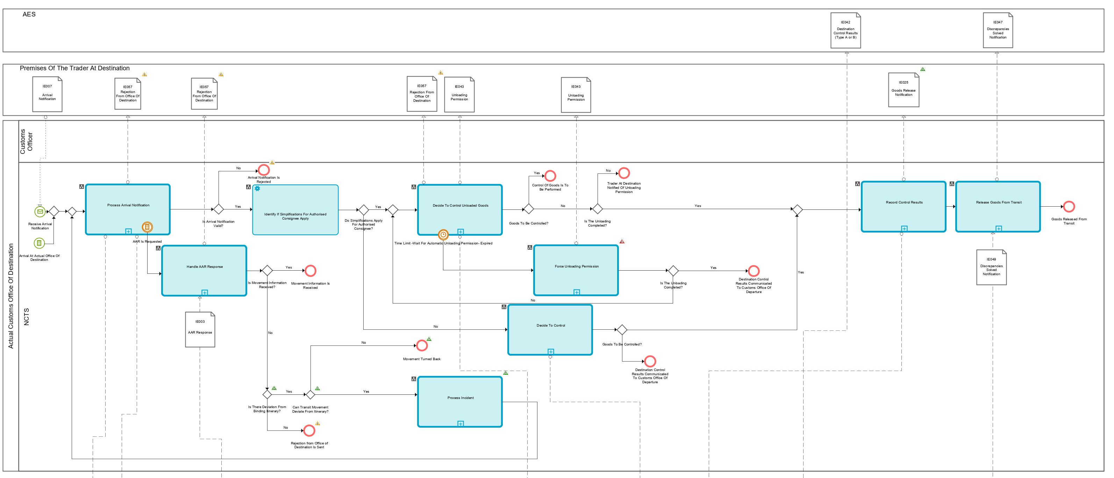
Figure 14: L4-TRA-01-03-Process Arrival - Part A
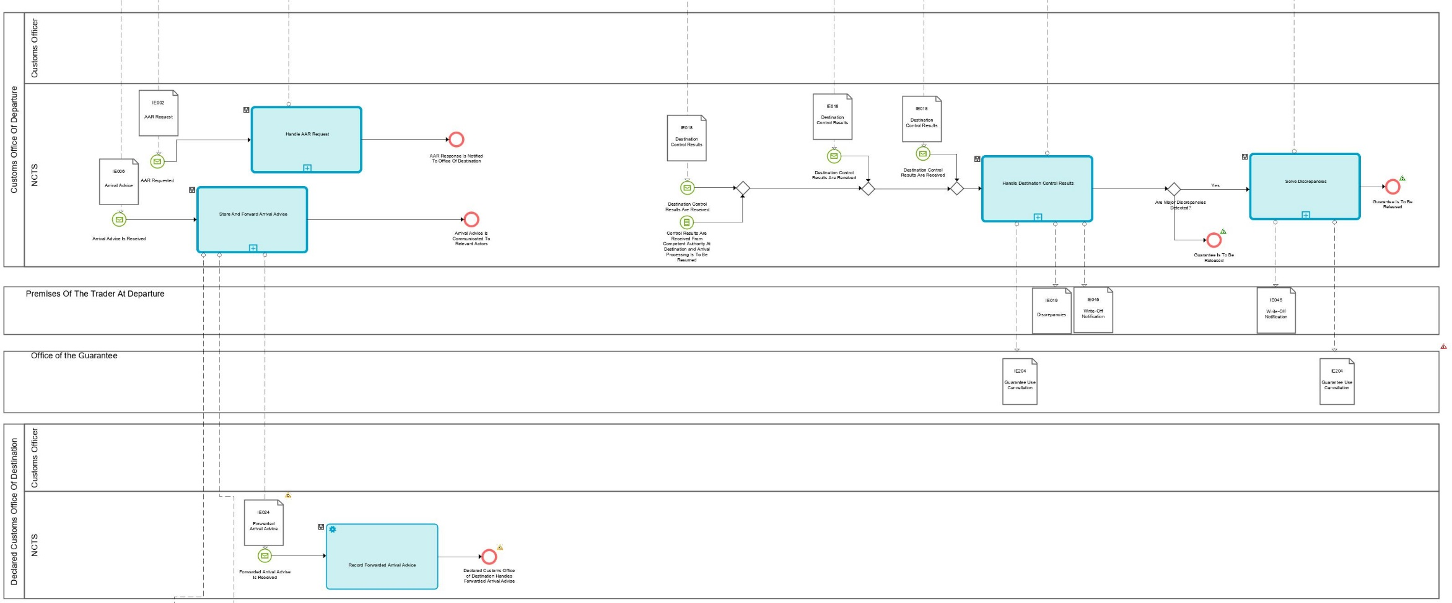
Figure 15: L4-TRA-01-03-Process Arrival - Part B
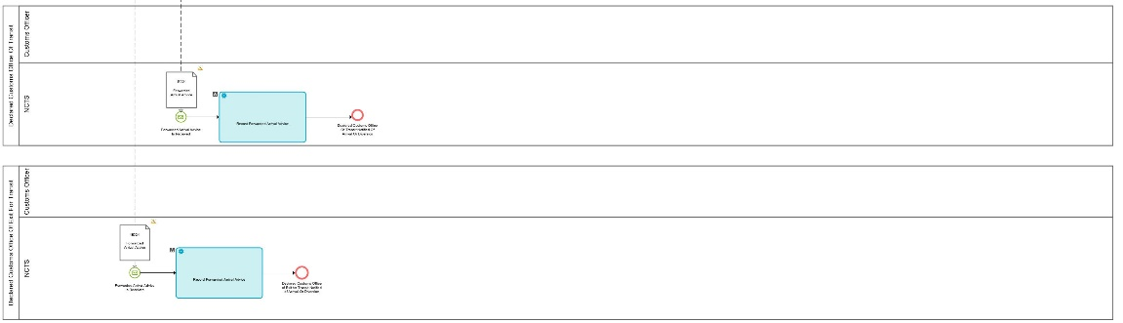
Figure 16: L4-TRA-01-03-Process Arrival - Part C
Major Event
Receive arrival notification
Organisation : National Customs Administration
Location : Actual Customs Office of Destination
When the consignment has arrived, the Trader at Destination sends an arrival notification (IE007) to the Actual Office of Destination. The consignment may arrive either at the Customs Office of Destination or in some other place called the ‘goods place’ which will be specified to the Customs Office of Destination (IE007. CONSIGNMENT.LOCATION OF GOODS). If the consignment is under the responsibility of an Authorised Consignee, the goods lay in the authorised place.

Arrival at Actual Office of Destination
Organisation : National Customs Administration
Location : Actual Customs Office of Destination
The consignment has reached its destination. The Customs Officer at the Actual Office of Destination records the arrival of the consignment in NCTS.
Minor Events
Anticipated Arrival Record is requested
Organisation : National Customs Administration
Location : Actual Customs Office of Destination
The consignment has reached its destination. The Authorised Consignee or the Trader at Destination notifies the Actual Office of Destination for the arrival of the consignment by sending the arrival notification (IE007) to the Actual Office of Destination or the Officer at the Actual Office of Destination records in NCTS the arrival of the consignment. Since the MRN is unknown to this Actual Office of Destination, NCTS has sent an Anticipated Arrival Record Request (IE002) to the Office of Departure.

Time Limit – Wait for Automatic Unloading Permission- Expired
Organisation : National Customs Administration
Location : Actual Customs Office of Destination
At the expiration of the timer ‘Wait for automatic unloading permission’ the Trader at Destination is automatically notified (IE043) that the unloading of the goods from the means of transport can be started.

Processes
Process arrival notification | Process: L4-TRA-01-03-01
Organisation : National Customs Administration
Location : Actual Customs Office of Destination
Constraint :
On reception of an arrival notification under simplified procedure, the Customs Office of Destination has to respond within the pre-defined time period defined in the authorisation of Authorised Consignee.
Description :
The consignment has reached its destination, or the Customs Office of Destination is notified (IE007) by the Authorised Consignee or by the Holder of Transit procedure representative of the arrival of a consignment.
When an arrival notification (IE007) is presented under simplified procedure (IE007.TRANSIT OPERATION. Simplified procedure flag = ‘Yes’), NCTS checks that the Trader who communicates the arrival (IE007.TRADER AT DESTINATION.Identification number) is indeed authorised (Authorised Consignee) to use simplified procedure at that Customs Office of Destination and checks that the location where the consignment can be controlled (IE007.CONSIGNMENT.LOCATION OF GOODS.Type of location = ‘B’) is amongst the various authorised places specified in the authorisation.
When an arrival notification (IE007) is presented under normal procedure (IE007.TRANSIT OPERATION. Simplified procedure flag = ‘No’), then the location where the consignment can be controlled is either:
- At the Customs Office of Destination, when IE007. ‘Type Of Location’ is not ‘A’ or ‘C’ or ‘D’;
- At a designated location of goods, when IE007. ‘Type Of Location’= ‘A’ and acceptable by the Customs Office, the system will notify the Customs Officer that he/she has to validate manually the location, no further processing is foreseen in NCTS to handle this kind of locations;
- At an approved place, when IE007. ‘Type Of Location’= ‘C’; in this case NCTS checks it against the various Customs sub places acceptable for the Customs Office of Destination.
When the arrival is invalid, NCTS rejects the arrival notification and notifies (IE057) the Trader at Destination that the presentation is invalid with the reason of the rejection.
When the arrival is valid, NCTS looks for the movement information referenced by the MRN brought in by the arrival notification (IE007.TRANSIT OPERATION.MRN).
If the movement information is not available either in case of international diversion or in case the consignment stops at this Office and the Anticipated Arrival Record has not been previously received (or is not nationally available) , NCTS requests (IE002) that information from the Country of Departure.
If an AAR request is made (IE002) to the Country of Departure, then this process ends by recording that the AAR has been requested.
If no diversion occurred, NCTS notifies (IE006) the Customs Office of Departure with the arrival advice and the arrival is recorded into NCTS. In case of simplified procedure, the timer “Wait for automatic unloading permission” is started to protect a non-decision to control the goods that could be taken by the Customs Officer.
Processing common to BPM L4-TRA-01-03-04.
An analysis of risk is done at this stage. NCTS triggers the risk analysis process. Data received are sent to the national risk analysis system and are processed against risk rules (including common risk criteria and national standards, where applicable). Risk analysis returns the risk analysis result code. Risk analysis results are communicated by the Customs Office of Departure through the Anticipated Arrival Record (IE001/IE003) can also be taken into account (if sent by the Customs Office of Departure) and only when both the Customs Office of Departure and the Actual Office of Destination belong to the Safety and Security Area.
NCTS records the results of the risk analysis.
Final situation :
If the arrival notification is not valid then it is rejected; the state of the Transit Operation is changed to ‘Diversion rejected’;
If there is an international diversion or it is decided to stop the movement (e.g. after registration of incidents En route), the Actual Customs Office of Destination sends an Anticipated Arrival Record request (IE002) and awaits the Anticipated Arrival Record information (IE003) from the Customs Office of Departure; the state of the Transit Operation is set to ‘AAR Requested’;
In the other cases, the arrival is accepted and recorded into NCTS, the Customs Office of Departure is notified of the arrival, the state of the Transit Operation is set to ‘Arrival Accepted’.
The risk analysis is carried out (common and/or national) and the result is recorded in NCTS.

Handle AAR response | Process: L4-TRA-01-03-04
Organisation : National Customs Administration
Location : Actual Customs Office of Destination
Constraint :

Description :
The Customs Office of Destination receives (IE003) the Anticipated Arrival Record information from the Customs Office of Departure about a Transit movement.
If the answer does not contain the requested AAR (IE003.TRANSIT OPERATION. AAR rejection reason is present), NCTS rejects the arrival and notifies (IE057) the Trader at Destination about the rejection.
In case of use of additional information codes ‘20100’ or ‘20200’, NCTS notifies the Customs officer at the Customs Office of Destination that the goods shall be kept under its control and not allow their removal other than to the Union or Common Transit Country having jurisdiction over the Customs Office of Departure, unless specifically authorised by the latter.
The provided AAR-response (IE003) contains the relevant safety and security data elements under following conditions:
- The requested AAR-data is provided (IE003.TRANSIT OPERATION. AAR rejection reason is not present)
- NCTS is used for safety and security [IE003.TRANSIT OPERATION. Security = '1' (ENS), ‘2’ (EXS) and ‘3’ (ENS and EXS)]
- The Actual Office of Destination is located inside the Safety and Security Area.
For the rest of the processing, see common processing described in BPM L4-TRA-01-03-01.
Additionally:
- Full safety and security related risk analysis for all the goods shall be initiated by NCTS and performed by the national risk application according to the rules set out by the risk management framework.
- The national risk analysis system communicates the risk analysis result to NCTS and NCTS records it in the transit declaration. If the risk analysis result relates to a specific goods item, then the relevant goods item is recorded (RISK ANALYSIS IDENTIFICATION.RISK ANALYSIS.Declaration goods item number). In any other case the ’ RISK ANALYSIS IDENTIFICATION.RISK ANALYSIS.Declaration goods item number’ remains unused.
- The calculation of the risk analysis identification code (IE003. RISK ANALYSIS IDENTIFICATION.Code) is not transparent to NCTS but is visible and used by NCTS to identify the nature of risk and any appropriate actions:
  - The value is 'R': Risk identified, to be handled at the next Customs Office (other than Office of Departure).;
  - The value is 'Y': Combined risk identified (national & common);
  - The value is 'X': National risk identified
  - The value is 'Z': No risk analysis performed at the Office of Departure.
- Random risk parameters shall be used additionally.
- If high risk is identified:
  - The Customs Officer is alerted and is asked to register a control decision.
  - Normal procedure: Next step is L4-TRA-01-03-08 -Decide to control.
  - Simplified procedure: The sending of the unloading permission (IE043) is blocked and the timer “Wait for Automatic Unloading Permission” is not started. Next step is “Control of the goods” (Manual Process).
When diversion occurred (movement information not available at the Customs Office of Destination), NCTS records the movement information (IE003.C_AAR_SND) into the system and notifies (IE006) the Customs Office of Departure that the arrival is accepted. In case of simplified procedure, and in case of no/low risk, a timer “Wait for automatic unloading permission” is started to protect a non-decision to control the goods that could be taken by the Customs Officer.
Final situation :
- Where the Anticipated Arrival Record request is rejected, the Trader at Destination is informed consequently with the IE057 message;
- Where the Anticipated Arrival Record request is accepted, the diversion is recorded into NCTS, the Customs Office of Departure is notified for the arrival, and the state of the Transit Operation is set to ‘Arrival Accepted’.

Process incidents | Process: L4-TRA-01-12
Organisation : National Customs Administration
Location : Actual Customs Office of Destination
Constraint :
The transit movement contains binding itinerary.
There are cases where a diversion might be requested so as the transit movement to end its journey to a country of destination that is not included among the list of countries based on binding itinerary as declared originally in the transit declaration by the Holder of the Transit Procedure and agreed with the Office of Departure.
Upon arrival of the transit movement to such a country (not included in the list of countries of the binding itinerary), and since the MRN is unknown, the Anticipated Transit Record is sent (IE002) to the Office of Departure, which checks that for the specific MRN, there is a binding itinerary and the diversion request comes from a country that is not included in the list of countries under the binding itinerary of the transit movement. Therefore, the Office of Departure replies with a negative IE003 that does not contain the details of the Anticipated Arrival Record (i.e. IE003. TRANSIT OPERATION.Request rejection reason code = '3' is present). Based on the above result of the diversion request, the Actual Office of Destination decides whether to allow or not the transit movement to divert to this Office despite the binding itinerary.
The Actual Office of Destination decides to allow the transit movement to end its journey to this country. Therefore, an incident registration occurs to justify the deviation from the binding itinerary to the Office of Departure. For this purpose, an Incident Notification message is sent to the Office of Departure (IE180) that contains at least one instance of the appropriate Incident Code (i.e. IE180. CONSIGNMENT.INCIDENT.Code = '1').
Upon completion of the incident registration, the Actual Office of Destination requests again the Anticipated Transit Record (IE002) and receives a positive IE003 (i.e. TRANSIT OPERATION.Request rejection reason code is absent). Next, the arrival process can be resumed to this Actual Office of Destination.
Final situation:
- The movement turns back since the deviation from the Binding Itinerary is not accepted, or
- The movement ends its journey to this Actual Office of Destination, whose country is not included in the list of countries based on the Binding Itinerary, following an Incident Registration and successful exchange of IE002 and IE003 (that contains the Anticipated Arrival Record).

Decide to control unloaded goods | Process: L4-TRA-01-03-05
Organisation : National Customs Administration
Location : Actual Customs Office of Destination
Constraint :
This process can only occur for movements under simplified procedure.
Description :
In case controls are decided to be performed, this decision is recorded in NCTS.
In case it is decided not to control the goods, this decision is recorded in NCTS and the Authorised Consignee is notified (IE043) of the decision granting the permission to start the unloading (IE043.TRANSIT OPERATION. Continue unloading flag is not present) or continue the unloading (IE043.TRANSIT OPERATION. Continue unloading flag is present) of the goods from the means of transport.

When the Actual Office of Destination indicates the permission to start the unloading, all the information about the Consignment is provided. When the Actual Office of Destination indicates the permission to continue the unloading, the information about the Consignment is not provided, and the Data Item
<CTL_CONTROL.Continue unloading> shall be used with an incremental value ('1', '2', '3', etc. ...) in
the subsequent (IE043) messages (one message for each authorisation to continue the unloading).

After the Office of Destination receives the Unloading Remarks (IE044) message from the authorised consignee, which is valid, the Unloading Remarks (IE044) are recorded, and NCTS identifies:
- If unloading is completed (i.e. IE044.UNLOADING REMARK.Unloading completion = ‘1-Yes), the state of seals is in good condition (i.e. IE044.UNLOADING REMARK.State of seals = ‘1-Yes’) and we have no presence of Unloading Remarks (i.e. IE044.UNLOADING REMARK.Conform = ‘1-Yes’), then the Office of Destination sends the Destination Control Results (IE018) message to the Office of Departure with satisfactory control results (i.e. Control Result Code is set to ‘A2’); or
- If unloading is completed (i.e. IE044.UNLOADING REMARK.Unloading completion = ‘1-Yes), the state of seals is in good condition (i.e. IE044.UNLOADING REMARK.State of seals = ‘1-Yes’) but we have presence of Unloading Remarks (i.e. IE044.UNLOADING REMARK.Conform = ‘0-No’), then the Office of Destination needs to decide whether to control or not the transit movement; or
- In all other cases that there are unloading remarks (i.e. IE044.UNLOADING REMARK.Conform = ‘0-No’) and/or the state of seals is not in good condition (i.e. IE044.UNLOADING REMARK.State of seals = ‘0-No’) and/or the unloading is not completed (i.e. IE044.UNLOADING REMARK.Unloading completion = ‘0-No’), the Office of Destination needs to decide whether to control or not the transit movement. In case “no control” is decided, the Office of Destination sends a new ‘Unloading Permission’ E_ULD_PER (IE043) message, and the status of the transit movement is set to the status “Unloading”.

Final situation :
One of the following situations can occur:
- In case no control at all, the state of the Transit Operation is set to ‘Unloading’ (if the unloading is not completed);
- A control has been decided, the state of the Transit Operation is set to ‘Under control’.

Force unloading permission | Process: L4-TRA-01-03-06
Organisation : National Customs Administration
Location : Actual Customs Office of Destination
Constraint :
This process can only occur for movements under simplified procedure.
Description :
The Customs Officer at Destination didn’t take the decision to control the goods within the agreed time period (i.e. the timer “Wait for Automatic Unloading Permission” has expired). Thus, NCTS notifies (IE043) the Trader that he/she can start the unloading of the goods and records the unloading permission.
Final situation :
The Trader at Destination is notified that he/she can start the unloading of the goods. The state of the Transit Operation is set to ‘Unloading’.

Decide to control | Process: L4-TRA-01-03-08
Organisation : National Customs Administration
Location : Actual Customs Office of Destination
Constraint :
This process can only occur for movements under Normal Procedure.
Description :
The process is started when an Arrival Notification is accepted. The Customs Officer registers his/her decision whether to control or not the goods:
- If the decision 'Goods to be Controlled' is ‘Yes’, ’then a manual control of the Goods is performed; the state at the Actual Office of Destination is changed to "Under Control”;
- If the decision 'Goods to be Controlled' is ‘No’, then the Customs Office of Destination sends to the Customs Office of Departure the destination control results with control result code ‘Considered Satisfactory’ (IE018.CONTROL RESULT.Code = ‘A2’) and the goods are ready for the next procedure / activity (e.g. temporary storage, import procedure); the state of the Transit Operation is set to ‘Goods released’.
Final situation :
Either no control is performed at all, the state of the Transit Operation is set to ‘Goods released’, or a control will be performed, the state of the Transit Operation is set to ‘Under Control’.

Record control results | Process: L4-TRA-01-03-11
Organisation : National Customs Administration
Location : Actual Customs Office of Destination
Constraint :
Description :
In case control is decided, the Customs Officer at the Customs Office of Destination records the results of control in NCTS or (only under Simplified Procedure) control may be decided after receiving unloading remarks (IE044) from an Authorised Consignee and these are translated to control results of type ‘A’ or ‘B’.
In case control results indicate major discrepancies, these are recorded into the destination control results sent to the Customs Office of Departure (IE018. CONTROL RESULT.Code = 'B1'). In case of major discrepancies, the Customs Office of Destination must always wait for the resolution of discrepancies performed at the Customs Office of Departure. Additionally, the Trader at Destination is notified that the goods cannot be fully released yet with the goods release notification (IE025) having the appropriate release indicator (IE025.TRANSIT OPERATION.Release indicator is equal to ‘2-Partial release’ or '4-No release of goods').
Even though the transit movement is not closed at the Office of Departure (i.e. not discharged), at the discretion of the Office of Destination, some of the goods at the Office of Destination can be released from Transit. If the Office of Destination is located within EU, and despite the fact that the major discrepancies are not yet resolved, those goods that can be released to the next procedure:
  - under the External transit, the goods are moved to Temporary Storage, before a possible release to free circulation;
  - under the Internal transit, the Union goods do not need to be released for free circulation, but they can proceed to other business operations (e.g. processing, or sale).

In case control results indicate no or minor discrepancies, these are recorded into the destination control results sent to the Customs Office of Departure (IE018. CONTROL RESULT.Code = 'A1' or ‘A5’), then NCTS records that the goods are ready for the next procedure / activity (e.g. temporary storage, import procedure). Additionally, the Trader at Destination is notified that the goods are fully released with the goods release notification (IE025) having the appropriate release indicator (IE025.TRANSIT OPERATION.Release indicator = ‘1-Full release – Movement closed’).

Excess goods in the transit declaration may also be discovered by the Actual Office of Destination. The term ‘goods in excess’ refers to the goods discovered while performing control at the Actual Office of Destination whose:
- commodity code is not included in the original declaration message received by the Actual Office of Destination (i.e. through the ‘Anticipated Arrival Record’ (IE001/IE003); and/or
- commodity code is included in the original declaration (i.e. through the ‘Anticipated Arrival Record’ (IE001/IE003), but whose actual net mass exceeds the declared net mass as per the original transit declaration.

In case of ‘goods in excess’, the following control result codes may be assigned to the whole transit declaration also to be sent to the Office of Departure through the destination control results (IE018):
- ‘B1’ control result code: Customs Debt incurred and thus must be included in the destination control results (IE018) meaning that:
  - All goods (declared and delivered) are released from transit;
  - Recovery procedure should be initiated due to the existence of excess goods (i.e. competency to be determined based on which authority can collect the debt);
  - Movement is not written off until recovery is completed.
- ‘A5’ control result code: Customs Debt incurred but extinguished and thus ‘A5’ control result code must be included into the destination control results (IE018) meaning that:
  - All goods (declared and delivered) are released from transit;
  - Transit movement can be written off at the Office of Departure (i.e. release of guarantee is also performed);
  - Excess goods are placed in a subsequent customs procedure.

Final situation :
Control results are stored into NCTS. The Customs Office of Departure is notified of the control results; if there are no or minor discrepancies, the state of the Transit Operation is set to ‘Goods released’; if there are major discrepancies, these must first be resolved by the Customs Office of Departure; the state of the Transit Operation is set to ‘Waiting for discrepancies resolution’.

Release goods from Transit | Process: L4-TRA-01-03-12
Organisation : National Customs Administration
Location : Actual Customs Office of Destination
Constraint :
Description :
In case the destination control results sent to the Customs Office of Departure indicate no or minor discrepancies (IE018. CONTROL RESULT.Code = 'A1' or ‘A5’), then NCTS records that the goods are ready for the next procedure / activity (e.g. temporary storage, import procedure). Even when the destination control results indicate major discrepancies (IE018. CONTROL RESULT.Code = 'B1'), at the discretion of the Office of Destination, some of the goods at the Office of Destination can be released from Transit. However, the movement is not written off at the Customs Office of Departure; the liability on the Holder of the Transit Procedure remains until the resolution of the major discrepancies.

In case the destination control results sent to the Office of Departure contain major discrepancies (IE018. CONTROL RESULT.Code = 'B1'), the Actual Office of Destination expects the discrepancies solved notification (IE049) from the Office of Departure. When the discrepancies solved notification (IE049) is received, the Actual Office of Destination determines whether these major discrepancies are resolved or not:
- If discrepancies are resolved (IE049.TRANSIT OPERATION.Discrepancies resolved = "1") within thirteen calendar days, the goods can be released from transit. NCTS records that the goods are ready for the next procedure / activity (e.g. temporary storage, import procedure). Additionally, the Trader at Destination is notified that the goods are fully released with the goods release notification (IE025) having the appropriate release indicator (IE025.TRANSIT OPERATION.Release indicator = ‘1-Full release – Movement closed’);
- If discrepancies remain unresolved after thirteen calendar days (IE049.TRANSIT OPERATION.Discrepancies resolved = "3"), recovery most probably needs to be initiated since the major discrepancies are not yet resolved; the state of the transit operation is set to “Under recovery decision”; an additional discrepancies solved notification (IE049) may be received afterwards indicating whether discrepancies are resolved (IE049.TRANSIT OPERATION.Discrepancies resolved = "1") or not resolved and thus recovery needs to be initiated (IE049.TRANSIT OPERATION.Discrepancies resolved = "2");
- If discrepancies are not resolved (IE049.TRANSIT OPERATION.Discrepancies resolved = "2"), recovery needs to be initiated; the state of the transit operation is set to “Under recovery decision”.

Final situation :
In case of no / minor discrepancies, or in case of major discrepancies that are resolved by the Customs Office of Departure, the goods are released from transit (the Trader can dispose of the goods); the state of the Transit Operation is set to ‘Goods released’. The goods are ready for the next procedure / activity (e.g. temporary storage, import procedure). In case of major discrepancies that are not resolved by the Customs Office of Departure, then recovery is justified; the state of the Transit Operation is set to “Under recovery decision”.

Handle AAR request | Process: L4-TRA-01-03-02
Organisation : National Customs Administration
Location : Customs Office of Departure
Constraint :
This business process is used to obtain data on a Transit Operation for which data is not available in the country of the actual Customs Office of Destination (international diversion or movement stopped). Automated response should be returned to Customs Office of Destination in maximum 60 seconds.
Safety and security risk analysis results shall be exchanged between the National Administrations only if they belong to the Safety and Security Area.
Description :
The Customs Office of Departure is asked (IE002) by the Customs Office of Destination to provide information about a movement. NCTS retrieves the movement information referenced by the MRN brought in the received information (IE002.TRANSIT OPERATION.MRN).
If any incident has occurred during the journey, NCTS sends the Anticipated Arrival Record response (IE003) that contains the Anticipated Arrival Record (IE001), and additional information on incident(s) that may have occurred during the journey and have been communicated to the Customs Office of Departure through the incident notification (IE180) messages. NCTS automatically sends (IE003) back to the Customs Office of Destination the required information about the movements. If the provided request (IE002) relates to a transit movement which is also used for safety and security (IE001. TRANSIT OPERATION. Security =’1’ (ENS) or ‘2’ (EXS) or ‘3’ (ENS and EXS), if the requested data is available at departure, then the response (IE003) shall contain the relevant additional safety and security data elements, provided that the Actual Office of Destination that receives the Anticipated Arrival Record information (IE003), belongs to the Safety and Security Area.
The safety and security risk analysis results shall be sent in IE003 if all of the following conditions are met:
- The requesting (actual) Customs Office of Destination is located inside the Safety and Security Area;
- The Customs Office of Departure is located inside the Safety and Security Area.
Final situation :
IE003 is sent to the Customs Office of Destination.

Store and forward arrival advice | Process L4-TRA-01-03-03
Organisation : National Customs Administration
Location : Customs Office of Departure
Constraint :
When two or more Offices of Transit or a Customs Office of Transit and the Customs Office of Destination belong to the same National Administration, then only one IE024 is sent to the National Administration in question.
Description :
The Customs Office of Departure is notified (IE006) about the acceptance of an arrival by the Customs Office of Destination. Based on the MRN brought in the arrival advice (IE006.TRANSIT OPERATION.MRN), NCTS records the arrival and identifies whether there is diversion of the consignment.
Upon arrival of the movement at destination, NCTS notifies (IE024) the declared Customs Office of Destination (in case of diversion, the movement has arrived not at Declared but at another Actual Office of Destination) and/or the declared Offices of Transit (which have not notified whether the consignment has crossed the frontier) and/or the declared Offices of Exit for Transit (which have not notified whether the consignment has left the Safety and Security Area). In addition, if a Customs Office has received a positive IE003 or positive IE115 or positive IE165, meaning that these message contain IE001, or IE050 or IE160 data, but these messages are not used (i.e. no response with IE006, or IE118 or IE168 was sent from this Customs Office), then an IE024 will also be sent to these actual offices in order to close the open IE003, and/or the open IE115 and/or the open IE165.
If the case occurs, NCTS notifies the Customs Officer that the movement has ended in a Contracting Party other than the one declared so that the Customs Office of Departure can take, where necessary, measures to regularise the situation.
In case of use of Guarantee codes ‘0’ and ‘1’, NCTS asks the Customs Office of Guarantee to credit the reference amount (IE209), which added back to the Guarantee balance.
In case an enquiry request at a Customs Office of Destination or Competent Authority of Enquiry at Destination had been sent (before the reception of the IE006) due to the non-timely arrival of the consignment, NCTS records the cancellation of the enquiry request upon reception of the IE006 and notifies (IE059 ) the Customs Office of Destination or Competent Authority of Enquiry at Destination (except the one which sent the arrival advice).
If during an enquiry the Customs Office of Departure is notified via IE143 with code 3 (return copy returned on) about the arrival at the Customs Office of Destination, the Customs Office of Departure awaits the arrival of the alternative proof and NCTS records the arrival of the consignment. When the Customs Office of Departure receives the alternative proof (see L4-TRA-01-06-02-Check Provided Information, L4-TRA-01-07-05-Waiting For Paper Control Result To Arrive), the movement is written off and the IE024 is sent to all involved offices to close the movement in their system.
In case Internal Transit follows Export, and the Arrival Advice (IE006) has been received from a non-appropriate Office of Destination (i.e. the Office of Destination is located in EU and does not have the role ‘’EXT’), the Office of Departure sends the Destination Control Results to AES (IE042) upon the reception of the Arrival Advice (IE006). That concludes the interconnection between NCTS and AES.
Final situation :
The Customs Office of Departure is notified of the arrival of the movement at destination; the state of the Transit Operation is set to ‘Arrived’; the credit of the reference amount is notified to the Office of Guarantee.

Handle destination control results | Process: L4-TRA-01-03-09
Organisation : National Customs Administration
Location : Customs Office of Departure
Constraint :
Description :
The Customs Office of Departure receives (IE018) the control results from the Customs Office of Destination. Based on the MRN brought in the control results (IE018.TRANSIT OPERATION.MRN), NCTS records these control results and the timer “Awaiting Receipt Of Control Results” is stopped.
When there are major discrepancies detected (IE018.CONTROL RESULT. Control result type is equal to “B1”) then:
- The Customs Officer or NCTS records that the Holder of Transit procedure responsibility is extended and notifies (IE019) the Holder of Transit procedure about their extended responsibility.
- The timer “Awaiting for Discrepancies Resolution” is initiated;
- When an enquiry request (IE142) is in progress about the movement, the Competent Authority of Enquiry at Departure cancels the enquiry request and sends the (IE059) message to the Actual Office of Destination / Competent Authority of Enquiry at Destination;
- The major discrepancies recorded into the destination control results (IE018) need either to be resolved or recovery to be initiated;
- In case, Internal Transit follows Export, NCTS notifies AES (IE042) about the major discrepancies recorded into the destination control results of NCTS (IE042.EXPORT OPERATION.CONTROL RESULT.Code = ‘B1’). The destination control result to AES (IE042) concludes the interconnection between NCTS and AES (i.e. no further communication between NCTS and AES);
When there are minor or no discrepancies detected (IE018.CONTROL RESULT. Control result type equal to “A”) then:
- The Customs Officer or NCTS records the write-off;
- NCTS asks the release of the guarantee (see process “L4-TRA-02-05 Release Guarantee”);
- When an enquiry request (IE142) is in progress about the movement, the Competent Authority of Enquiry at Departure cancels the enquiry request and sends the (IE059) message to the Actual Office of Destination / Competent Authority of Enquiry at Destination;
- In case, Internal Transit follows Export, NCTS notifies AES (IE042) about the no/minor discrepancies recorded into the transit destination control results (IE042.EXPORT OPERATION.CONTROL RESULT.Code = 'A1’, or ‘A2’, or ‘A5’). The destination control results to AES (IE042) concludes the interconnection between NCTS and AES (i.e. no further communication between NCTS and AES);
- The Master timer “Recovery recommended” stops;
- NCTS notifies (IE045) the Holder of the Transit Procedure that the movement is written-off.
Final situation :
If there are no discrepancies then the movement is written-off; the release of the guarantee is asked; any enquiry is cancelled; the state of the Transit Operation is set to ‘Movement written off’. If there are discrepancies, these have first to be solved; the state of the Transit Operation is set to ‘Movement under resolution’.

Solve discrepancies | Process: L4-TRA-01-03-10
Organisation : National Customs Administration
Location : Customs Office of Departure
Constraint :
Description :
This is a procedure to be handled if control results are of type ‘B1’ (IE018.CONTROL RESULT. Control result type equal to ‘B’). The Customs Office of Destination must wait for the discrepancies resolution notification (IE049) from the Office of Departure.

The sorting out and the resolution of the discrepancies is a paper-based procedure that is handled outside NCTS, but NCTS will provide Customs Officer at Office of Departure and Office of Destination with:
- Access to the information about that movement, based on the MRN brought in the control results (IE018.TRANSIT OPERATION.MRN);
- Tools to allow them to record and track the operations performed in order to solve those discrepancies (see under Heading 2.13 ‘Assist users in their daily work’). IE144 and IE145 can be used to exchange information during the enquiry and recovery procedure.
When applicable, i.e. when incident occurred and the Office of Destination notified (IE018) via the control results that other official documents will follow, the Office of Departure may decide to wait for these documents in order to solve the discrepancies.

The Office of Departure sends the Discrepancies solved notification (IE049) to the Actual Office of Destination. One of the following values is recorded in the discrepancies resolution notification (IE049. TRANSIT OPERATION.Discrepancies resolved):
- The value ‘1’. This means that discrepancies are resolved by the customs office of departure;
- The value ‘2’. This means that discrepancies are confirmed by the customs office of departure. The recovery process will be started (e.g. at departure);
- The value ‘3’. This means that the timer “Awaiting for Discrepancies Resolution” expired (after thirteen (13) days) and customs office of departure did not resolve discrepancies yet.

After the discrepancies are solved and the discrepancies notification message (IE049.TRANSIT OPERATION.Discrepancies resolved = “1”) is sent to the Actual Office of Destination:
- NCTS records the write-off, and notifies (IE045) the Holder of Transit procedure;
- NCTS asks the release of the guarantee (see process “L4-TRA-02-05 Release Guarantee”);
- The timer “Awaiting for Discrepancies Resolution” stops;
- The Master timer “Recovery recommended” stops.

In case the Office of Departure decides that the discrepancies are confirmed and not solved, the discrepancies notification message (IE049.TRANSIT OPERATION.Discrepancies resolved = “2”) is sent to the Actual Office of Destination, informing about the fact that recovery needs to be initiated; the state of the transit movement is changed to “Recovery recommended”. The timer “Awaiting for Discrepancies Resolution” stops.

Upon expiration of the timer “Awaiting for Discrepancies Resolution”, the discrepancies notification message (IE049.TRANSIT OPERATION.Discrepancies resolved = “3”) is automatically sent to the Actual Office of Destination. The Officer at the Office of Departure is notified that timer expired and is alerted by NCTS to provide a decision about the resolution status of the major discrepancies. When the Officer has an updated status about the resolution of the major discrepancies, a new discrepancies notification message (IE049) is sent to the Actual Office of Destination with an updated discrepancies resolved value (IE049.TRANSIT OPERATION.Discrepancies resolved = “1” or “2”).

Final situation :
- When the discrepancies are solved, then the movement is written-off; the release of the guarantee is asked; the state of the Transit Operation is set to ‘Movement written off’.
- When the discrepancies cannot be solved by the Office of Departure, the recovery needs to be initiated; the state of the Transit Operation is set to ‘Recovery recommended’;
- When the discrepancies are not yet solved and the timer “Awaiting for Discrepancies Resolution” expires, the discrepancies notification message (IE049.TRANSIT OPERATION.Discrepancies resolved = “3”) is automatically sent to the Actual Office of Destination; the state of the Transit Operation remains ‘Movement under resolution’.

Major Result
Trader at Destination notified of Unloading Permission
Organisation: National Customs Administration
Location: Actual Customs Office of Destination
The Customs Office of Destination notified authorised consignee to start unloading goods from the means of transport.

Control of goods to be performed
Organisation: National Customs Administration
Location: Actual Customs Office of Destination
The Customs Office of Destination decided to perform control.

Destination control results communicated to Customs Office of Departure
Organisation: National Customs Administration
Location: Actual Customs Office of Destination
The destination control results (IE018) are sent to the Customs Office of Departure.

Goods released from transit
Organisation: National Customs Administration
Location: Actual Customs Office of Destination
The goods of the movement are released from transit.

Guarantee is to be released
Organisation: National Customs Administration
Location: Customs Office of Departure
The Office of Departure releases the Guarantee.
Minor Results
Arrival notification is rejected
Organisation: National Customs Administration
Location: Actual Customs Office of Destination
The Customs Office of Destination rejects the arrival notification (IE007).

Rejection from Office of Destination is sent
Organisation: National Customs Administration
Location: Actual Customs Office of Destination
The Trader at Destination receives the rejection notification from the Actual Office of Destination (IE057).

Movement information is received
Organisation: National Customs Administration
Location: Actual Customs Office of Destination
The Actual Office of Destination has received the Anticipated Arrival Record response (IE003).

Movement turned back
Organisation: National Customs Administration
Location: Actual Customs Office of Destination
The Actual Office of Destination does not allow the transit movement to deviate from the Binding Itinerary and thus turns back.

AAR response is notified to Office of Destination
Organisation: National Customs Administration
Location: Customs Office of Departure
The Anticipated Arrival Record response (IE003) is sent to the Actual Office of Destination.

Arrival advice is communicated to relevant actors
Organisation: National Customs Administration
Location: Customs Office of Departure
The declared Offices are notified that the transit movement has arrived at destination.

Declared Customs Office of Destination handles forwarded arrival advise
Organisation: National Customs Administration
Location: Customs Office of Destination
The Declared Office of Destination is notified that the transit movement has arrived at another destination.

Declared Customs Office of Transit notified of arrival or diversion
Organisation: National Customs Administration
Location: Customs Office of Transit
The Declared Office of Transit is notified that the transit movement has arrived at destination.

Declared Customs Office of Exit for Transit notified of arrival or diversion
Organisation: National Customs Administration
Location: Customs Office of Exit for Transit
The Declared Office of Exit for Transit is notified that the transit movement has arrived at destination.

Remarks
- Once controls are decided to be performed at the Authorised Consignee’s premises, NCTS records the control type and control results per type.
- Neither the Authorised Consignee nor the Holder of the procedure’s representative at destination is notified by the Customs that the movement is written-off.
- Once the transit procedure ends correctly or the goods are released from Transit, they are submitted to another customs procedure or put in a temporary storage, as far as they are not fully released. These procedures are not in the scope of NCTS.
- Safety and security related data and risk analysis results sent (IE001/IE003) by the Customs Office of Departure to the Customs Office of Destination shall not be forwarded to the trader at destination by means of the unloading permission (IE043).
- Safety and security related data shall not to be included neither in the unloading remarks (IE044) nor in the Destination control results (IE018).

L4-TRA-01-04-Process Movement At Customs Office Of Transit
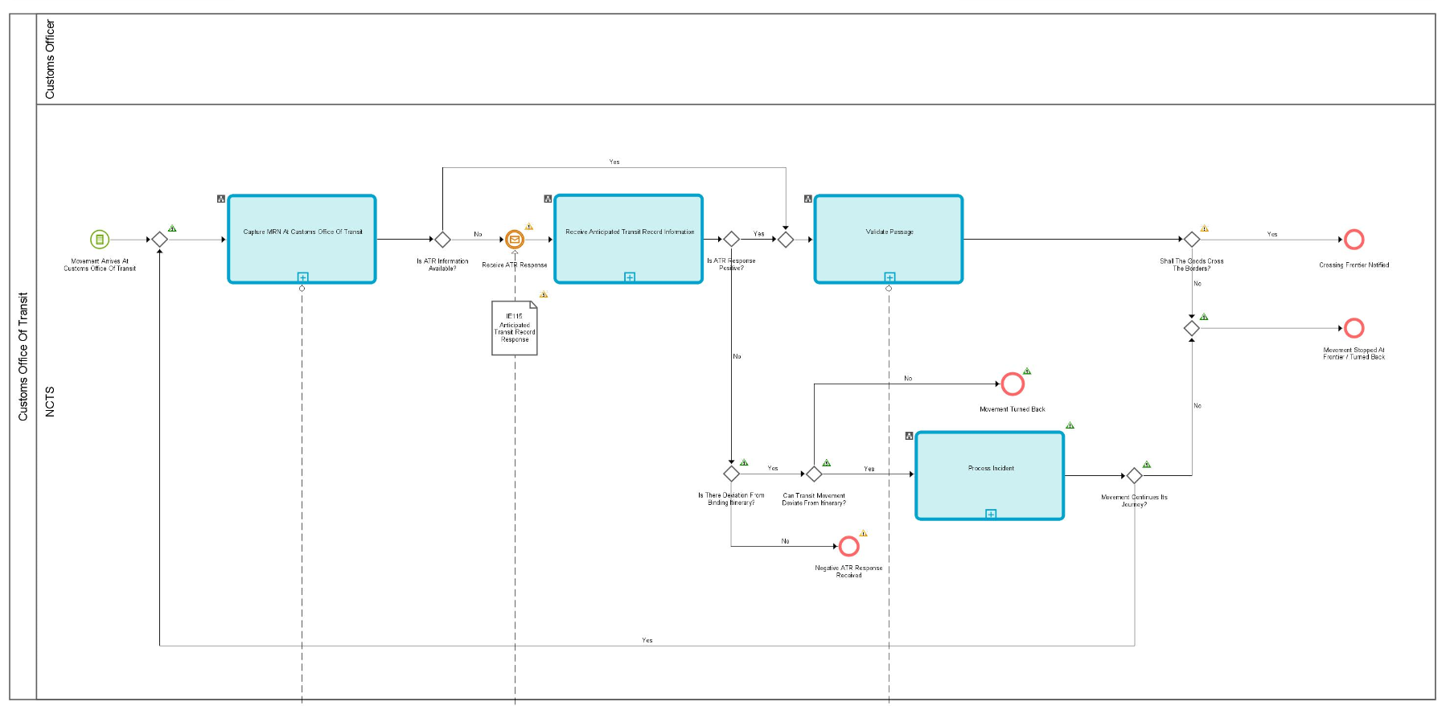
Figure 17: L4-TRA-01-04-Process Movement At Customs Office Of Transit - Part A

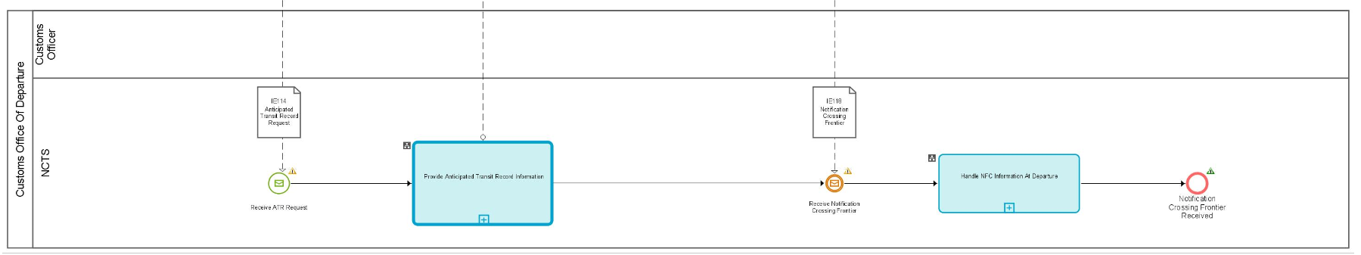
Figure 18: L4-TRA-01-04-Process Movement At Customs Office Of Transit - Part B
Major Events

Movement arrives at Customs Office of Transit
Organisation : National Customs Administration
Location : Customs Office of Transit
The vehicle with the Transit consignment arrives at the Office of Transit. The consignment and the Transit Accompanying Document (TAD) or MRN of Transit Declaration in an electronically readable format (e.g. as Barcode) are presented to the Office of Transit Officer. As per Article 41 of Appendix 1 of CTC, in case of CTC country, the Customs Office of Departure has to provide the printout of Transit Accompanying Document (TAD) to the Declarant (i.e. to the Holder of the Transit Procedure).

Minor Events

Receive ATR Request
Organisation : National Customs Administration
Location : Customs Office of Departure
The ATR Information is requested from Customs Office of Departure.

Receive ATR Response
Organisation : National Customs Administration
Location : Customs Office of Transit
The ATR Information is received from Customs Office of Departure.
Processes
Capture MRN at Customs Office of Transit | Process: L4-TRA-01-04-01
Organisation : National Customs Administration
Location : Customs Office of Transit
Constraint :
This process must be done as soon as possible in order not to slow down the traffic flow.
Description :
The Carrier notifies the Customs Office of Transit about the arrival of the consignment. Then, the Officer captures (or scans) the MRN of Transit declaration into NCTS.
NCTS looks for the Anticipated Transit Record (ATR) information:
- when the movement information is not available in case of international diversion, NCTS asks (IE114) that information from the Office of Departure and warns the Customs Officer;
- when the ATR information is available then the passage can be validated by the Customs Officer.
Final situation :
- If the ATR-information is available the passage can be validated.
- If there is an international diversion, the Customs Office of Transit waits for the information from the Customs Office of Departure; the state of the Transit Operation is set to ‘ATR Requested’.

Receive Anticipated Transit Record Information | Process: L4-TRA-01-04-03
Organisation : National Customs Administration
Location : Customs Office of Transit
Constraint :
If the Office of Transit receiving the Anticipated Transit Record response is the Customs Office of First Entry into the Safety and Security Area or if that cannot be determined, whether or not it is the First Customs Office of Entry into the Safety and Security Area, it shall apply the safety and security regulation and perform all related tasks within the prescribed time limits under following conditions:
- NCTS is also used for the purpose of safety and security;
- The (actual) Customs Office of Transit is located inside the Safety and Security Area.
Description :
The Customs Office of Transit receives (IE115) the Anticipated Transit Record Information from the Customs Office of Departure. NCTS records automatically the Anticipated Transit Record Information about the movement identified by IE115.TRANSIT OPERATION.MRN. If the provided Anticipated Transit Record response (IE115) contains the requested Anticipated Transit Record (IE115.TRANSIT OPERATION.Request rejection reason code is not present) and if it is used for safety and security [IE115.TRANSIT OPERATION. Security = ‘1’ (ENS) or ‘2’ (EXS) or ‘3’ (ENS & EXS)], then the Anticipated Transit Record response contains the relevant safety and security data elements. But, if the provided Anticipated Transit Record response (IE115) does not contain the requested Anticipated Transit Record information (IE115.TRANSIT OPERATION.Request rejection reason code is present), the received (IE115) Anticipated Transit Record information is rejected.
If risk analysis results are communicated by the Customs Office of Departure (IE115), the results shall be recorded and either be accepted or be considered when carrying out own risk analysis.
If the constraint is met:
- Full safety and security related risk analysis for all the goods shall be initiated by NCTS and performed by the national risk application according to the rules set out by the risk management framework. The national risk analysis system generates the risk analysis code. If the identified risk relates to a specific goods item of the transit declaration, the relevant goods item number shall be identified by the national risk analysis system.
- The national risk analysis system communicates the risk analysis result to NCTS and NCTS records it in the transit declaration. If the risk analysis result relates to a specific goods item, then the relevant goods item is recorded (RISK ANALYSIS IDENTIFICATION.RISK ANALYSIS.Declaration goods item number). In any other case the ’ RISK ANALYSIS IDENTIFICATION.RISK ANALYSIS.Declaration goods item number’ remains unused.
- The calculation of the risk analysis identification code (IE115. RISK ANALYSIS IDENTIFICATION.Code) is not transparent to NCTS and used by NCTS to identify the nature of risk and any appropriate actions.
  - The value is 'R': Risk identified, to be handled at the next Customs Office (other than Office of Departure);
  - The value is 'Y': Combined risk identified (national & common);
  - The value is 'X': National risk identified
  - The value is 'Z': No risk analysis performed at the Office of Departure.
- Random risk parameters shall be used additionally.
The system notifies the Customs Officer that the information to validate the passage is available. If risk is identified, the Customs Officer is alerted and is asked to register a control decision.
Final situation :
The Anticipated Transit Record Information is available to support any control which may be appropriate; the state of the Transit Operation is set to ‘ATR Created’ or, the Anticipated Transit Record Information is not available; the state of the Transit Operation is set to ‘ATR Rejected’.

Process incidents | Process: L4-TRA-01-12
Organisation : National Customs Administration
Location : Customs Office of Transit
Constraint :
The transit movement contains binding itinerary.
There are cases where diversion might be requested from a country that is not included in the list of countries based on binding itinerary, which is declared originally in the transit declaration by the Holder of the Transit Procedure and agreed with the Office of Departure.
Upon arrival of the transit movement to such a country (not included in the list of countries of the binding itinerary), and given the fact that the MRN is unknown, the Anticipated Transit Record is sent (IE114) to the Office of Departure, which checks that for the specific MRN, there is a binding itinerary and the diversion request comes from a country that is not included in the list of countries under the binding itinerary of the transit movement. Therefore, the Office of Departure replies with a negative IE115 that does not contain the details of the Anticipated Transit Record (i.e. IE115. TRANSIT OPERATION.Request rejection reason code = '3' is present). Based on the above result of the diversion request, the Actual Office of Transit decides whether to allow or not the transit movement to divert to this Office despite the binding itinerary.
In case the Actual Office of Transit does not allow the movement crossing the border, the movement needs to turn back and continue its journey by following the Binding Itinerary. However, in case the Actual Office of Transit allows the movement to deviate from its Binding Itinerary, an incident registration occurs to justify this deviation to the Office of Departure. For this purpose, an Incident Notification message is sent to the Office of Departure (IE180) that contains at least one instance of the appropriate Incident Code (i.e. IE180. CONSIGNMENT.INCIDENT.Code = '1').
Upon completion of the incident registration, the Actual Office of Transit requests again the Anticipated Transit Record (IE114) and receives a positive IE115 (i.e. TRANSIT OPERATION.Request rejection reason code is absent). Next, the passage validation takes place at this Customs Office of Transit.
Final situation:
- The movement stops / turns back since the deviation from the Binding Itinerary is not accepted, or
- The movement continues its journey and passage is validated.

Validate Passage | Process: L4-TRA-01-04-04
Organisation : National Customs Administration
Location : Customs Office of Transit
Constraint : This process requires retrieval of data within one minute so as not to hold up traffic.
If the Customs Office of Transit acts as a Customs Office of First Entry or if that cannot be determined whether or not it is the Customs Office of First Entry, it shall apply the safety and security regulation and shall perform all related tasks within the prescribed time limits under the following conditions:
- NCTS is also used for the purpose of safety and security;
- The Customs Office of Transit is located inside the Safety and Security Area.
Description :
On request of a Customs Officer, NCTS retrieves the movement information identified by the MRN and provided the Anticipated Transit Record Information is available, safety and security checks are performed:
- NCTS warns the Customs Officer if the movement is used for safety and security purposes [IE050/IE115.TRANSIT OPERATION. Security = ‘1’ (ENS) or ‘2’ (EXS) or ‘3’ (ENS & EXS)];
- NCTS warns the Customs Officer about the risk analysis performed upon reception of the Anticipated Transit Record information response (IE050/IE115 .RISK ANALYSIS IDENTIFICATION.Code).
- If risk analysis had proposed to take measures at the Customs Office of Transit but the Customs Officer decides not to control, then NCTS requires the Customs Officer to confirm the decision not to control.
The Customs Officer takes the appropriate action in NCTS and notifies the Goods Carrier. Subsequently, NCTS:
- records the action whether the consignment has to be controlled prior to the registration of the frontier crossing or if the consignment has to be stopped.
- records the action whether the consignment has to be turned back.
- notifies the Customs Officer that he/she has to register the Notification Crossing Frontier information if the consignment may cross the frontier.
Final situation :
The passage has been validated and the Transit movement, either
- it may cross the frontier, the Notification Crossing Frontier information is recorded into NCTS, the state of the Transit Operation is set to ‘NCF registered’, or
- it is turned back, the state of the Transit Operation is set to ‘Movement turned-back’, or
- it must be stopped at the frontier; the state of the Transit Operation is set to ‘Movement stopped’.

Provide Anticipated Transit Record Information | Process: L4-TRA-01-04-02
Organisation : National Customs Administration
Location : Customs Office of Departure
Constraint: This process must be done as soon as possible in order not to slow down the traffic flow.
Safety and security risk analysis results shall be exchanged only between National Administrations that belong to the Safety and Security Area.
Description :
This process is automatically performed by the system without a human intervention.
The Office of Departure is asked (IE114) by the Customs Office of Transit to provide the Anticipated Transit Record (ATR) about a movement (IE115).
NCTS looks for the movement information identified by IE114.TRANSIT OPERATION.MRN and automatically sends (IE115) back the required Anticipated Transit Record (ATR) about the movement or the reason of their rejection without the Anticipated Transit Record (ATR). If the provided request (IE114) relates to a transit movement which is also used for safety and security [IE115.TRANSIT OPERATION. Security = ‘1’ (ENS) or ‘2’ (EXS) or ‘3’ (ENS & EXS)], and if the requested data is available at departure, then the response (IE115) shall contain the relevant additional safety and security data elements.
If En-route information is available, related to the transit movement then the response (IE115) shall contain the relevant additional Incident data elements.
The safety and security risk analysis results shall be sent in IE115 if all the following conditions are met:
- The requesting (actual) Office of Transit is located in the Safety and Security Area;
- The declared Office of Departure is located in the Safety and Security Area;
Final situation :
The response about the Anticipated Transit Record (ATR) is sent to the Customs Office of Transit.

Handle Notification Crossing Frontier information at Departure | Process: L4-TRA-01-04-05
Organisation : National Customs Administration
Location : Customs Office of Departure
Constraint :
Description :
This process is performed automatically.
The Customs Office of Departure receives (IE118) the Notification Crossing Frontier information for the movement identified by IE118.TRANSIT OPERATION.MRN from a Customs Office of Transit; NCTS records this Notification Crossing Frontier information.
The Office of Departure performs the required checks to detect anomalies in the pattern of frontiers crossing and notifies the Customs Officer when appropriate.
Final situation :
The Notification Crossing Frontier information has been handled at the Customs Office of Departure.
Major Results
Crossing frontier notified
Organisation : National Customs Administration
Location : Customs Office of Transit
The notification for the crossing of the frontier is sent to the Office of Departure.

Movement stopped at frontier / turned back
Organisation : National Customs Administration
Location : Customs Office of Transit
The Transit movement has been stopped at the frontier and may be considered as arrived at destination. In that case, the Customs Office of Transit may be considered as an actual Customs Office of Destination, so the event “Arrival At Actual Office Of Destination” is activated for the process “L4-TRA-01-03-Process Arrival”.
However, it does not mean that this Office of Transit will always act as an Actual Office of Destination. There might be several reasons:
- There is no guarantee valid in that country (i.e. EU MS or CTC), and therefore the goods are not authorised to enter the country;
- According to the risk analysis results, the goods cannot enter the EU (or CTC country).

The principle of “turning the truck back” may not apply in cases when the goods leave the EU to cross the third country. Transit is suspended in the third country, and it continues when the goods re-enter the territory of the EU or CTC country. In this case, the Office of Transit is situated at the EU exit border. If the goods cannot leave the EU, this Office of Transit becomes the Actual Office of Destination.
There are also several circumstances (e.g. road blocked due to danger or accident), where the Transit movement cannot be allowed to cross the frontier (i.e. must be turned back).

Minor Results

Negative ATR response received
Organisation : National Customs Administration
Location : Customs Office of Transit
The Office of Transit has received a negative Anticipated Transit Record response (IE115), and the state at the Office of Transit is set to “ATR Rejected”. This means that the Office of Departure has not allowed the consignment to divert to this particular Office of Transit.
In case that the negative Anticipated Transit Record response (IE115) is not related to a deviation from the Binding Itinerary, the Office of Transit cannot proceed with any other actions related to passage validation.
However, if the negative Anticipated Transit Record response (IE115) is related to a deviation from the Binding Itinerary, the Customs Office of Transit decides whether to allow or not the transit movement to deviate from its Binding Itinerary. If the decision is positive (i.e. movement does not need to turn back), then the Customs Office of Transit proceeds with the registration of an incident.

Movement turned back
Organisation : National Customs Administration
Location : Customs Office of Transit
The Office of Transit has decided the transit movement not to cross its frontiers but to turn back.

Notification Crossing Frontier information received
Organisation : National Customs Administration
Location : Customs Office of Departure
The receipt of the Notification Crossing Frontier information (concerning a passage through a Customs Office of Transit) has been handled at departure.

Assumptions
- The logic for the fraud detection (in the context of “bureau de passage” and especially in case of diversion) can only be based on:
- At the Customs Office of Transit (on-line):
- The existence of the movement in the NCTS will be checked (by retrieving or requesting the Anticipated Transit Record Information). If the movement does not exist at the Customs Office of Departure, the NCTS Accompanying Document or MRN of Transit Declaration in an electronically readable format will be considered as forged.
- A warning will be given by the system if the movement is already recorded as having entered this country (of the Customs Office of Transit).
- At the Customs Office of Departure (off-line):
- If a diversion has been reported, a check is performed against the consistency of the “frontier crossing pattern”, and the system gives a warning if irregularities are detected. UNgen.060 describes the rules which will be applied to check the consistency.
- In case of diversion of a movement marked as binding itinerary, and the carrier arrives at an Actual Office of Transit whose country does not belong to the list of countries of the Binding Itinerary declared for the transit movement and there is also no previous registration of an Incident for the deviation from the Binding Itinerary to this country, the Office of Departure must reject the diversion request (IE114) to this Actual Office of Transit.

Nevertheless, when the Office of Departure has received an Incident for the deviation from the Binding Itinerary to this specific country, prior to any diversion request (IE114) sent by the Actual Office of Transit, the Office of Departure will respond with a positive Anticipated Transit Record response (IE115) to that Actual Office of Transit.
Remark
The Customs Office of Transit will inform the Customs Office of Departure by means of the Notification Crossing Frontier information (IE118) when the consignment crosses the frontier of the Customs Office of Transit. However, based on the Article 304 (6) of UCC-IA there is an exception where the consignment does not have to be presented at the Customs Office of Transit in case of transport by rail. In that case the customs office of transit can verify the border passage of the goods by other means. Such verification shall take place only in case of need. The verification may also take place retrospectively. Thus, when the traffic type at the border is ‘rail’, the customs office of transit is not obliged to notify the customs office of departure with the Notification Crossing Frontier information when the consignment crosses the border.

Handle enquiry

L4-TRA-01-05-Status Request
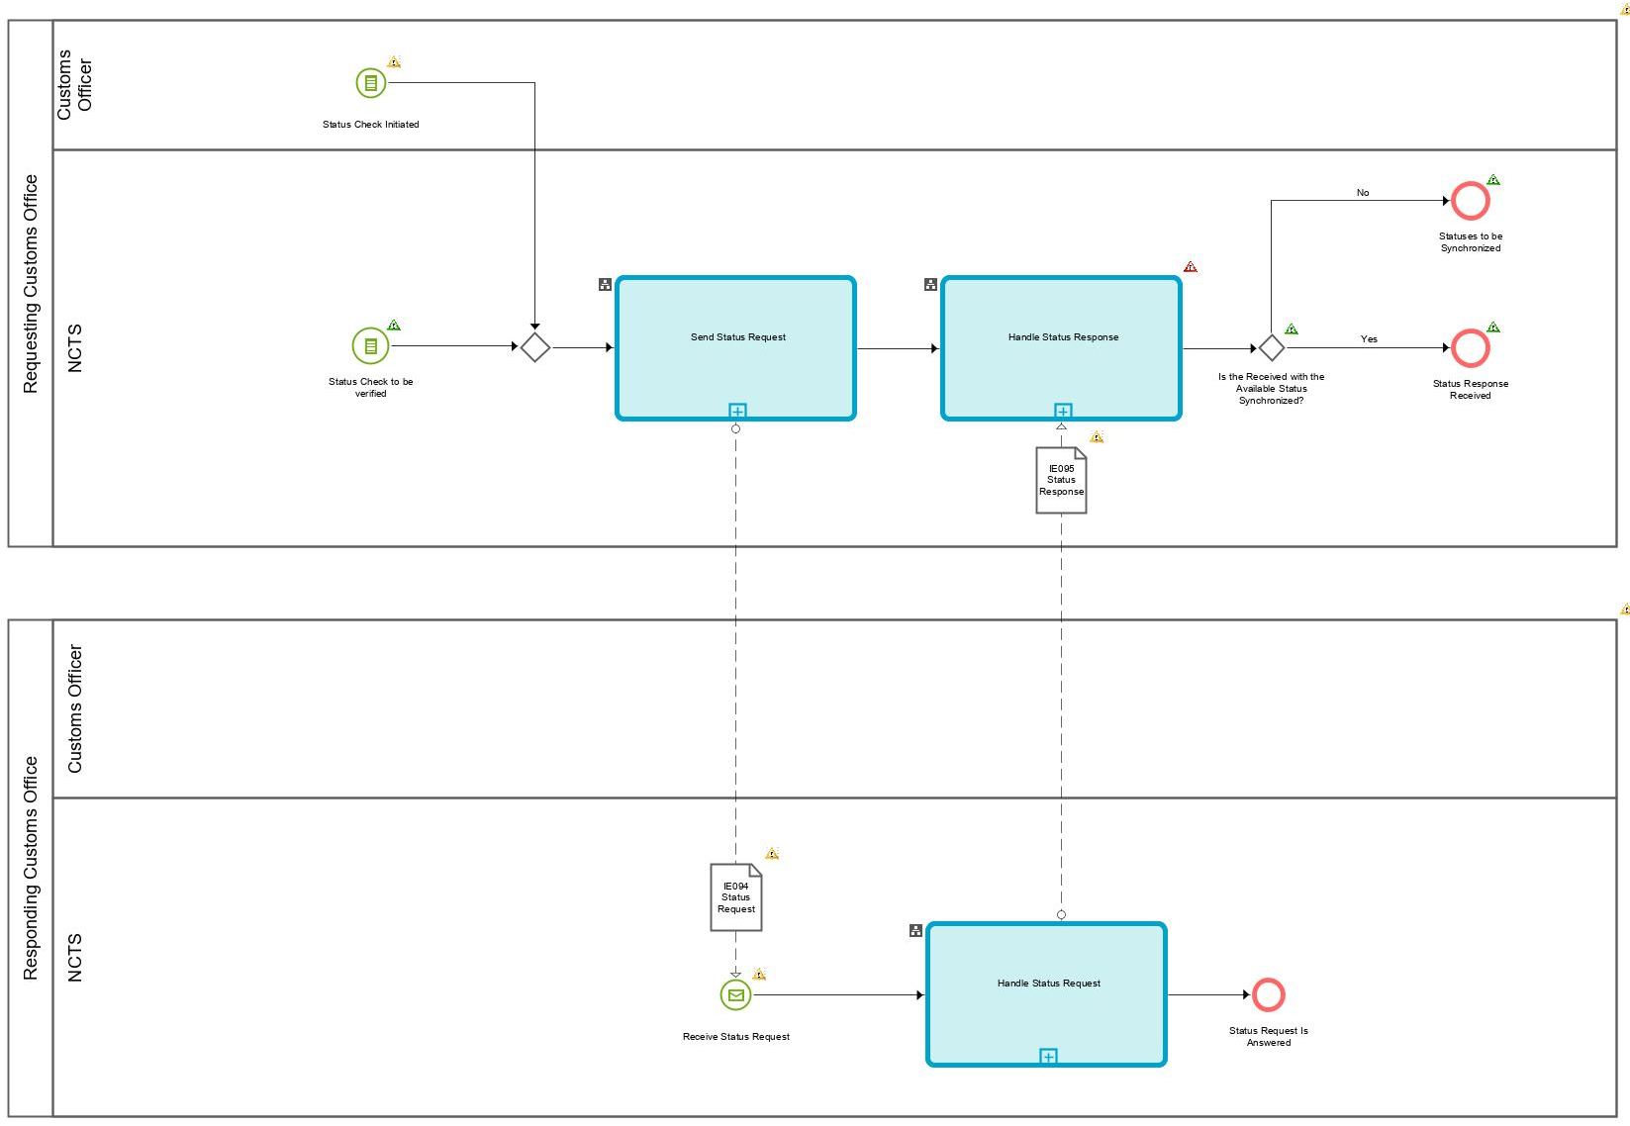
Figure 19: L4-TRA-01-05-Status Request

Major Events

Status check to be verified
Organisation : National Customs Administration
Location : Competent Authority of Country of Departure
(Timed event)
The time allotted for the receipt of the arrival advice (IE006) or of the control result (IE018) (See Process L4-TRA-01-02-02-Issue Transit Transaction Data) has expired and the transit movement is set to the ‘Enquiry recommended’ state. These time-out periods, that indicate that the status request should be sent, are defined by the Competent Authority of Country of Departure using the values permitted in the relevant legal framework.
The value of this/these “timer(s)” may evolve during the lifetime of the movement. Upon receipt of the arrival advice, its value will change. It may also be manually shortened by a Customs Officer.
When the control results are received (IE018) from the Customs Office of Destination, or when the movement is written-off for other reasons, the timer stops.
N.B. This event can also consist of information received by the Competent Authorities of Country of Departure that the transit procedure has not ended correctly, or they suspect that to be the case (Articles 226(3)(a) and 227(2)(a) of the Code, Article 310 (3) UCC IA).

Status check initiated
Organisation : National Customs Administration
Location : Country of Departure
The Customs Officer at the Country of Departure has initiated and sent the status request to any Customs Office involved into the transit movement, so as to be informed about the current status of that Customs Office.
Processes
Send Status Request | Process: L4-TRA-01-05-01
Organisation : National Customs Administration
Location : Country of Departure
Constraint :
Description :
The timer 'Time to start enquiry' has expired. In case the Country of Customs Office of Departure has not received an IE006, it sends the status request (IE094) to the Country of Customs Office of Destination (declared) or to the latest Actual Office of Destination where a positive Anticipated Arrival Record (IE003) was sent, else in cases where it has received an IE006 and the timer ‘Awaiting Receipt Of Control Results’ to receive IE018 has expired then the status request (IE094) will be sent to the Country of Customs Office of Destination where the IE006 was issued (can be the declared or the new, actual one). In case the state at Customs Office of Departure is ‘Enquiry recommended’, the state anterior to the ‘Enquiry recommended’ is placed in the IE094.
When NCTS receives the status response (IE095) from the Country of Customs Office of Destination (declared or actual), the status of the Declared Customs Office of Destination is automatically recorded by the Customs Office of Departure.
Additionally, the status request (IE094) can also be sent any time by the Customs Officer at Departure to any customs office (i.e. Office of Transit or Office of Exit for Transit or Office of Destination) in order to be informed of the latest status of the specific Custom Office that has previously received the transit record (i.e. through IE001/IE003/IE050/IE115/IE160/IE165).
Final situation: Upon expiration of the timer “Time to start enquiry”, the state is set to ‘Enquiry recommended’ and the status request is automatically sent to the Declared Customs Office of Destination, OR the Customs Officer at Departure has sent the status request to any Customs Office (i.e. Office of Transit or Office of Exit for Transit or Office of Destination) involved into the transit movement to be informed of the latest status at that Office.

Handle Status Request | Process: L4-TRA-01-05-02
Organisation : National Customs Administration
Location : Country of Destination
Constraint :
Description :
The NCTS system at the Country of Customs Office of Destination (declared or actual) checks the state and automatically replies to the Country of Departure with the IE095, containing the state at Customs Office of Destination. If the state at destination doesn’t correspond with the one at departure and no error message has been generated the missing message(s) (IE006 and/or IE018) must be sent by the Customs Office of Destination (intelligent IE095 = IE095 and at the same time IE006/IE018 as well without any intervention from a Customs Officer).
If the original messages IE006 and/or IE018 caused an error message, the amended message(s) has (have) to be resent otherwise it should be done automatically. If this is not possible within a given time limit (Articles 226(3)(a) and 227(2)(a) of the Code, Article 310 ICC IA), the Country of Customs Office of Destination immediately transmits by all possible means the missing information in order to allow the Country of Departure to give the proper follow up of the procedure.
The NCTS system at the Country of Customs Office of Exit for Transit (declared or actual) or at the Country of Customs Office of Transit (declared or actual) checks the state and automatically replies to the Country of Departure with the IE095 containing the current state at Customs Office of Exit for Transit or at Customs Office of Transit.
Final situation: The status request is answered. In case the Customs Office of Destination replies to the status request, missing message(s) is/are resent or missing information is forwarded by other means.

Handle Status Response | Process: L4-TRA-01-05-03
Organisation : National Customs Administration
Location : Country of Departure
Constraint :
Description :
The NCTS-System at Country of Departure automatically checks in the received IE095 from the Custom Office of Destination whether the state at destination is corresponding to the state at departure, and whether in the meanwhile, an IE006 and/or an IE018 has/have been received.
If the state does not correspond and an IE006 and/or IE018 has/have been received the Arrival processing is resumed (see "L4-TRA-01-03-Process Arrival").
If the state does correspond or there is/are no IE006 and/or IE018 received within the given time limit the Competent Authority of Country of Departure shall start the enquiry procedure.
When not done directly by the Competent Authority of Country of Departure, NCTS retrieves the movement information identified by the MRN brought in the timers “Awaiting Receipt Of Arrival Advice” and “Awaiting Receipt Of Control Results” (time allotted for the receipt of the arrival advice and/or the control results from the Customs Office of Destination) started by the process “L4-TRA-01-02-02-Issue Transit Transaction Data” and notifies the Customs Officer, who either starts the enquiry process or postpones it to a later time. In the latter case, he re-sets the relevant timer.
The state remains 'Enquiry recommended'.
The NCTS-System at Country of Departure stores the status of the received IE095 from the Custom Office of Transit or Customs Office of Exit for Transit and display it to the Customs Officer at departure for informational purposes.
Final situation :
The status of the received IE095 is stored. In case the IE095 is received from the Customs Office of Destination, either the movement can be written off, or the Customs Officer at Competent Authority at Departure may decide to reset the timer to start enquiry or to start the enquiry procedure.
Results
Statuses to be synchronised
Organisation : National Customs Administration
Location : Competent Authority of Country of Departure
The IE006 and/or IE018 are received together with the IE095. The transit movement has arrived and in case IE018 is also received, the transit movement can be either written off or major discrepancies to be resolved.

Status response received
Organisation : National Customs Administration
Location : Competent Authority of Country of Departure
The status response has been received at the Competent Authority at Departure.

L4-TRA-01-06-Handle Enquiry - Enquiry Procedure (Option A) – Contacting the Holder of Transit Procedure
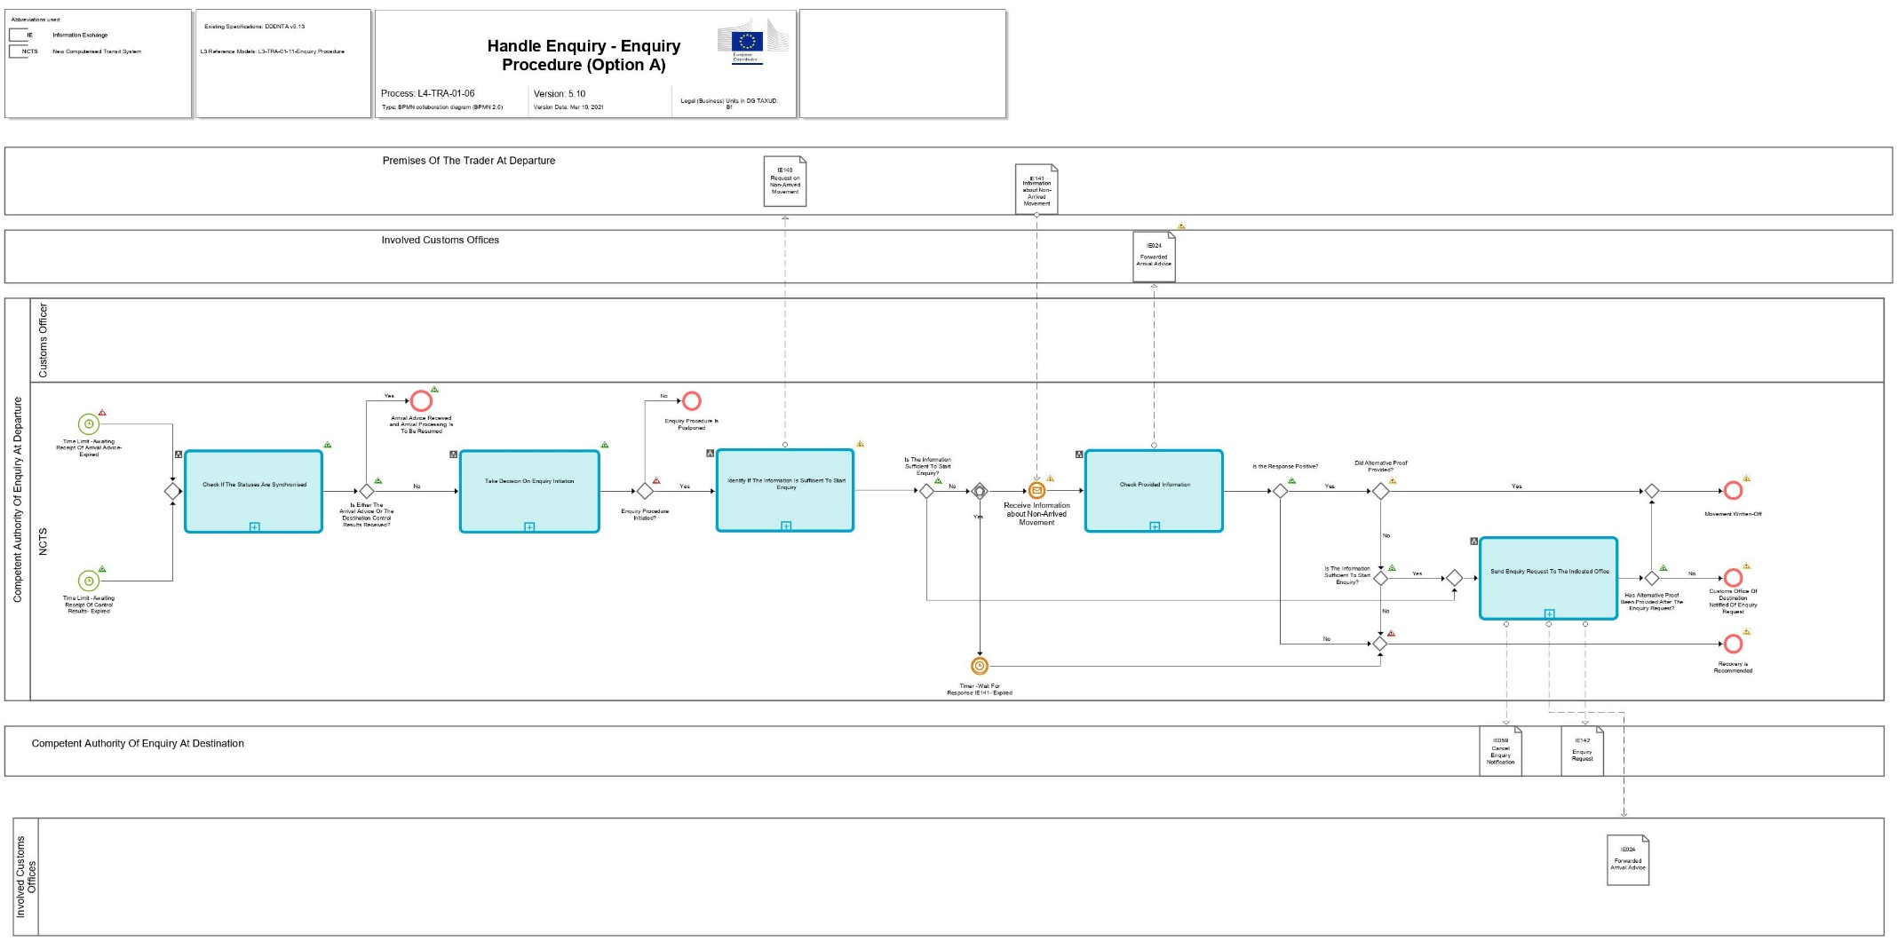
Figure 20: L4-TRA-01-06-Handle Enquiry - Enquiry Procedure (Option A) – Part A
Figure 21: L4-TRA-01-06-Handle Enquiry - Enquiry Procedure (Option A) – Part B
Major Events
Time Limit -Awaiting Receipt Of Arrival Advice- Expired
Organisation : National Customs Administration
Location : Customs Office of Departure
(Timed event)
The “Awaiting Receipt of Arrival Advice” timer expires and no ‘Arrival Advice’ (IE006) message has been received.

Time Limit -Awaiting Receipt Of Control Results- Expired
Organisation : National Customs Administration
Location : Customs Office of Departure
(Timed event)
The “Awaiting Receipt Of Control Results” timer expires and no ‘Destination Control Results’ (IE018) message has been received.
Minor Events
Time Limit-Wait for Response IE141-Expired
Organisation : National Customs Administration
Location : Customs Office of Departure
(Timed event)
The Holder of Transit procedure provides no information within the allotted time limit and a time-out has occurred. This time-out period is 35 days.

Receive Information about non-arrived movement
Organisation : Holder of Transit procedure
Location : Premises of the Trader at Departure
(Timed event)
The Holder of Transit procedure provides information (IE141) within the defined time limit.
Processes
Check if the statuses are synchronised | Process: L4-TRA-01-06-04
Organisation : National Customs Administration
Location : Competent Authority of Country of Departure
Constraint :
Description:
Any of the timers “Awaiting receipt of Arrival Advice” and/or “Awaiting receipt of Control Results” has expired and no IE006 and/or no IE018 have yet been received. The Competent Authority of County of Departure automatically sends the status request (IE094) to the Declared Customs Office of Destination, which replies with the IE095. In case the IE006/IE018 have already been sent by the Declared Office of Destination, but for some technical issue, these messages were not received by the Office of Departure, then the Declared Office of Destination sees this misalignment in the statuses and resends the IE006/IE018 along with the IE095. In that case, the arrival process is resumed (please see L4-TRA-01-03-Process Arrival).
In case the statuses are synchronised, meaning that the IE006 and/or IE018 messages are still expected, the status remains “Enquiry recommended” and the Customs Officer at the Competent Authority of Country of Departure decides either to initiate enquiry or postpone it for later by setting new time limits for the timers “Awaiting receipt of Arrival Advice” and/or “Awaiting receipt of Control Results”.
Final situation:
- After the exchange of the IE094/IE095, the IE006/IE018 are resent by the Office of Destination to the Office of Departure and the arrival processing is resumed.
- After the exchange of the IE094/IE095, there are still no IE006/IE018 and the status remain “Enquiry recommended”. The Competent Authority of the Country of Departure decides either to initiate enquiry or postpone it for later.

Take decision on Enquiry initiation | Process: L4-TRA-01-06-05
Organisation : National Customs Administration
Location : Competent Authority of Country of Departure
Constraint :
Description:
Following the results of the synchronisation of the statuses with the IE094/IE095 messages between the Customs Office of Departure and the Customs Office of Destination, and assuming that the state remains under “Enquiry recommended”, the Competent Authority decides to initiate enquiry or postpone it for later by setting new time limits for the timers “Awaiting receipt of Arrival Advice” and/or “Awaiting receipt of Control Results”.
Final situation:
- The Competent Authority of the Country of Departure decides either to initiate enquiry or postpone it for later.

Identify if the information is sufficient to start Enquiry | Process: L4-TRA-01-06-01
Organisation : National Customs Administration
Location : Competent Authority of Country of Departure
Constraint :
Description:
The state is under “Enquiry recommended”, and the Competent Authority of the Country of Departure decides to initiate enquiry. The state of the transit operation is set to “Under enquiry procedure”. Nevertheless, NCTS allows the Customs Officer either to continue with the enquiry process immediately or to postpone it to a later time. In the latter case, NCTS will allow the Customs Officer to reset the timers “Awaiting Receipt Of Arrival Advice” and “Awaiting Receipt Of Control Results as needed.
In the event that enquiry is initiated, the Competent Authority of the Country of Departure check if they possess sufficient information. In case the Holder of the Transit Procedure is contacted to provide information for the non-arrived movement (IE140), the timer “Time to Enquire Holder on non-arrived movement” stops. Nevertheless, if the timer “Time to Enquire Holder on non-arrived movement” expires, then the information to initiate enquiry is considered sufficient.
If the information for the Consignee is considered sufficient it starts the enquiry procedure by sending the enquiry request (IE142) to the Declared Customs Office of Destination or to any other office that the Competent Authority of Departure consider necessary.
If an arrival advice has already been received (IE006 - see Process “L4-TRA-01-03-03-Store and forward arrival advice”) and/or the information for the Consignee is considered sufficient or the IE140 has already been sent at an earlier stage, the Holder of Transit procedure will not be contacted at this point of the operation (Article 310(5)(6)).
Final situation:
- The state of the transit operation is set to “Under enquiry procedure”. The Competent Authority of the Country of Departure decides to either contact the Holder of the Procedure when the information to start the enquiry procedure is not sufficient, otherwise the enquiry request (IE142) is sent without contacting the Holder of the Transit Procedure.

Check Provided Information | Process: L4-TRA-01-06-02
Organisation : National Customs Administration
Location : Competent Authority of Country of Departure
Constraint :
Description :
If the Holder of Transit procedure provides alternative proof (in accordance with current law) the movement can be written-off (L4-TRA-01-03-09-Handle Destination Control Results) and the IE024 is sent to all involved offices to close that movement.
If the Holder of Transit procedure provides the Competent Authority of Country of Departure with other sufficient information (no alternative proof) or a new Customs Office of Destination or information about the Actual Consignee, this information will be forwarded to the Customs Office of Destination (declared or actual) with the Enquiry Request (IE142).
If the Holder of Transit procedure did not provide information at all within 35 days or if the information provided is not sufficient to discharge the Union/Common Transit procedure, the recovery procedure (see "L4-TRA-01-08-Handle Recovery - Recovery Procedure (Option A) ") is recommended. In that case, the status of the transit operation is set to ‘Recovery recommended’.
Final situation:
- The information about the non-arrived movement is received by the Competent Authority of the Country of Departure. If the information is sufficient, the Competent Authority of the Country of Departure can proceed by sending the enquiry request.
- The information is insufficient or the Holder of the Transit Procedure does not reply within the time limit about the non-arrived movement, then recovery is recommended.

Send enquiry request to the indicated office | Process: L4-TRA-01-06-03
Organisation : National Customs Administration
Location : Competent Authority of Country of Departure
Constraint :
Description :
This process always demands an intervention of a Customs Officer.
The Competent Authority of Country of Departure continues the enquiry procedure with a request at the Customs Office of Destination. Based on the fact that information to initiate enquiry is sufficient ( the Holder of the Transit Procedure, may have also been contacted) the IE142 (indicating additional information is available) will be sent to the actual Customs Office of Destination. The timer ‘Wait For Enquiry Response” starts and the timer “Time to Enquire Holder on non-arrived movement” stops in case this timer is still running (i.e. Holder of the Transit Procedure is not contacted).
In case there had been an open IE142 sent to the Declared Customs Office of Destination, which has not replied with an enquiry response (IE143), this IE142 shall be cancelled beforehand by sending the IE059. There shall never be more than one IE142 pending at the same time. NCTS records the cancellation.
In case the timer ‘Wait For Enquiry Response” expires and no enquiry response (IE143) has yet been received, the enquiry request (IE142) is cancelled (IE059). The movement remains though in the ‘Under enquiry procedure’ state.
In case alternative proof is sent, while an enquiry request (IE142) is still open (no IE143 yet), the movement can be written off by the Competent Authority of the Country at Departure. In that case the timer ‘Wait For Enquiry Response” stops, the open enquiry request is cancelled (IE059) and the IE024 is forwarded to the involved offices.
Final situation: An enquiry request has been sent to the Actual Customs Office of Destination and the timer is set. An eventual pending enquiry is cancelled (state remains ‘Under enquiry procedure’) and the Customs Office requested for enquiry is notified of its cancellation and any work related to that enquiry can stop, or additional info is forwarded to the Requested Office. In case alternative proof is sent, the movement can be written-off and the status of the transit operation is set to “Movement written-off”.

Major Results
Customs Office of Destination notified of enquiry request
Organisation : National Customs Administration
Location : Competent Authority of Country of Departure
The Competent Authority of Country of Departure sends the enquiry request (IE142) to the Competent Authority of Country of Destination.

Recovery is recommended
Organisation : National Customs Administration
Location : Competent Authority of Country of Departure
Following investigation during the enquiry procedure, recovery is recommended.

Movement written off
Organisation : National Customs Administration
Location : Competent Authority of Country of Departure
Alternative proof allows to write off the movement.

Minor Results
Arrival advice received and arrival processing is to be resumed
Organisation : National Customs Administration
Location : Customs Office of Departure
After the expiration of the timer “”Time to start enquiry”, an IE006/IE018 are received and the arrival processing is resumed.

Enquiry procedure is postponed
Organisation : National Customs Administration
Location : Customs Office of Departure
Under the status “Enquiry recommended”, the Competent Authority of the Country of Departure has decided to postpone the initiation of enquiry.

L4-TRA-01-07-Handle Enquiry - Enquiry Procedure (Option B)- Contacting Customs Office of Destination
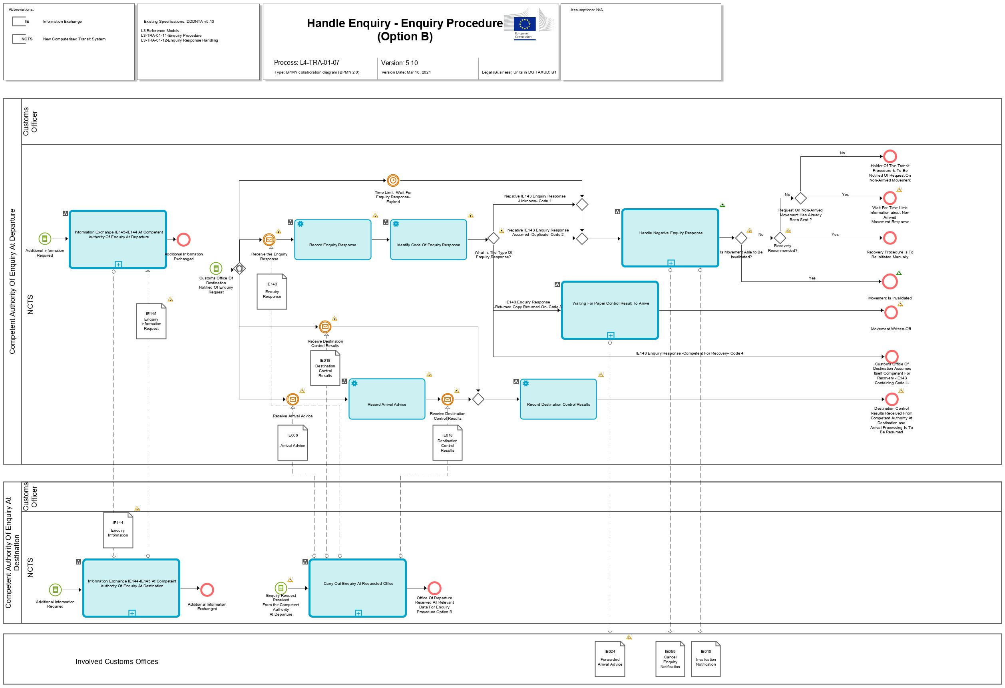
Figure 22: L4-TRA-01-07-Handle Enquiry - Enquiry Procedure (Option B) - Part A
Figure 23: L4-TRA-01-07-Handle Enquiry - Enquiry Procedure (Option B) - Part B

Major Events
Additional information required
Organisation : National Customs Administration
Location : Competent Authority of Country of Departure
The Competent Authority of Country of Departure exchanges additional information with the Competent Authority of Country of Destination.

Customs Office of Destination notified of enquiry request
Organisation : National Customs Administration
Location : Competent Authority of Country of Departure
An enquiry request (IE142) has been sent by the Competent Authority of Country of Departure to the Competent Authority of Country of Destination.
Processes
Information Exchange IE145-IE144 at Competent Authority of Enquiry at Departure | Process: L4-TRA-01-07-01
Organisation : National Customs Administration
Location : Competent Authority of Country of Departure
Constraint : It is only allowed to use message IE144 after the enquiry/recovery procedure has been started and until the enquiry/recovery procedure is completed.
Description :
For additional information or question exchange, the messages IE144 and IE145 can be used, whereas the IE144 is sent only by the Competent Authority of Country of Departure and IE145 is sent only by the Competent Authority of Country of Destination. This information exchange can be started either by the Country of Departure (IE144) or the Country of Destination (IE145), no reply is needed since it can be only information sent and not a question asked. Additional documents will be sent by other than NCTS means. These two messages can be sent during the whole process of enquiry and/or recovery to assure the exchange of information between the offices involved.
Final situation: information and/or questions have been exchanged between the Country of Departure and the Country of Destination.

Information Exchange IE144-IE145 at Competent Authority of Enquiry at Destination | Process: L4-TRA-01-07-02
Organisation : National Customs Administration
Location : Competent Authority of Country of Destination
Constraint : It is only allowed to use message IE145 after the enquiry and/or recovery procedure has been started and until the enquiry and/or recovery procedure is completed.
Description :
For additional information or question exchange, the messages IE144 and IE145 can be used, whereas the IE144 is sent only by the Competent Authority of Country of Departure and the IE145 is sent only by the Competent Authority of Country of Destination. This information exchange can be started either by the Country of Departure (IE144) or the Country of Destination (IE145), no reply is needed since it can be only information sent and not a question asked. Additional documents will be sent by other than NCTS means. These two messages can be sent during the whole process of enquiry and/or recovery to assure the exchange of information between the offices involved.
Final situation: information and/or questions have been exchanged between the Country of Departure and the Country of Destination.

Carry out enquiry at requested Office | Process: L4-TRA-01-07-03
Organisation : National Customs Administration
Location : Requested Customs Office of Destination
Constraint : The NCTS must warn the requested Customs Office of Destination when an enquiry request has arrived.
Description :
Remark : This process may be interrupted upon reception (IE059) of an enquiry cancellation (see Process L4-TRA-01-03-09).
The Customs Officer performs the required action in order to provide the enquiry results to the Competent Authority of Country of Departure.
This might include completing the actual controlling of the consignment if it was delayed for some reason. Or it might merely be that the control results were not recorded into the system yet. Or, consignees may be contacted to establish the whereabouts of the movement. The general “Customs’ movements’ state system” will be available to support these actions (see “section 2.13 – Assist Users in their daily work “).
When the Customs Office of Destination needs the available additional information (indicated in IE142) from the Competent Authority of Country of Departure, an exchange of extra information (via IE144 and IE145) will take place (see L4-TRA-01-07-01, L4-TRA-01-07-02), whereas the IE144 is sent only by the Customs Office of Departure and IE145 is sent only by the Customs Office of Destination. This information exchange can be started either by the Customs Office of Departure or the Customs Office of Destination, but no reply is needed since it can be only information sent and not a question asked.
When the consignment is not located, the Customs Office of Destination sends (IE143) the negative enquiry response to the Competent Authority of Country of Departure, confirming that the movement was never presented at this Customs Office of Destination or a duplicate (in particular two MRNs for the same consignment) has been found.
When the movement is located (arrived) and control results are available these must be communicated with the IE006/IE018, no IE143 is needed in these cases since the IE006 and the IE018 or where the IE006 has already been received earlier the IE018 are positive answers to the IE142. Additionally, no enquiry cancellation (IE059) needs to be sent to the Office of Destination that has replied with IE006/IE018 instead of IE143. However, the enquiry cancellation (IE059) needs to be sent to the other Office of Destination that has not replied with IE006/IE018 and the IE143 is still pending from that Customs Office. In rare, exceptional cases where it is not possible to send the available IE006/IE018, the IE143 containing code 3 and the paper control result must be sent (“Case of business continuity procedure (Annex 72-04)”). The principle 'What starts in NCTS must end in NCTS!' remains valid.
The sending of the IE006 and IE018 or the IE018 is only allowed when the transit operation has ended within the prescribed time limits and there is no withdrawal from Customs supervision. It has to be a regular ending procedure within the time limit (e.g. registration of TAD forgotten) or an acceptance of a late presentation in accordance with current law.
In case the Customs Office of Destination assumes itself competent for recovery it sends an enquiry response (IE143 containing code 4) to the Competent Authority of Country of Departure asking for competency for recovery.
Final situation: Either the Competent Authority of Country of Departure has been informed with a negative response, or normal arrival processing can be resumed (positive response), or recovery is requested by the Customs Office of Destination.

Handles negative enquiry response | Process: L4-TRA-01-07-04
Organisation : National Customs Administration
Location : Customs Administration of Departure
Constraint : In case an IE006 has been received, the answer IE143 containing code 1 (movement unknown at destination) cannot be used.
Description :
If the timer ‘Wait for Enquiry response’ has expired and no response was received (in this case enquiry request is cancelled with IE059) or a negative IE143 ('unknown') from Customs Office of Destination has been received, a check will be performed if the Holder of the Transit Procedure was informed via IE140 at an earlier stage. In case the 'request on non-arrived movement' (IE140) has not already been sent to the Holder of the Transit Procedure the Competent Authority of Country of Departure proceeds to Process L4-TRA-01-06-01- Send Enquiry Request / Send Request on Non-Arrived Movement. The state remains 'Under enquiry procedure'.
In case the enquiry request has already been sent, the Competent Authority of Country of Departure shall wait. If the enquiry response (with response code 4) is received, the state is set to ‚Recovery recommended’ (Article 311 UCC IA). Once this state is reached, recovery procedure shall be started.
If a negative answer ‘duplicate’ was received the Customs Office of Departure has to perform the required checks and possibly the Customs Office of Departure to invalidate the transit movement. A negative enquiry response (IE143 ‚unknown’; ‚duplicate’) which indicates that enquiries at the Customs Office of Destination are completed stops the timer 'Wait for enquiry response'. A new IE142 can be sent to another office or to the same office if additional information from the Holder of Transit procedure is available (see L4-TRA-01-06-Handle Enquiry - Enquiry Procedure (Option A)). In case the timer ‘Wait for Enquiry response’ has not yet expired but the Customs Officer has serious proof that justify the start of a recovery procedure (see L4-TRA-01-08-Handle Recovery - Recovery Procedure (Option A)) he/she can recommend recovery and the enquiry request is cancelled (IE059). In these cases, the movement is set to 'Recovery recommended'. This can be done at any time after the movement has been released.
Final situation: A check will be performed whether the Holder of Transit procedure was informed, if not IE140 is sent or another IE142 is sent or ‘duplicate’ will be checked, or recovery starts.

Waiting for paper control result to arrive | Process: L4-TRA-01-07-05
Organisation : National Customs Administration
Location : Customs Administration of Departure
Constraint : The process is applied only within the business continuity procedure.
Description :
The Customs Office of Departure is informed by IE143 containing Code 3 (Return Copy returned on) that the movement has arrived and can be written off manually based on the paper copy that will arrive. If the time between the IE143 and the arrival of the mentioned proof is unexpectedly long it can use the IE144/IE145 to solve the issue (Case of business continuity (Annex 72-04)).
When the proof arrives the Customs Office of Departure sends the IE024 to all involved offices to close that movement.
Final situation: Paper control result arrived, arrival process can be resumed, all involved offices are informed about the closing.

Major Results
Destination control results received from Competent Authority at Destination and
arrival processing is to be resumed
Organisation : National Customs Administration
Location : Customs Office of Destination
IE006 and/or IE018 had been sent and the movement will be written off.

Movement Written-Off
Organisation : National Customs Administration
Location : Customs Office of Destination, Offices of Transit
IE024 had been sent to all involved offices and the movement is written off.

Customs Office of Destination assumes itself competent for Recovery -IE143 containing code 4-
Organisation : National Customs Administration
Location : Customs Administration of Departure
An IE143 with response code ‘4-Request for Recovery at Destination’ is received.

Movement is Invalidated
Organisation : National Customs Administration
Location : Customs Administration of Departure
An IE143 with response code ‘2-Assumed Duplication’ has been received and subsequently transit movement is invalidated.

Recovery procedure is to be initiated manually
Organisation : National Customs Administration
Location : Customs Administration of Departure
The Competent Authority of Recovery at Departure decides to initiate recovery.

Wait for time limit information about non-arrived movement response
Organisation : National Customs Administration
Location : Customs Administration of Departure
An IE141 is expected from the Holder of the Transit Procedure.

Holder Of The Transit Procedure is to be notified of request on non-arrived movement
Organisation : National Customs Administration
Location : Customs Administration of Departure
An IE140 is to be sent to the Holder of the Transit Procedure.

Handle Recovery

L4-TRA-01-08-Handle Recovery - Recovery Procedure (Option A) – IE150 (Recovery request) is sent to Competent Authority at Destnation
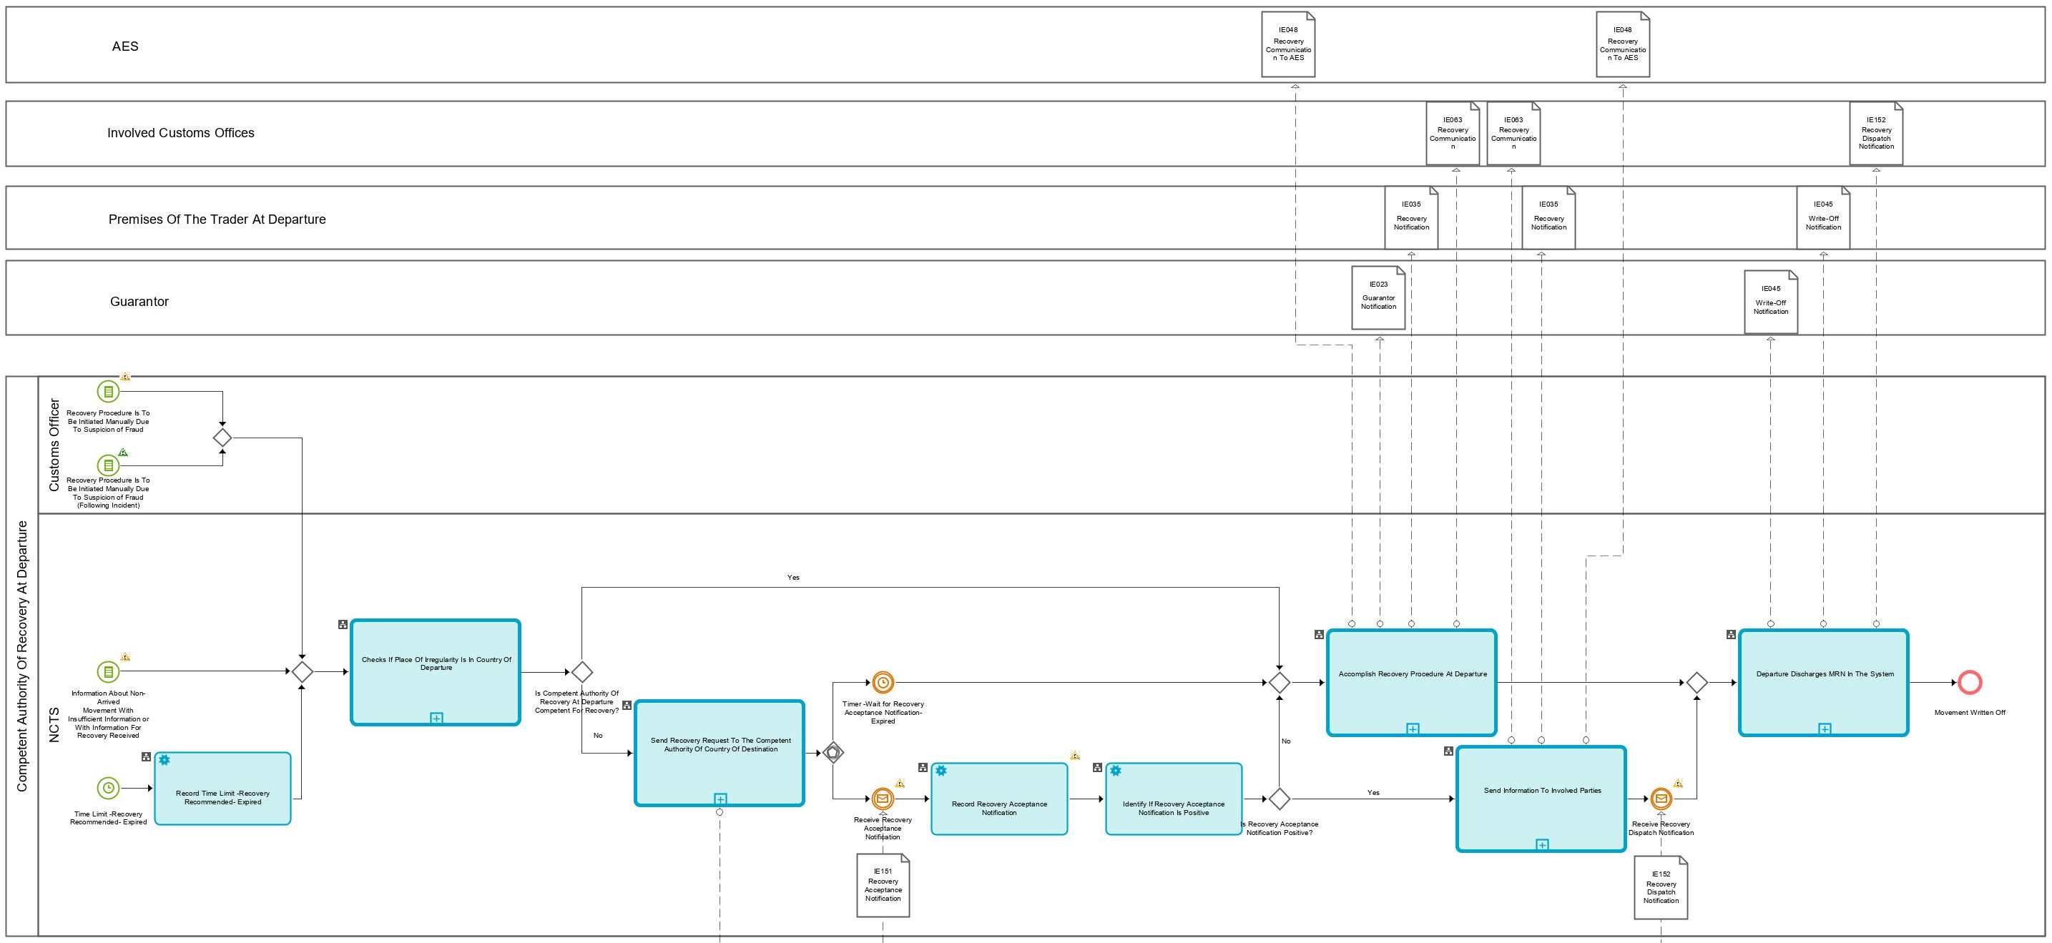
Figure 24: L4-TRA-01-08-Handle Recovery - Recovery Procedure (Option A) - Part A

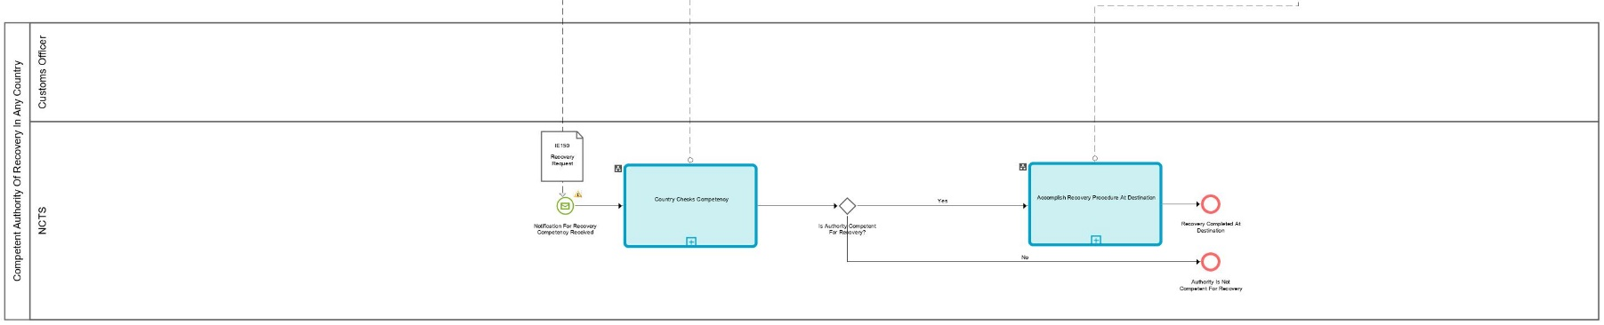
Figure 25: L4-TRA-01-08-Handle Recovery - Recovery Procedure (Option A) - Part B
Major Events
Time Limit -Recovery Recommended- expired
Organisation : National Customs Administration
Location : Competent Authority of Country of Departure
(Timed event)
The master timer 'Recovery recommended' has expired. This time out indicates that recovery procedure must be started.
This time-out period is set when the movement is released for transit and is defined as 7 months after the Expected Arrival Date of the transit movement to the Declared Office of Destination.
A Customs Officer can also start the Recovery procedure manually at any time after the release of the movement in case irregularities are discovered.

Information about non-arrived movement with insufficient information or with information for Recovery received
Organisation : National Customs Administration
Location : Competent Authority of Country of Departure
No IE141 within the given time limit (see process L4-TRA-01-06-02-Check Provided Information) or an IE141 with insufficient information or with information for recovery has been received from the Holder of the Transit Procedure. In that case, Recovery must be started (based on Article 77 (2) UCC DA).

Recovery procedure is to be initiated manually due to suspicion of fraud
Organisation : National Customs Administration
Location : Competent Authority of Country of Departure
The Competent Authority of Country of Departure decides to manually initiate recovery due to the discovery of irregularities.
Processes
Checks if place of irregularity is in country of Departure | Process: L4-TRA-01-08-01
Organisation : National Customs Administration
Location : Competent Authority of Country of Departure
Constraint :
Description :
The Competent Authority at Departure investigates if the place of irregularity is in the Country of Departure to decide if it is competent or not. If it is in its own country it is competent and shall carry out recovery. The movement remains in the 'Recovery recommended' state until Recovery is initiated. For the case of missing or insufficient IE141, the state is set to 'Recovery recommended' in L4-TRA-01-06-02-Check Provided Information.
If the irregularity did not take place at the Country of Departure, the competency shall be transmitted (IE150) to the responsible Country (may also be the country of transit). The movement stays in the ‘Recovery recommended’ state. Provided that the other country accepts the competency for Recovery (IE151.RECOVERY.Recovery acceptance = '1-Yes'), the state shall be changed into 'Under recovery procedure' and the recovery communication (IE063) will be sent by the Competent Authority of Departure to the involved offices of the transit movement.
Final situation: Recovery will be started or recovery request will be sent.

Send Recovery request to the Competent Authority of country of Destination | Process: L4-TRA-01-08-02
Organisation : National Customs Administration
Location : Competent Authority of Country of Departure
Constraint :
Description :
In case the Competent Authority at Departure is not competent, a Recovery request (IE150) is sent to the Competent Authority of another country. The timer 'Wait for Recovery Acceptance Notification' is set.
In cases where there is an IE118, the IE150 will be usually sent to the country where the last Customs Office of Transit (i.e. Office of Entry) is situated. However, it is up to the Competent Authority of Country of Departure to decide where the IE150 needs to be sent.
Final situation :
Recovery request is sent and timer started.

Country checks competency | Process: L4-TRA-01-08-03
Organisation : National Customs Administration
Location : Competent Authority of Recovery in any Country
Constraint :
Description :
The request for Recovery is received (IE150) and recorded. The Competent Authority of the other country decides if it is competent or not. The answer (competent or not) is sent with the message 'Recovery acceptance notification' (IE151).
If the requested Competent Authority is competent, the Competent Authority of Recovery of the Country will start the Recovery Procedure and will reply with positive IE151 [IE151.RECOVERY.Recovery acceptance = "Yes")].
If the requested Competent Authority is not competent, the Competent Authority of Recovery of the Country will reply with negative IE151 [IE151.RECOVERY.Recovery acceptance = "No")].
Final situation :
The answer is sent to the Competent Authority of Recovery at Departure. Eventually, Recovery will be started at the other country, depending on whether the IE151 is positive or negative.

Accomplish recovery procedure at Destination | Process: L4-TRA-01-08-04
Organisation : National Customs Administration
Location : Competent Authority of Country of Destination
Constraint :
Description :
The amount of duties and other taxes to be recovered is calculated.
Upon completion of the Recovery Procedure, with successful Recovery of duties and taxes, the Competent Authority for Recovery at Destination informs the Competent Authority at Departure with a Recovery dispatch notification (IE152) due to the completion of Recovery; the movement will then be written off (L4-TRA-01-08-07-Departure Discharges MRN In The System) and, the relevant Customs Office of Guarantee is notified to release the guarantee (IE204) and the movement to be written-off.
Final situation :
The recovery procedure has been completed and the Competent Authority of the Country of Departure is informed. Hence, the movement can be written-off (L4-TRA-01-08-07-Departure Discharges MRN In The System).

Accomplish Recovery procedure at Departure | Process: L4-TRA-01-08-05
Organisation : National Customs Administration
Location : Competent Authority of Country of Departure
Constraint :
Description :
If the Country of Departure is competent or an IE151 with a negative answer is received from other country, the Competent Authority at Departure starts the Recovery and all involved offices that have received an IE001, IE003 (positive), IE050, IE115 (positive), IE160, IE165 (positive), and in case of an Office of Incident Registration where an IE180 has been received, are notified (IE063). Based on the MRN brought in the recovery communication (IE063.TRANSIT OPERATION.MRN), NCTS records the start of the recovery procedure. The state is set to 'Under recovery procedure'. Upon the start of recovery in case Transit follows Export (i.e. internal transit), and in case no IE042 has been sent previously, AES is notified (IE048) about the recovery as well. That concludes the interconnection between NCTS and AES.
The IE035 is also sent to the Holder of Transit procedure and the IE023 is sent to the Guarantor.
The amount of duties and other taxes to be recovered is calculated.
The recovery procedure seeks to recover the duties and taxes first from the Holder of Transit procedure or from any identified debtor; if this is not possible, from the Guarantor (unless the movement was covered by a cash guarantee) within three years of the date of acceptance of the Transit declaration (Article 117(3) Appendix I, Convention/Art. 85(2) Delegated Act).
Upon completion of the recovery procedure, with successful recovery of duties, taxes and interest on arrears from the Holder of Transit procedure or Guarantor, the Competent Authority for Recovery at Departure writes off the movement (L4-TRA-01-08-07-Departure Discharges MRN In The System), and the relevant Customs Office of Guarantee is notified to release the guarantee (IE204).
Final situation: The Recovery Procedure has been completed and the movement can be written-off (L4-TRA-01-08-07-Departure Discharges MRN In The System). The Holder of Transit procedure and the Guarantor are informed about the Recovery Procedure, the declared Customs Office of Destination no longer waits for a movement with that MRN and every involved Customs Office is informed about the initiation of recovery via IE063.

Send information to involved parties | Process: L4-TRA-01-08-06
Organisation : National Customs Administration
Location : Competent Authority of Country of Departure
Constraint :
Description :
The Competent Authority of Country of Departure accepts to transfer competency for Recovery to the other country and thus sends a positive Recovery acceptance notification (IE151) to the other country. Additionally, the Recovery communication (IE063) is sent to the involved Offices that have previously received an IE001, IE003 (positive), IE050, IE115 (positive), IE160 or IE165 (positive) related to the movement or when an IE180 has been received (i.e. Office of Transit, Office Exit for Transit, Office of Incident Registration and Office of Destination). Moreover, in case of Internal Transit follows Export, NCTS sends the recovery notification (IE048) to AES (provided that no IE042 has been sent previously). That concludes the interconnection between NCTS and AES.
The Holder of Transit procedure will also be informed with the IE035 about the initiation of recovery.
Based on the MRN brought in the recovery communication (IE063.TRANSIT OPERATION.MRN), NCTS records the start of the recovery procedure. The movement is set in the state ‘Under recovery procedure’.
Final situation :
Recovery will be started in another country. All involved offices are informed via IE063 and do no longer wait for a movement with that MRN.

Departure discharges MRN in the system | Process: L4-TRA-01-08-07
Organisation : National Customs Administration
Location : Competent Authority of Country of Departure
Constraint :
Description :
Upon completion of the Recovery Procedure with successful recovery of duties and taxes from the Holder of Transit procedure and/or Guarantor, the Competent Authority for Recovery at Departure writes off the movement, and the relevant Customs Office of Guarantee is notified to release the guarantee (IE204).
- NCTS records the write-off and notifies (IE045) the Holder of Transit procedure that the movement is written-off.
- NCTS also notifies (IE152) all involved offices which have previously received the IE063 (apart from the Competent Authority of the Other Country that has performed recovery and notified with IE152 the Competent Authority of Country of Departure).
Final situation :
The movement is written-off; the release of the guarantee is performed (IE204); the state of the Transit Operation is set to 'Movement written off', the Holder of Transit procedure is informed about the write-off of the transit movement.
Major Results
Movement written off
Organisation : National Customs Administration
Location : Competent Authority of Country of Departure
After successful completion of Recovery, guarantee is released, and the transit movement is written off.

Recovery completed at Destination
Organisation : National Customs Administration
Location : Competent Authority of Country of Destination
The Competent Authority of Country of Destination completed Recovery.

Authority is not competent for Recovery
Organisation : National Customs Administration
Location : Competent Authority of Country of Destination
The Competent Authority of Country of Destination is not considered competent to perform Recovery.

L4-TRA-01-09-Handle Recovery - Recovery Procedure (Option B) – IE143 'Recovery request' or IE150 is received from Competent Authority at Destnation
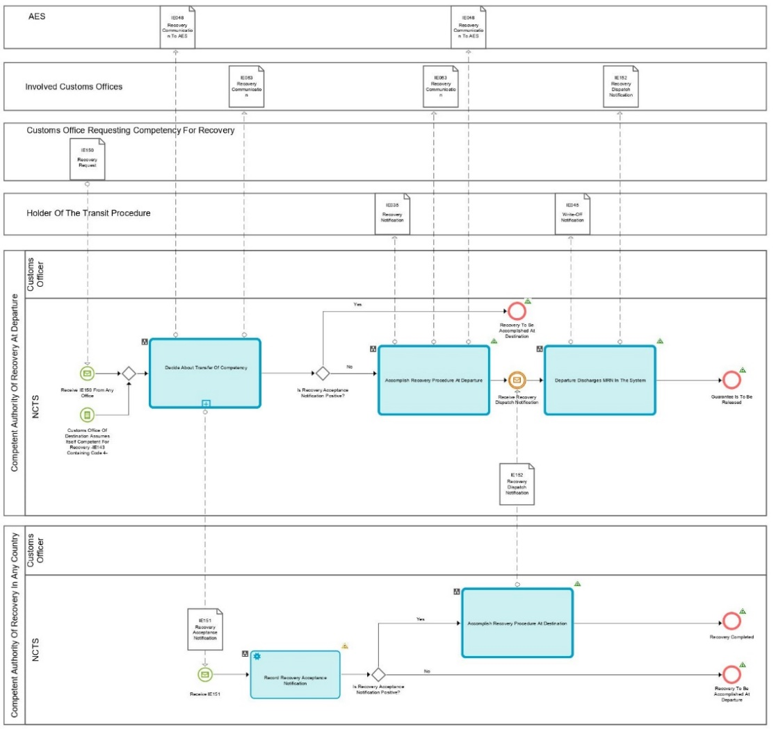
Figure 26: L4-TRA-01-09-Handle Recovery - Recovery Procedure (Option B)

Major Events
Customs Office Of Destination assumes itself competent for Recovery -Enquiry response containing code 4-
Organisation : National Customs Administration
Location : Competent Authority of Country of Departure
An IE143 containing code 4 (request for Recovery at Destination) from the Actual Customs Office Of Destination has been received.
The IE143 with request code ‘4’ is received by the Competent Authority of Enquiry at Departure because, based on the information available, the Competent Authority of Country of Destination assumes itself as competent for recovery.

Receive Recovery request (IE150) from any Office
Organisation : National Customs Administration
Location : Competent Authority of Country of Departure
A recovery request (IE150) message has been received from any other country which assumes itself as competent for recovery. This may occur at any time after the movement is released for transit.
An IE150 from any other office has been received.

Processes

Decide about transfer of competency | Process: L4-TRA-01-09-01
Organisation : National Customs Administration
Location : Competent Authority of Country Departure
Constraint :
Description :
An IE143 with the request for recovery (containing code 4) or an IE150 has been sent by the Competent Authority of the Other Country. Based on that, the Competent Authority of Country of Departure decides whether the competency shall be transferred or not.
If the Competent Authority of Country of Departure has decided not to transfer the competency, the IE151 with a negative answer is sent to the Requesting Office (IE151.RECOVERY.Recovery acceptance = 'No') and the process continues as described in L4-TRA-01-08-05-Accomplish Recovery Procedure at Departure.
In case the Requesting Office has additional information the IE144/145 can be used.
If the Competent Authority of Country of Departure has decided to transfer the competency, the IE151 with a positive answer is sent to the requesting office (IE151.RECOVERY.Recovery acceptance = 'Yes'). The process continues as described in L4-TRA-01-08-04-Accomplish Recovery Procedure at Destination. The Recovery communication (IE063) is sent to all the involved parties that have previously received any of IE001, IE003 (positive), IE050, IE115 (positive), IE160, IE165 (positive) and to the Office of Incident Registration that has notified for Incident Registration (IE180) the Office of Departure. Moreover, the Holder of the Transit Procedure is notified for the initiation of the Recovery (IE035). Lastly, in case internal transit follows Export and no IE042 message has already been sent, the IE048 message is sent to AES.
Final situation: Decision about transferring competency has been taken, Recovery Procedure at Departure or at Destination will start and all involved parties are notified.

Accomplish recovery procedure at Destination | Process: L4-TRA-01-08-04
Organisation : National Customs Administration
Location : Competent Authority of Country of Destination
Constraint :
Description :
The amount of duties and other taxes to be recovered is calculated.
Upon completion of the Recovery Procedure, with successful Recovery of duties and taxes, the Competent Authority for Recovery at Destination informs the Competent Authority at Departure with a Recovery dispatch notification (IE152) for the completion of Recovery; the movement will then be written off (L4-TRA-01-08-07-Departure Discharges MRN In The System) and, the relevant Customs Office of Guarantee is notified to release the guarantee (IE204) and the movement to be written off.
Final situation :
The recovery procedure has been completed and the Competent Authority of Country of Departure is informed. Hence, the movement can be written-off (L4-TRA-01-08-07-Departure Discharges MRN In The System).

Accomplish Recovery procedure at Departure | Process: L4-TRA-01-08-05
Organisation : National Customs Administration
Location : Competent Authority of Country of Departure
Constraint :
Description :
If the Country of Departure is competent or an IE151 with a negative answer is received from other country, the Competent Authority at Departure starts the Recovery and all involved offices that have received an IE001, IE003 (positive), IE050, IE115 (positive), IE160, IE165 (positive), and in case of an Office of Incident Registration where an IE180 has been received, are notified (IE063). Based on the MRN brought in the recovery communication (IE063.TRANSIT OPERATION.MRN), NCTS records the start of the recovery procedure. The state is set to 'Under recovery procedure'. Upon the start of recovery in case Transit follows Export (i.e. internal transit), and in case no IE042 has been sent previously, AES is notified (IE048) about the recovery as well. That concludes the interconnection between NCTS and AES.
The IE035 is also sent to the Holder of Transit procedure and the IE023 is sent to the Guarantor.
The amount of duties and other taxes to be recovered is calculated.
The recovery procedure seeks to recover the duties and taxes first from the Holder of Transit procedure or from any identified debtor; if this is not possible, from the Guarantor (unless the movement was covered by a cash guarantee) within three years of the date of acceptance of the Transit declaration (Article 117(3) Appendix I, Convention/Art. 85(2) Delegated Act).
Upon completion of the recovery procedure, with successful recovery of duties, taxes and interest on arrears from the Holder of Transit procedure or Guarantor, the Competent Authority for Recovery at Departure writes off the movement (L4-TRA-01-08-07-Departure Discharges MRN In The System), and the relevant Customs Office of Guarantee is notified to release the guarantee (IE204).
Final situation: The Recovery Procedure has been completed and the movement can be written-off (L4-TRA-01-08-07-Departure Discharges MRN In The System). The Holder of Transit procedure and the Guarantor are informed about the Recovery Procedure, the declared Customs Office of Destination no longer waits for a movement with that MRN and every involved Customs Office is informed about the initiation of recovery via IE063.

Departure discharges MRN in the system | Process: L4-TRA-01-08-07
Organisation : National Customs Administration
Location : Competent Authority of Country of Departure
Constraint :
Description :
Upon completion of the Recovery Procedure with successful recovery of duties and taxes from the Holder of Transit procedure and/or Guarantor, the Competent Authority for Recovery at Departure writes off the movement, and the relevant Customs Office of Guarantee is notified to release the guarantee (IE204).
- NCTS records the write-off and notifies (IE045) the Holder of Transit procedure that the movement is written-off.
- NCTS also notifies (IE152) all involved offices which have previously received the IE063 (apart from the Competent Authority of the Other Country that has performed recovery and notified with IE152 the Competent Authority of Country of Departure).
Final situation :
The movement is written-off; the release of the guarantee is performed (IE204); the state of the Transit Operation is set to 'Movement written off', the Holder of Transit procedure is informed about the write-off of the transit movement.
Major Results
Guarantee is to be released
Organisation : National Customs Administration
Location : Competent Authority of Country of Departure
After successful completion of Recovery, guarantee is released.

Recovery to be accomplished at Destination
Organisation : National Customs Administration
Location : Competent Authority of Country of Departure
The Competent Authority of Country of Destination starts Recovery.

Recovery completed
Organisation : National Customs Administration
Location : Competent Authority of Country of Other Country
The Competent Authority of Country of Destination completed Recovery.

Recovery to be accomplished at Departure
Organisation : National Customs Administration
Location : Competent Authority of Country of Other Country
The Competent Authority of Country of Departure starts Recovery.

L4-TRA-01-11-Process Query Movement Information
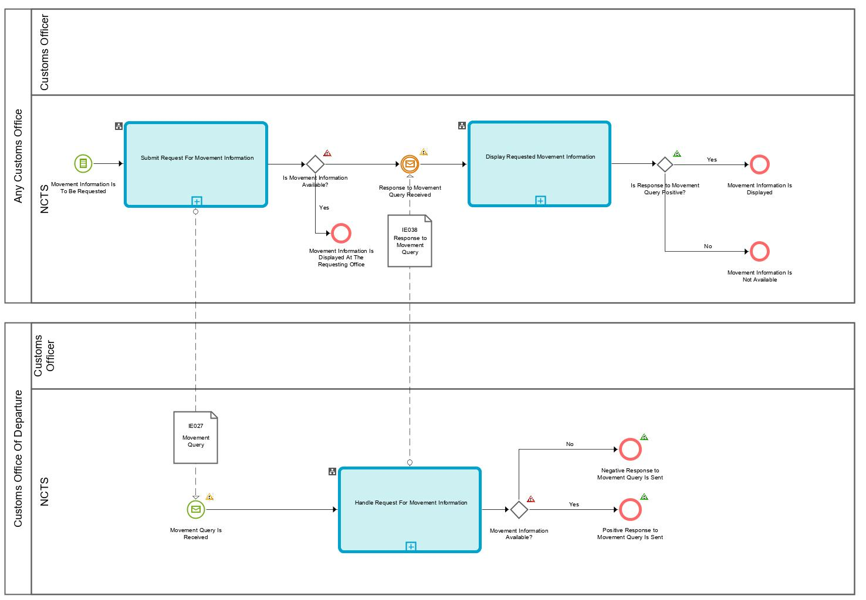
Figure 27: L4-TRA-01-11-Process Query Movement Information
Major Events
Movement information is to be requested
Organisation : National Customs Administration
Location : Customs Office of Departure, Customs Office of Destination, Customs Office of Guarantee, Customs Office of Transit, Customs Office of Exit for Transit, Customs Office of Incident Registration
A Customs Officer with an appropriate level of Authorisation and access to NCTS at any Customs Office, requests the movement information for a movement with a given MRN.
N.B. This includes the case of an incident registration if access to the NCTS is available.
Processes
Submit request for movement information | Process: L4-TRA-01-11-01
Organisation : National Customs Administration
Location : Customs Office of Departure, Customs Office of Destination, Customs Office of Guarantee, Customs Office of Transit, Customs Office of Exit for Transit, Customs Office of Incident Registration
Constraint :
The movement information may be located in a different country (that of the Customs Office of Departure).
A Customs Officer submits a request for movement information based on a given MRN.
NCTS looks for the movement:
- when the movement information is available at the Office where the request is submitted, NCTS retrieves and displays it to the Customs Officer immediately.
- when the movement information is not available at the Office where the request is submitted, NCTS notifies the Customs Officer that the information is not available and automatically sends (IE027) a request to the Country of Departure.
The requesting Customs Offices receives (IE038) the response to the request. NCTS displays the received information or the received error message.
Final situation :
The movement information is returned or a request for movement information is submitted to the Customs Office of Departure.

Handle request for movement information | Process: L4-TRA-01-11-02
Organisation : National Customs Administration
Location : Customs Office of Departure
Constraint :
If the provided request (IE027) relates to a transit movement which is used for safety and security (IE001.TRANSIT OPERATION. Security = ‘1’ (ENS), ‘2’ (EXS) and ‘3’ (ENS and EXS), then the response (IE038) shall contain the relevant additional safety and security data elements.
Safety and security risk analysis results shall be exchanged only between National Administrations that belong to Safety and Security Area.
The Country of Departure receives (IE027) a request for movement information from a Customs Office. NCTS looks for the movement based on the MRN (i.e. identified by IE027.TRANSIT OPERATION.MRN) and provides positive (IE038) to the requesting Customs Office with the movement information or, negative (IE038) if the movement doesn’t exist at the Customs Office of Departure (i.e. IE038.TRANSIT OPERATION.Request rejection reason code is present).
Safety and security related risk analysis results shall be included in IE038 if all of the following conditions are fulfilled:
- The Customs Office of Departure and the Office performing the movement query are both located in the Safety and Security Area.
Final situation :
If available, a positive response with the movement information is conveyed to the requester, otherwise a negative response is conveyed.

Display requested movement information | Process: L4-TRA-01-11-03
Organisation : National Customs Administration
Location : Customs Office of Departure, Customs Office of Destination, Customs Office of Guarantee, Customs Office of Transit, Customs Office of Exit for Transit, Customs Office of Incident Registration
Constraint :
If the provided response (IE038) relates to a transit movement which is used for safety and security (IE001. TRANSIT OPERATION. Security = ‘1’ (ENS), ‘2’ (EXS) and ‘3’ (ENS and EXS), then the response (IE038) contains the relevant additional safety and security data elements.
The requesting Customs Offices receives (IE038) the response to the request. If the response (IE038) is positive, NCTS displays the received information or a notification of the unknown movement in case of negative response (IE038).
Final situation :
The outcome of the requested movement information is displayed.

Major Results
Movement information is displayed
Organisation : National Customs Administration
Location : Customs Office of Departure, Customs Office of Destination, Customs Office of Guarantee, Customs Office of Transit, Customs Office of Exit for Transit, Customs Office of Incident Registration
The movement information is displayed in case a positive response (IE038) has been received.

Movement information is not available
Organisation : National Customs Administration
Location : Customs Office of Departure, Customs Office of Destination, Customs Office of Guarantee, Customs Office of Transit, Customs Office of Exit for Transit, Customs Office of Incident Registration
A notification of the unknown movement information is displayed in case a negative response (IE038) has been received.

L4-TRA-01-12-Process Incidents En Route
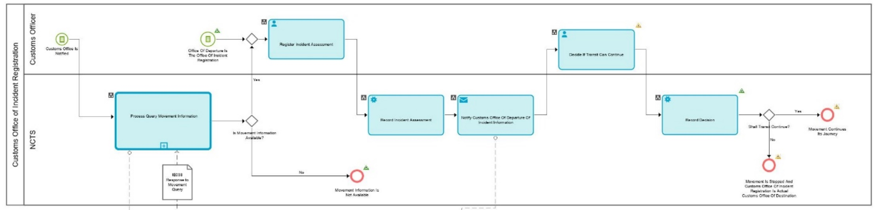
Figure 28: L4-TRA-01-12-Process Incidents En Route - Part A
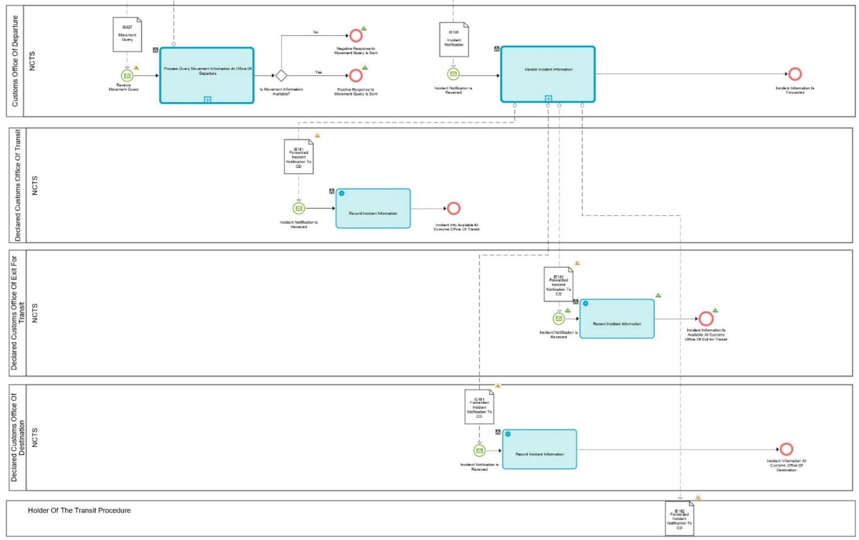
Figure 29: L4-TRA-01-12-Process Incidents En Route - Part B

Major Event
Customs Officer is notified of incident
Organisation : National Customs Administration
Location : Customs Office of Incident Registration
Customs Office of Incident Registration is notified that an incident occurred during a transit movement.
Processes
Process Query Movement Information | Process: L4-TRA-01-11
Organisation : National Customs Administration
Location : Customs Office of Incident Registration
Constraint :
- Nearest Customs Office to the place of the incident occurred is notified of the incident.
- In justified cases, Customs Officer may decide to perform a control of the goods (part of decision by Customs to continue or end the movement).
Description :
The process is triggered when an En-route incident occurs to a Transit movement. Such an incident can be:
(a) the carrier is obliged to deviate from the itinerary prescribed in accordance with Article 298 of UCC/IA Regulation due to circumstances beyond his control;
(b) seals are broken or tampered with in the course of a transport operation for reasons beyond the carrier's control;
(c) under the supervision of the customs authority, goods are transferred from one means of transport to another means of transport;
(d) imminent danger necessitates immediate partial or total unloading of the sealed means of transport;
(e) there is an incident which may affect the ability of the holder of the procedure or the carrier to comply with his obligations;
(f) any of the elements constituting a single means of transport as referred to in Article 296(2) UCC/IA is changed.
The carrier presents without undue delay after the incident the goods together with the NCTS Accompanying Document or MRN of Transit Declaration in an electronically readable format, to the nearest customs authority (Customs Office of Incident Registration) of the National Administration in whose territory the means of transport is located.
In case the Customs Office of Incident Registration was not included in the declared Transit movement and Movement Information is not available, then it requests the consignment information from the Customs Office of Departure based on the MRN provided (see Process L4-TRA-01-11-Process Query Movement Information).
If the Movement information is available, then the Customs Office of Incident Registration proceeds to register the incident and notify the Customs Office of Departure (IE180) and then decide whether the transit movement can continue its journey or not. If the Customs Officer decides that the transit movement cannot continue then the Customs Office of Incident Registration becomes the actual Customs Office of Destination and starts performing the relevant transit formalities (see Process L4-TRA-01-03-Process Arrival).
If the Customs Office of Incident Registration decides that the transit movement can continue, then the transit movement continues its journey.
If an incident occurs at an involved with the transit movement Customs Office of Transit or at Customs Office of Exit for Transit or at Customs Office of Destination, then this particular office acts first as a Customs Office of Incident Registration. and then as a Customs Office of Transit or as a Customs Office of Exit for Transit or as a Customs Office of Destination accordingly.
Final situation :
- The movement continues its journey after the incident registration.
- When the Transit cannot continue the Customs Office where the Incident was registered performs the Actual Customs Office of Destination formalities.
- The Incident information is registered to the system.

Handle Incident Information | Process: L4-TRA-01-12-01
Organisation : National Customs Administration
Location : Customs Office of Departure
Constraint :
Description :
The Customs Office of Departure is notified (IE180) by the Customs Office of Incident Registration of the incident.
When Incident Information is recorded, Customs Office of Departure forwards to the involved Offices the incident(s) notification (IE181) based on the following conditions:
- In case a Customs Office of Transit is involved and identifies that no (IE118) Notification Crossing Frontier -information was received earlier for that particular movement and no IE024 was sent, Customs Office of Departure notifies the particular Customs Office of Transit of the incident information (IE181).
- In case a Customs Office of Exit for Transit is involved and identifies that no (IE168) Notification Leaving Security Area -information was received earlier for that particular movement and no IE024 was sent, Customs Office of Departure notifies the particular Customs Office of Exit for Transit of the incident information (IE181).
- In case no Arrival Advice (IE006) and/or no Destination Control Results (IE018) for that particular movement and no IE024 was sent, Customs Office of Departure notifies the particular Declared/Actual Customs Office of Destination of the incident information (IE181).
Customs Office of Departure also notifies the Holder of the Transit Procedure (IE182) in case the transit declaration data was received electronically.

Final situation :
Incident information is communicated to the involved Customs Offices and to the Holder of the Transit Procedure.

Major Results
Movement is stopped and Customs Office of Incident Registration is Actual Office of Destination
Organisation : National Customs Administration
Location : Office Incident Registration
Since the transit movement is stopped, the Customs Office Of Incident Registration performs the Actual Customs Office of Destination formalities.

Movement continues its journey
Organisation : National Customs Administration
Location : Office Incident Registration
The Customs Office Of Incident Registration decides the transit movement to continue its journey.

Holder of Transit procedure notified of incident
Organisation : Trader
Location : Customs Office Of Incident Registration
The Holder of the Transit procedure is notified by the Customs Office of Departure that an incident occurred to the transit movement, with the relevant incident details and impact.

Customs Office of Transit notified of incident
Organisation : National Customs Administration
Location : Customs Office of Transit
The Customs Office of Transit notified by the Customs Office of Departure that an incident occurred to a transit movement.

Customs Office of Exit for Transit notified of incident
Organisation : National Customs Administration
Location : Customs Office of Exit for Transit
The Customs Office of Exit for Transit notified by the Customs Office of Departure that an incident occurred to a transit movement.

Customs Office of Destination notified of incident
Organisation : National Customs Administration
Location : Customs Office of Destination
The Customs Office of Destination notified by the Customs Office of Departure that an incident occurred to a transit movement.

Minor Result

Movement MRN is unknown
Organisation : National Customs Administration
Location : Customs Office of Incident Registration
The movement query returned to the Customs Office of Incident Registration that the movement is unknown.

L4-TRA-01-13- Process Formalities Prior To Exit Of Goods At Customs Office Of Exit For Transit
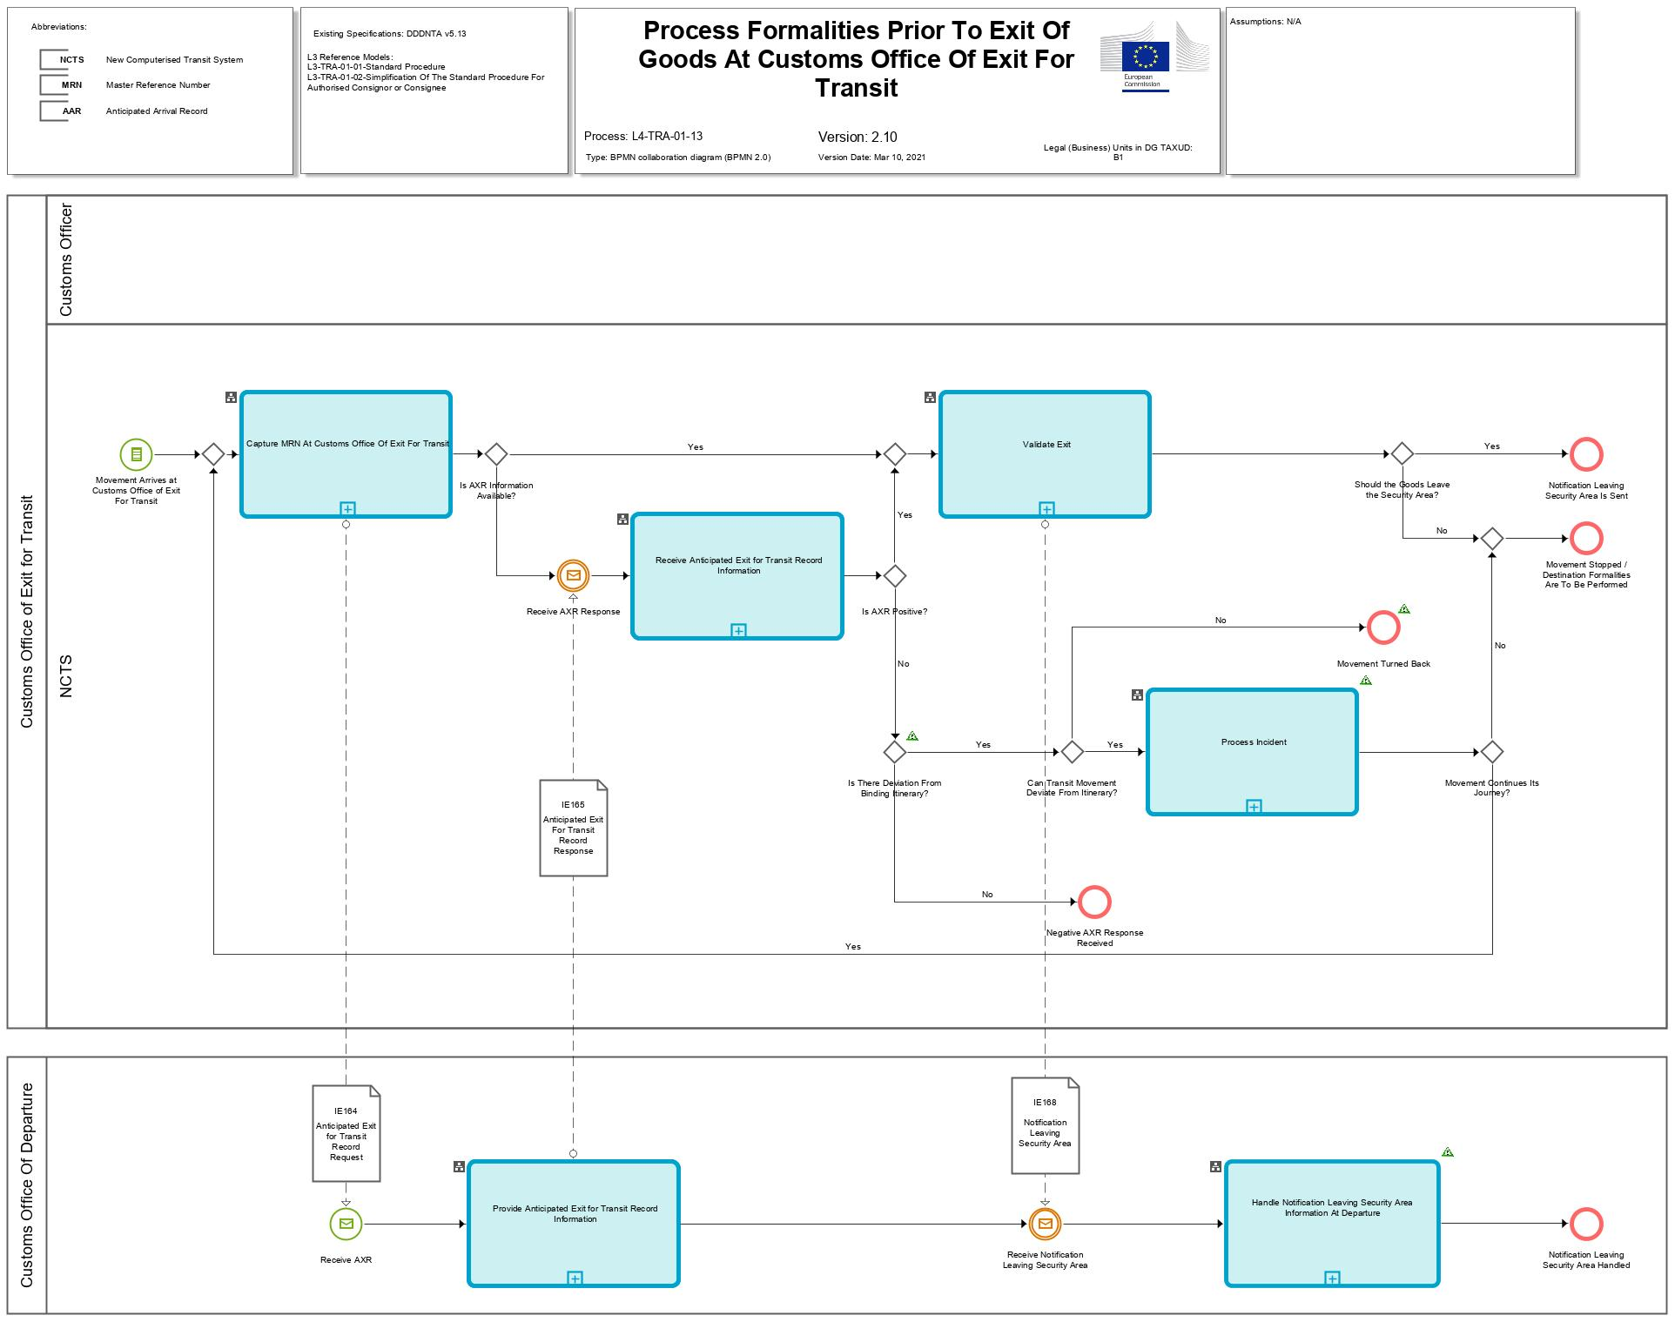
Figure 30: L4-TRA-01-13-Process Formalities Prior To Exit Of Goods At Customs Office Of Exit For Transit - Part A

Figure 31: L4-TRA-01-13-Process Formalities Prior To Exit Of Goods At Customs Office Of Exit For Transit (Part B)
Major Event
Movement arrives at Customs Office of Exit for Transit
Organisation : National Customs Administration
Location : Actual Customs Office of Exit For Transit
The vehicle with the Transit consignment arrives at the Office of Exit Transit. The consignment and the MRN of Transit Declaration in an electronically readable format (e.g. as Barcode) are presented to the Office of Exit for Transit.
Minor Event
Receive AXR
Organisation : National Customs Administration
Location : Customs Office of Departure
The Anticipated Exit for Transit Record information is requested from the Customs Office of Departure.

Receive AXR Response
Organisation : National Customs Administration
Location : Actual Customs Office of Exit For Transit
The Anticipated Exit for Transit Record information is received by the Customs Office of Exit for Transit.
Processes
Capture MRN at Customs Office of Exit for Transit | Process: L4-TRA-01-13-01
Organisation : National Customs Administration
Location : Customs Office of Exit for Transit
Constraint :
This process must be done as soon as possible in order not to slow down the traffic flow.
Description :
The Carrier notifies the Customs Office of Exit for Transit about the arrival of the consignment. Then, the Officer captures (or scans) the MRN of Transit declaration into NCTS.
NCTS looks for the Anticipated Exit for Transit Record (AXR) information:
- when the movement information is not available in case of international diversion, NCTS asks (IE164) that information from the Office of Departure and warns the Customs Officer;
- when the AXR information is available then the passage can be validated by the Customs Officer.
Final situation :
- If the AXR-information is available, the exit of the transit from Safety and Security Area can be validated.
- If there is an international diversion, the Customs Office of Transit waits for the information from the Customs Office of Departure; the state of the Transit Operation is set to ‘AXR Requested’.

Receive Anticipated Exit for Transit Record Information | Process: L4-TRA-01-13-03
Organisation : National Customs Administration
Location : Customs Office of Exit for Transit
Constraint :
We have the following conditions:
- NCTS is also used for the purpose of safety and security;
- The (actual) Customs Office of Exit for Transit is located inside the Safety and Security Area.
Description :
The Customs Office of Exit for Transit receives (IE165) the Anticipated Exit for Transit Record Information from the Customs Office of Departure. NCTS records automatically the Anticipated Transit Record Information about the movement identified by IE165.TRANSIT OPERATION.MRN. If the provided Anticipated Exit for Transit Record response (IE165) contains the requested Anticipated Exit for Transit Record (IE165.TRANSIT OPERATION.Request rejection reason is not present), then the Anticipated Exit for Transit Record response contains the relevant safety and security data elements. But, if the provided Anticipated Exit for Transit Record response (IE165) does not contain the requested Anticipated Transit Record information (IE165.TRANSIT OPERATION.Request rejection reason is present), the received (IE165) Anticipated Exit for Transit Record information is rejected.
Additionally, risk analysis results are communicated by the Customs Office of Departure (IE165). The results shall be recorded and shall be considered when carrying out own risk analysis:
- Full safety and security related risk analysis for all the goods shall be initiated by NCTS and performed by the national risk application according to the rules set out by the risk management framework. The national risk analysis system generates the risk analysis code. If the identified risk relates to a specific goods item of the transit declaration, the relevant goods item number shall be identified by the national risk analysis system.
- The national risk analysis system communicates the risk analysis result to NCTS and NCTS records it in the transit declaration. If the risk analysis result relates to a specific goods item, then the relevant goods item is recorded (RISK ANALYSIS IDENTIFICATION.RISK ANALYSIS.Declaration goods item number). In any other case the ’ RISK ANALYSIS IDENTIFICATION.RISK ANALYSIS.Declaration goods item number’ remains unused.
- The calculation of the risk analysis identification code (IE001. RISK ANALYSIS IDENTIFICATION.Code) is not transparent to NCTS but used by NCTS to identify the nature of risk and any appropriate actions.
  - The value is 'R': Risk identified, to be handled at the next Customs Office (other than Office of Departure);
  - The value is 'Y': Combined risk identified (national & common);
  - The value is 'X': National risk identified
  - The value is 'Z': No risk analysis performed at the Office of Departure.
- Random risk parameters shall be used additionally.
The system notifies the Customs Officer that the information to validate the exit of transit movement from the Safety and Security Area is available. If risk is identified, the Customs Officer is alerted and is asked to register a control decision.
Final situation :
The Anticipated Exit for Transit Record Information is available to support any control which may be appropriate; the state of the Transit Operation is set to ‘AXR Created’ or, the Anticipated Exit for Transit Record Information is not available; the state of the Transit Operation is set to ‘AXR Rejected’.

Process incident | Process: L4-TRA-01-12
Organisation : National Customs Administration
Location : Customs Office of Exit for Transit
Constraint :
The transit movement contains binding itinerary.
There are cases where a diversion might be requested so as the transit movement to leave the Safety and Security Area from a Customs Office of Exit Transit that is not included in the list of countries based on binding itinerary as declared originally in the transit declaration by the Holder of the Transit Procedure and agreed with the Office of Departure.
Upon arrival of the transit movement to such a country (not included in the list of countries of the binding itinerary), and given the fact that the MRN is unknown, the Anticipated Exit for Transit Record is sent (IE164) to the Office of Departure, which checks that for the specific MRN, there is a binding itinerary and the diversion request comes from a country that is not included in the list of countries under the binding itinerary of the transit movement. Therefore, the Office of Departure replies with a negative IE165 that does not contain the details of the Anticipated Transit Record (i.e. IE165. TRANSIT OPERATION.Request rejection reason code = '3' is present). Based on the above result of the diversion request, the Actual Office of Exit for Transit decides whether to allow or not the transit movement to divert to this Office despite the binding itinerary.
Therefore, an incident registration occurs to justify the deviation from the binding itinerary to the Office of Departure. For this purpose, an Incident Notification message is sent to the Office of Departure (IE180) that contains at least one instance of the appropriate Incident Code (i.e. IE180. CONSIGNMENT.INCIDENT.Code = '1'). Finally, the Actual Office of Exit for Transit decides to allow the transit movement to cross the frontiers of this Customs Office of Exit for Transit.
Upon completion of the incident registration, the Actual Office of Exit for Transit requests again the Anticipated Exit for Transit Record (IE164) and receives a positive IE165 (i.e. TRANSIT OPERATION.Request rejection reason code is absent). Next, the ‘Validate Exit from Safety and Security Area’ takes place at this Customs Office of Exit for Transit.
Final situation:
- The movement stops / turns back since the deviation from the Binding Itinerary is not accepted, or
- The movement continues its journey and passage is validated.

Validate Exit | Process: L4-TRA-01-13-04
Organisation : National Customs Administration
Location : Customs Office of Transit
Constraint : We have the following conditions:
- NCTS is also used for the purpose of safety and security;
- The Customs Office of Transit is located inside the Safety and Security Area.
Description :
On request of a Customs Officer, NCTS retrieves the movement information identified by the MRN and provided the Anticipated Exit for Transit Record Information is available, safety and security checks are performed:
- NCTS warns the Customs Officer about the risk analysis performed upon reception of the Anticipated Exit for Transit Record information response (IE160/IE165 .RISK ANALYSIS IDENTIFICATION.Code).
- If risk analysis had proposed to take measures at the Customs Office of Exit for Transit but the Customs Officer decides not to control, then NCTS requires the Customs Officer to confirm the decision not to control.
The Customs Officer takes the appropriate action and NCTS:
- records the action and notifies the Goods Carrier if the consignment has to be controlled prior to the registration of leaving the Safety and Security Area or if the consignment has to be stopped.
- records the action and notifies the Goods Carrier if the consignment has to stop its journey meaning that this Actual Office of Exit for Transit will become the Actual Office of Destination.
Final situation :
The Anticipated Exit for Transit Record has been validated and the Transit movement either may leave the Safety and Security Area, this information is recorded into NCTS, the state of the Transit Operation is set to ‘Movement left Security Area’, or movement stops at this Actual Office of Exit for Transit, the state of the Transit Operation is set to ‘Movement stopped’ and this Office of Exit for Transit becomes Actual Office of Destination.

Provide Anticipated Exit for Transit Record Information | Process: L4-TRA-01-13-02
Organisation : National Customs Administration
Location : Customs Office of Departure
Constraint: This process must be done as soon as possible in order not to slow down the traffic flow.
Safety and security risk analysis results shall be exchanged.
Description :
This process is automatically performed by the system without a human intervention.
The Office of Departure is asked (IE164) by the Customs Office of Exit for Transit to provide the Anticipated Exit for Transit Record (AXR) about a movement (IE165).
NCTS looks for the movement information identified by IE164.TRANSIT OPERATION.MRN and automatically sends (IE165) back the required Anticipated Exit for Transit Record (AXR) about the movement or the reason of their rejection without the Anticipated Exit for Transit Record (AXR). The response (IE165) shall contain the relevant additional safety and security data elements.
If En-route information is available, related to the transit movement then the response (IE165) shall contain the relevant additional Incident data elements.
Final situation :
The response about the Anticipated Transit Record (AXR) is sent to the Customs Office of Transit.

Handle notification leaving Security Area information at Departure | Process: L4-TRA-01-13-05
Organisation : National Customs Administration
Location : Customs Office of Departure
Constraint :
Description :
This process is performed automatically.
The Customs Office of Departure receives (IE168) the Notification Leaving Security Area information for the movement identified by IE168.TRANSIT OPERATION.MRN from a Customs Office of Exit for Transit; NCTS records this Notification Leaving Security Area information.
Final situation :
The Notification Leaving Security Area information has been handled at the Customs Office of Departure.
Major Results
Notification leaving security area is sent
Organisation : National Customs Administration
Location : Customs Office of Exit for Transit
The notification leaving security area is sent to the Office of Departure.

Movement Stopped / Destination Formalities are to be performed
Organisation : National Customs Administration
Location : Customs Office of Exit for Transit
The Transit movement has been stopped at the frontier and may be considered as arrived at destination. In that case, the Customs Office of Exit for Transit must be considered as an actual Customs Office of Destination, so the event “Arrival At Actual Office Of Destination” is activated for the process “L4-TRA-01-03-Process Arrival”.

Minor Results

Negative AXR response received
Organisation : National Customs Administration
Location : Customs Office of Exit for Transit
The Office of Exit for Transit has received a negative Anticipated Exit for Transit Record response (IE165), and the state at the Office of Transit is set to “AXR Rejected”. This means that the Office of Departure has not allowed the consignment to divert to this particular Office of Exit for Transit.
In case that the negative Anticipated Exit for Transit Record response (IE165) is not related to a deviation from the Binding Itinerary, the Office of Exit for Transit cannot proceed with any other actions.
However, if the negative Anticipated Exit for Transit Record response (IE165) is related to a deviation from the Binding Itinerary, the Customs Office of Exit for Transit decides whether to allow or not the transit movement to deviate from its Binding Itinerary. If the decision is positive (i.e. movement does not need to turn back), then the Customs Office of Exit for Transit proceeds with the registration of an incident.

Movement turned back
Organisation : National Customs Administration
Location : Customs Office of Exit for Transit
The Office of Exit for Transit has decided the transit movement to turn back.

Notification leaving security area handled
Organisation : National Customs Administration
Location : Customs Office of Departure
The receipt of the Notification Leaving Security Area information through the Customs Office of Exit for Transit has been handled at departure.

Assist users in their daily work
Beside the processes described in the previous parts of this section, the NCTS must provide systems to help users in their daily work by providing the services described below. Those services are presented for information to guide development at National level and so, they are only indicative.
A major concern for users, either Customs Officer or Trader, is to know the states of the Transit movements (i.e. which processes they passed through) in order to organise the work in the Customs (or Traders) Offices and to track a specific movement.
The identification of the main states of a Transit operation is presented ARIS State Transition Diagrams’. The diagram is used to serve both the identification of the ‘history’ and the ‘follow-up’ of the movement.

Services

Customs’ movements state system

The Customs Officer at departure
The Customs Officer needs a system to manage the accepted declarations, from the acceptance to the release for Transit.
He needs a system in order to be able to:
- List the declarations in a tabular view with the following columns:
- LRN (required because it is possible to load declaration from magnetic or optic media; so, those declarations are treated in batch mode and the Trader doesn’t know immediately the MRN);
- MRN;
- declaration type;
- state (as defined in the state transition diagram);
- date: the date related to the state change: e.g. acceptance date if the movement is not yet released for Transit;
- TIN (Trader Identification Number);
- Security (Y/N);
- binding itinerary (Y/N);
- risk analysis result (an integer value between 0 and 100);
- delay of the Authorisation (only present for simplified procedures);
- reminder delay to control.
- This list can be filtered using the following criteria:
- MRN in a given range;
- type of declaration set to a given value;
- state set to a given value;
- date (related to the current state) between two given dates: this filter can only be used in conjunction with the ‘state’ filter;
- a given Customs Office of Departure;
- a given Customs Office of Destination;
- a given TIN (Holder of Transit procedure);
- a given TIN (Authorised Consignee);
- Simplified/Normal procedure: Yes or No or All;
- Security (Y/N);
- Binding Itinerary (Y/N);
- risk analysis result greater or equal to a given value;
- Proposed for control: Yes or No or All.
- Remark: those criteria are cumulative, and the current selection may be printed.
- After selection of a declaration:
- access the declaration details view in update mode (corrections), with possibility to:
- print declaration description information;
- access full NCTS information on item referenced in the declaration (navigation mode): countries, commodity codes, Customs Offices, and other reference lists.
- update the state of the declaration (decide to control, decide to release, …);
- register decision to control;
- register departure control results;
- enter/modify the amount calculated/proposed for duties & taxes;
- modify the default value for the allowed travel time;
- modify the calculated value for the date when the control results are expected;
- perform a risk analysis;
- overrule a risk analysis result;
- describe a binding itinerary;
- access the ‘forecast events system’ (agenda);
- access the declaration state history;
- access the declaration data history;
- access the guarantee information (GU11 - ‘Check Guarantee Integrity’);
- access movement related parameters (enquiry timer, …).

The DTI Trader at destination
The DTI Trader needs a system to capture and to manage his movement data.
He needs a system in order to be able to:
- List the movement data in a tabular view with the following columns:
- MRN;
- declaration type;
- date: the date related to the state change: e.g.
- expected arrival date;
- arrival date;
- release from Transit date.
- state (see state transition diagram);
- TIN (Trader Identification Number).
- This list can be filtered using the following criteria:
- MRN in a given range;
- type of declaration set to a given value;
- date (related to the current state) between two given dates;
- state set to a given value;
- a given Customs Office of Departure;
- a given TIN;
- simplified/normal procedure: Yes or No or All.
- Remark: those criteria are cumulative, and the current selection may be printed.
- After selection of a movement data:
- access the movement data view in read only mode, with possibility to:
- print the description information;
- access full NCTS information on item referenced in the declaration (navigation mode): countries, commodity codes, Customs Offices, and other reference lists.
- capture and submit arrival data (incident & transhipment);
- capture and submit unloading remarks and completion;
- access the movement state history.

The Customs Officer at destination
The Customs Officer needs a system to manage movement data, from the AAR arrival to the release from Transit.
He needs a system in order to be able to:
- List the movement data in a tabular view with the following columns:
- MRN;
- declaration type;
- state (as defined in the state transition diagram);
- date : the date related to the state change: e.g.
- expected arrival date if the movement is not yet arrived at destination;
- arrival date if the movement is arrived at destination.
- TIN (Trader Identification Number of the Holder of the Transit Procedure’s representative at Destination);
- TIN (Trader Identification Number of the Authorised Consignee, in case of simplified procedure);
- Security (Y/N);
- risk analysis result (an integer value between 0 and 100);
- delay of the Authorisation (only present for simplified procedures);
- reminder delay to control.
- This list can be filtered using the following criteria:
- MRN in a given range;
- type of declaration set to a given value;
- state set to a given value;
- date (related to the current state) between two given dates: this filter can only be used in conjunction with the ‘state’ filter;
- a given Customs Office of Departure;
- a given Customs Office of Destination;
- a given TIN (Trader Identification Number of the Holder of Transit procedure representative at Destination);
- a given TIN (Trader Identification Number of the Authorised Consignee, in case of simplified procedure);
- simplified/normal procedure: Yes or No or All;
- Security (Y/N);
- risk analysis result greater or equal to a given value;
- Proposed for control: Yes or No or All.
- Remark: those criteria are cumulative, and the current selection may be printed.
- After selection of a movement data:
- access the movement data view in read only mode, with possibility to:
- print the description information;
- access full NCTS information on item referenced in the declaration (navigation mode): countries, commodity codes, Customs Offices, and other reference lists.
- capture and submit arrival data (incident & transhipment);
- capture and submit unloading remarks and completion;
- update the state of the movement (decide to control, decide to release, …);
- register decision to control;
- register destination control results;
- perform a risk analysis ;
- overrule a risk analysis result;
- access the ‘forecast events system’ (agenda);
- access the movement data state history;
- access the movement data history.

Forecast events system
The Customs Officer needs a system in order to be able to:
- list forecast events about all movements (see preceding paragraph) in a tabular view with the following columns: expected date, MRN, type of event, associated free text and state of the event. Additional features include:
- this list can be filtered using the following criteria: expected date between two given dates, one type of event, state set to a given value; those criteria are cumulative;
- the current selection can be printed.
- after the selection of an event which is always related to a movement:
- access the same functionality as in the customs’ movements' state system, after the selection of a movement.

Customs’ declarations state system
The Customs Officer needs a system to capture and to manage declaration of those Traders who are not electronically (neither EDI nor DTI) connected to the system.
He needs a system in order to be able to:
- List his declarations in a tabular view with the following columns:
- LRN;
- declaration type;
- the date related to the state change: e.g.
- creation date if the declaration is currently in preparation and has not yet been submitted in order to be formally validated;
- submission date if the declaration is ready and has been submitted in order to be formally validated;
- rejection date if the acceptance failed.
- state (see state transition diagram);
- TIN (Holder of Transit procedure identification number).
- Remark: MRN is not amongst the columns because when the MRN is known the Customs Officer will use the ‘Customs movements' state system’.
- This list can be filtered using the following criteria:
- LRN in a given range;
- type of declaration set to a given value;
- date (related to the current state) between two given dates;
- state set to a given value;
- a given TIN (Holder of Transit procedure identification number);
- a given user (the declaration can have been prepared by the current user himself of by one of his colleagues).
- Remark: those criteria are cumulative, and the current selection may be printed.
- After selection of a declaration:
- access the declaration details view in update mode (corrections), with possibility to:
- print declaration description information;
- access full NCTS information on item referenced in the declaration (navigation mode): countries, commodity codes, Customs Offices, and other reference lists.
- submit the declaration;
- correct/ amend the declaration;
- rectify minor discrepancies;
- access the declaration state history;
- access the declaration data history;
- access the guarantee information (L4-TRA-02-01-Check Guarantee Integrity).

Trader’s declarations state system
The DTI Trader needs a system to capture and to manage his declarations.
He needs a system in order to be able to:
- List his declarations in a tabular view with the following columns:
- LRN;
- MRN if available;
- declaration type;
- date: the date related to the state change: e.g.
- creation date if the declaration is currently in preparation and has not yet been submitted in order to be formally validated;
- submission date if the declaration is ready and has been submitted in order to be formally validated;
- acceptance date if the movement is not yet released for Transit;
- release for Transit date.
- state (see state transition diagram).
- This list can be filtered using the following criteria:
- LRN in a given range;
- MRN in a given range;
- type of declaration set to a given value;
- date (related to the current state) between two given dates;
- state set to a given value.
- Remark: those criteria are cumulative, and the current selection may be printed.
- After selection of a declaration:
- access the declaration details view in update mode (corrections), with possibility to:
- print declaration description information;
- access full NCTS information on item referenced in the declaration (navigation mode): countries, commodity codes, Customs Offices, and other reference lists.
- submit the declaration;
- correct / amend the declaration;
- access the declaration state history;
- access the declaration data history;
- ask for release;
- access the guarantee information (L4-TRA-02-01-Check Guarantee Integrity).

Listing system
Traders, using NCTS through DTI, need a system in order to be able to pre-prepare the input for a declaration with several items:
- create, update, remove and view lists. A list will be identified by a local list number; each item in the list will include the following:
- number of the item;
- container number(s), packages (marks & numbers, number, and kind);
- description of the goods and optionally its commodity code;
- optionally, quantity;
- optionally additional information;
- country of dispatch/export;
- net mass;
- gross mass (in Kg);
- optionally the consignor;
- optionally the consignee.

Enquiry state system
The Customs Officers need a system in order to be able to:
- list enquiry requests in a tabular view with the following columns: MRN, received date, state (see ‘State Transitional Diagram’), reminder flag (equivalence of TC20/ TC22), origin (country, town, Office), Holder of Transit procedure, movement “known or not” flag. Additional features include:
- this list can be ordered by MRN or received date or state or origin;
- this list can be filtered using the following criteria: MRN in a given range (thus filtered on origin), received date between two given dates, Holder of Transit procedure set to a given identification, state set to a given value; those criteria are cumulative;
- the current selection may be type printed.
- at Customs Office of Departure, after selection of an enquiry request:
- access Holder of Transit procedure information (telephone/fax number, address, responsible persons);
- access the movement details view as in the customs’ movements' state system.

Recovery state system
The Customs Officers need a system in order to be able to:
- list of recoveries in progress in a tabular view with the following columns: MRN, received date, state (see ‘State Transitional Diagram’), origin (country, town, Office), Holder of Transit procedure l/Guarantor, movement “known or not” flag. Additional features include:
- this list can be ordered by MRN or received date or state or origin;
- this list can be filtered using the following criteria: MRN in a given range (thus filtered on origin), received date between two given dates, Holder of the Transit Procedure/Guarantor set to a given identification, state set to a given value; those criteria are cumulative;
- the current selection may be printed.
- at Customs Office of Departure, after selection of a recovery request:
- access Holder of Transit procedure /Guarantor information (telephone/fax number, address, responsible persons);
- access the movement details view as in the customs’ movements' state system.

For guarantee management, these are general or dependent on a particular guarantee type rather than related to a specific business thread; they are thus expressed for the business area as a whole rather than detailed by Transit business thread.
Collapsed if activities are visualised in another diagram. Note that this is only to be used if the subprocess occurs in one lane, as no pools/lanes are modelled in a subprocess diagram.
The purpose of a result (major or minor) and a final situation (being part of the textual description of the process) are quite different. Starting from a unique event, the flow of processes up to the completion of the thread will depend on the conditions met by each executed process, this flow defining a path. While a path is gone through, each executed process leaves the system in a stable situation which is described under the final situation and one or more results (major or minor) are produced in order to describe what the business has provided in the different encountered circumstances.
Under Article 189 UCC/ DA - Reg. (EU) n° 2015/2446, external transit must also be used if either Union goods are exported to a common transit country or Union good exports pass through a common transit country and one of the following applies: (1) the Union goods have undergone customs export formalities with a view to refunds being granted on export to third countries under the common agricultural policy; (2) the Union goods have come from intervention stocks, they are subject to measures of control as to their use or destination, and they have undergone customs formalities on export to third countries under the common agricultural policy; (3) the Union goods are eligible for the repayment or remission of import duties on condition that they are placed under External transit in accordance with Article 118(4) of the Code.
Including the random selection of movement to control.
The calculation of duties and taxes is a national matter and there is no common approach.
International diversion: movement diverted to another country than the one of the declared Customs Office of Destination. National diversion: movement diverted to another Customs Office of Destination but in the same country than the one of the declared Customs Office of Destination.
A Customs Office can become an Actual Office of Destination when the movement stops: - In case an incident occurs during the journey and the Customs Office of Incident Registration decides that the transit movement cannot continue its journey. Then, the particular Customs Office of Incident Registration becomes the Actual Office of Destination; - In case the consignment arrives at the Office of Exit for Transit and following risk assessment and control, the consignment is not allowed to leave the Safety and Security Area. Then, the particular Customs Office of Exit for Transit becomes the Actual Customs Office of Destination; - In case the consignment arrives at the Office of Transit and following risk assessment and control for the passage validation, the consignment is not allowed to cross the borders of this Office of Transit. Then, the particular Customs Office of Transit may become the Actual Customs Office of Destination, provided the Carrier and the Officer at this particular Office reach to an agreement that the movement is eligible to end its journey at this Office.
Article 215 (2) UCC: The transit procedure shall be discharged by the customs authorities when they are in a position to establish, on the basis of a comparison of the data available to the customs office of departure and those available to the customs office of destination, that the procedure has ended correctly.
International diversion: movement diverted to another country than the one of the declared Customs Office of Transit.
International diversion: movement diverted to another country than the one of the declared Customs Office of Exit for Transit.
Any data captured must follow the same rules that those of the corresponding IE and business rules expressed in the logical data model.
meaning that the grid will only contain rows matching the value of the filter.
Any data captured must follow the same rules that those of the corresponding IE and business rules expressed in the logical data model.
Any data captured must follow the same rules that those of the corresponding IE and business rules expressed in the logical data model.
Reminder only to be used for movements released before 01.07.2009 (old enquiry procedure).

